Explanted after 3 months Native porcine superflexor tendon

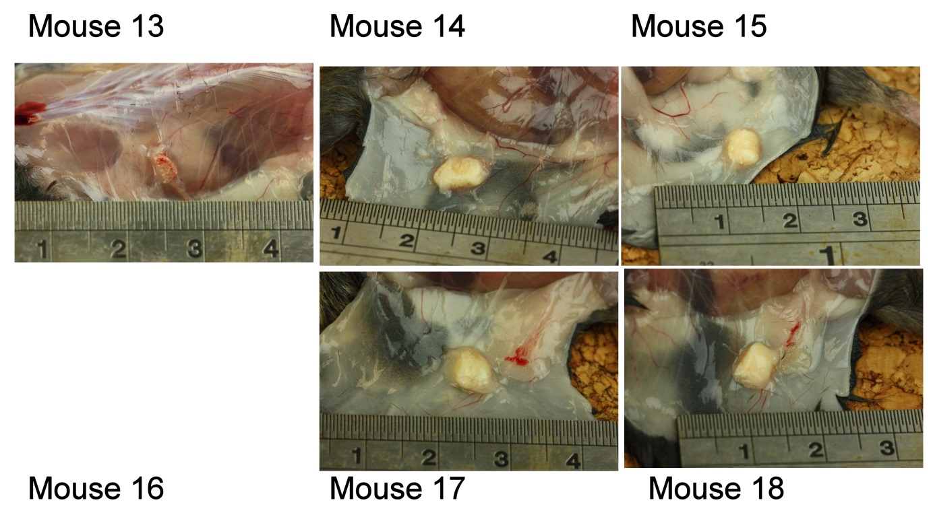

Explanted after 3 months Decellularised porcine superflexor tendon

