- Snack choice after meal

Q91. Following my evening meal (and dessert if I choose to consume one), I would select the following snack to consume as I take part in my usual evening routine(e.g. watching TV, reading):

1=Corn Chip/Potato Crisp Grab Bag 2=Typical Potted Yoghurt
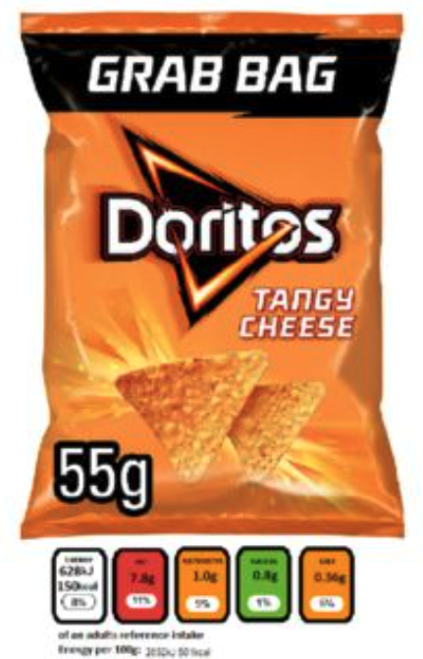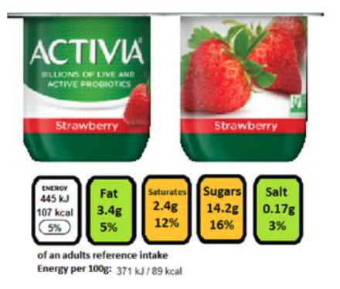

3=Sweet, Salted or Sweet 'n' Salted Popcorn 4=Chocolate Dessert Pot

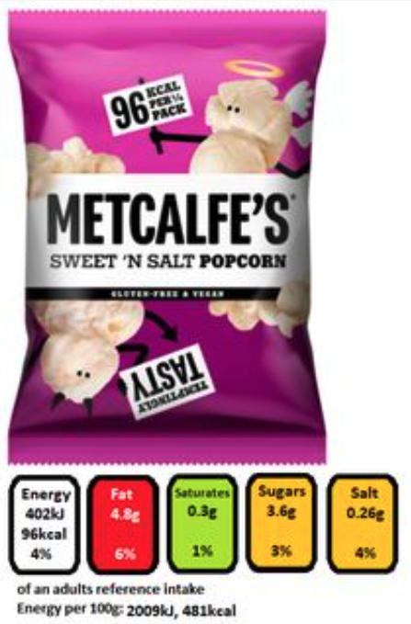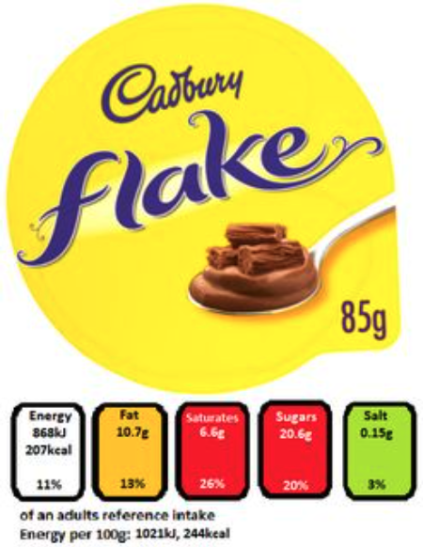
5=Dried Fruit Bag 6=Toffee/Sweet Coated Popcorn

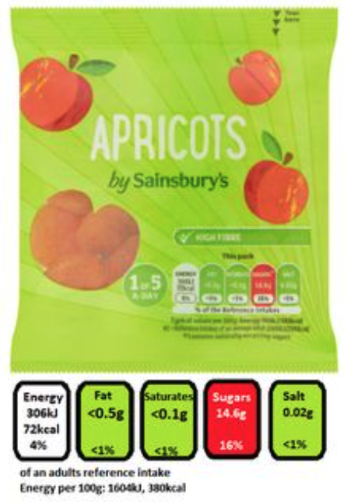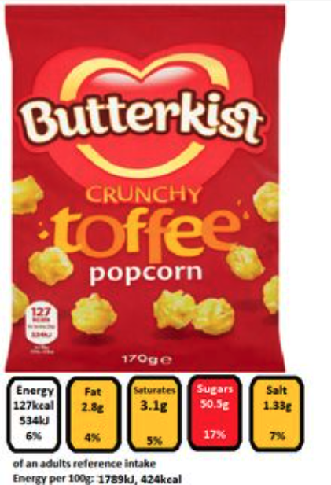

7=I would not consume a snack in this occasion

8=I would prefer to consume an alternative snack on this occasion

