- Snack choice between meals

Q90. On a normal working day, if I have time between eating my Lunch and Evening meal, I would prefer to consume the following product to at my desk or place of work:

1=Typical Chocolate Snack Bar 2=Malted Loaf or Fruit Bread
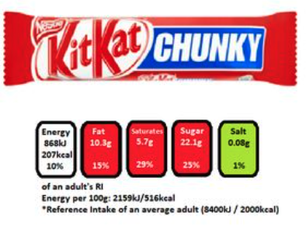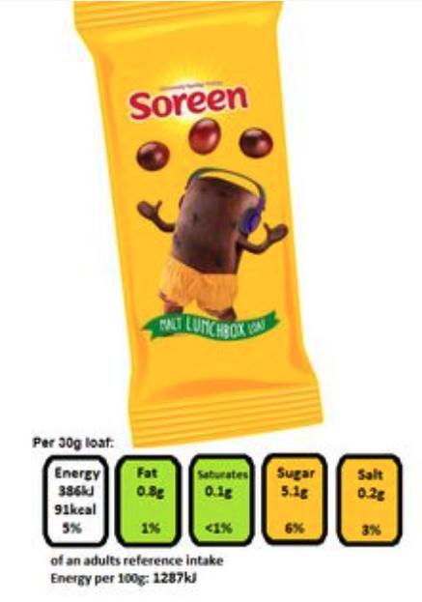
3=Cake Slices 4=Snacking Rice Crackers
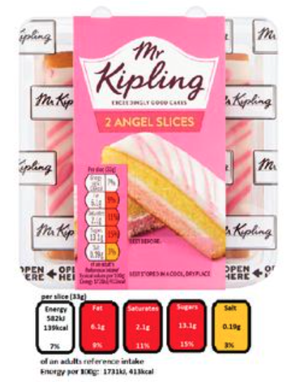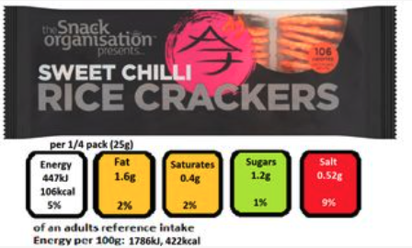
5=Typical flavoured nut and seed mix 6=Typical Crisp/Corn Snack Grab Bag
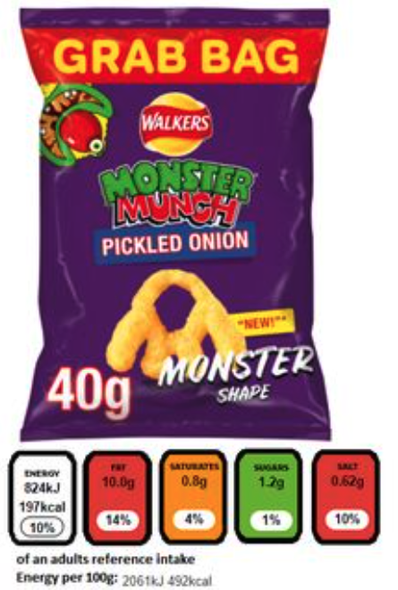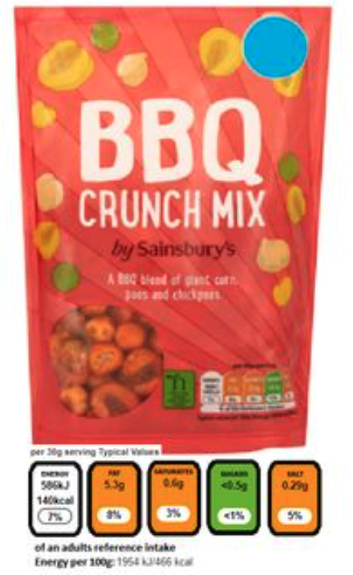

7=I would not consume a snack in this occasion

8=I would prefer to consume an alternative snack on this occasion

