- Snack choice Morning

Q89. If I am looking to eat a snack on the go (e.g. Morning commute) between breakfast and lunch I would prefer to consume this product from the following options (pick one):

1=Crispy Fruit Breakfast Bar 2=Honey and Oat Granola Bar

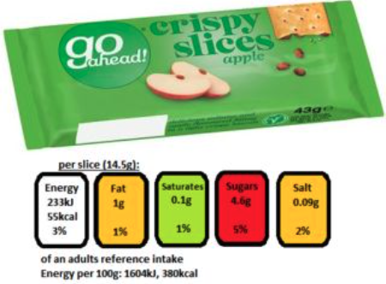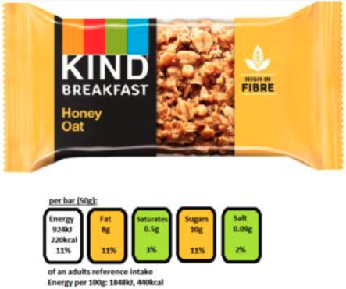

3=All Butter Pastry Item 4=Typical Sweet Cereal Bar
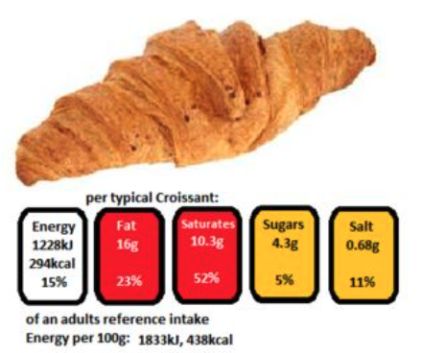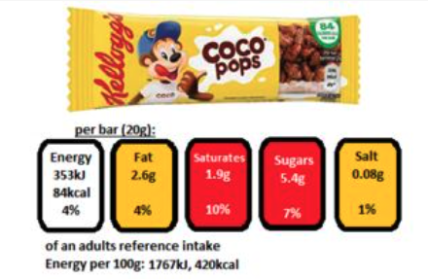

5=On the Go Yogurt 6=Large Meat Pastry
with Crispy Granola Topper

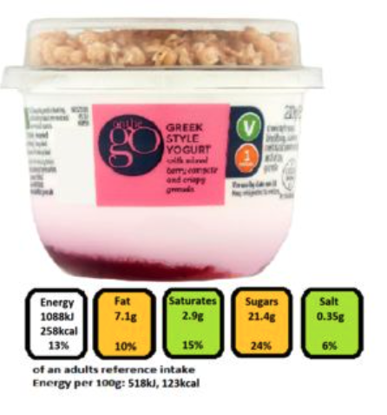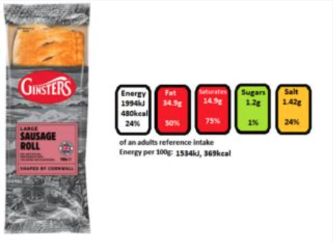

7= I would not consume a snack on this occasion.

8= I would prefer to consume an alternative snack on this occasion.

