Technical Report- Discrete Event Simulation model on CDI diagnostic tests

Model structure

Model structure schematics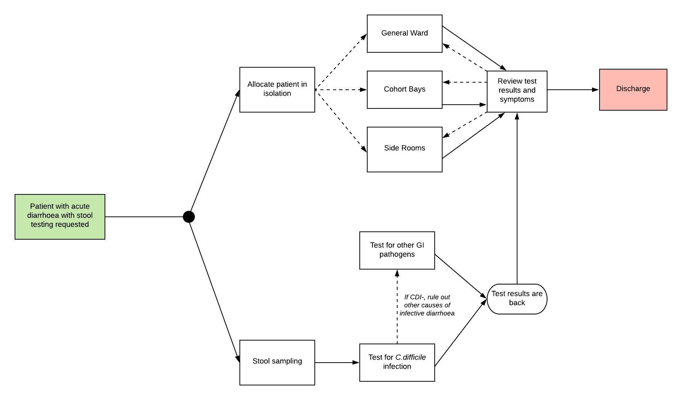
Figure 1

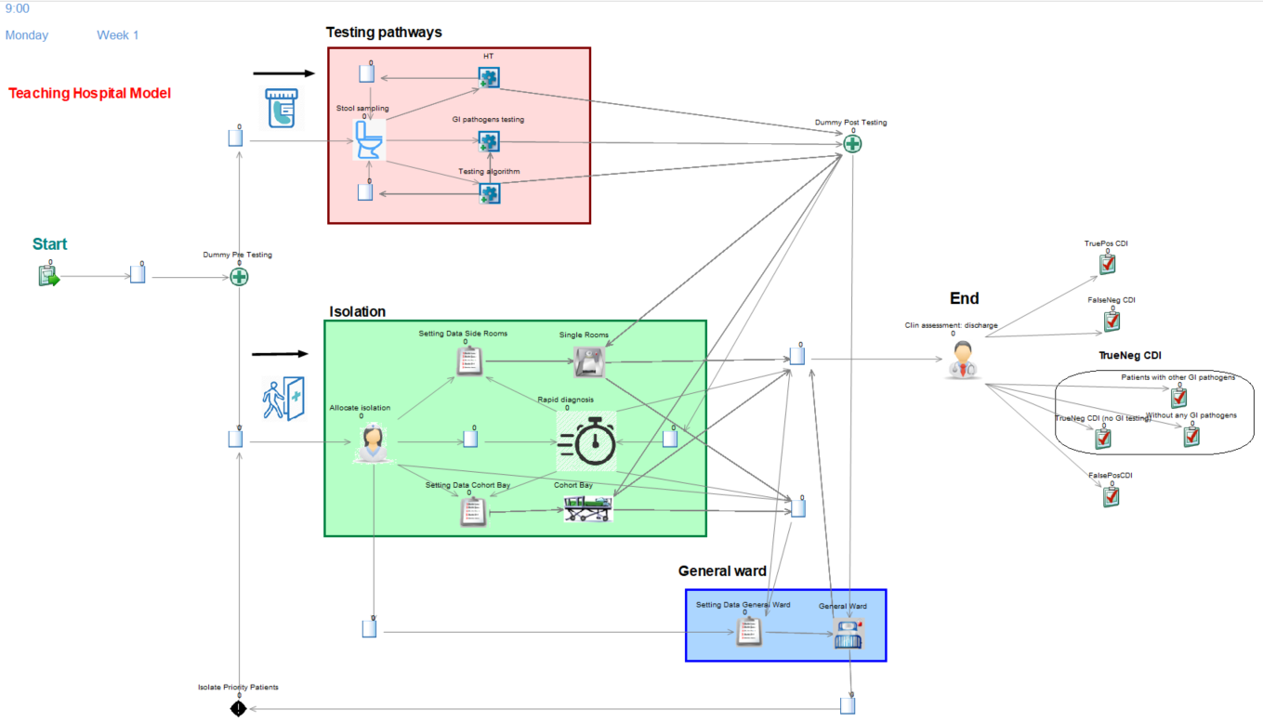
Figure 2
- Start- Patients with symptoms enter the model (Figure 3)
- Adult patients with first episode of acute diarrhoea with stool testing being requested enter the simulation. The arrival of a patient at the hospital is set according to a certain inter-arrival time which is defined using an exponential distribution. This distribution is based on the number of samples being tested for CDI over a month.
- Each patient entering the simulation is randomly assigned true disease status for CDI (infected or non-infected), true disease status for other gastrointestinal (GI) pathogens, duration of symptoms and hospital length of stay based on some probability distributions (please see Table 1 in the main text for more details). As we are assuming no risk of co-infection, patients truly positive for CDI are assumed to be negative to other GI pathogens. Similarly, patients truly positive for other GI pathogens are assumed to be negative to CDI.
- Patients are placed in empirical isolation while their stools are getting tested. Stool testing and presumptive isolation happen simultaneously. The simulation has the functionality to divide a single entity, or patient, into two parts (called “batching” in Simul8) which share the same information (e.g. disease prevalence, time to enter the model), and to re-combine those two parts (called “component”) of an entity at a later event (i.e. once test results are back). This helps to simulate different events happening simultaneously to an entity. This approach is used in the model to track: (i) what side-room a patient enters, depending on the current availability of side rooms, and (ii) the various processes of the testing pathway that each individual’s test sample undergoes (e.g. sample preparation, setting the machine, reviewing test results). The division of entities into their two respective components is undertaken at the start of the model (i.e. at Dummy Pre Testing activity). Once the patient’s test result is received, the two components are recombined and information on patient’s health is updated upon receipt of test results.
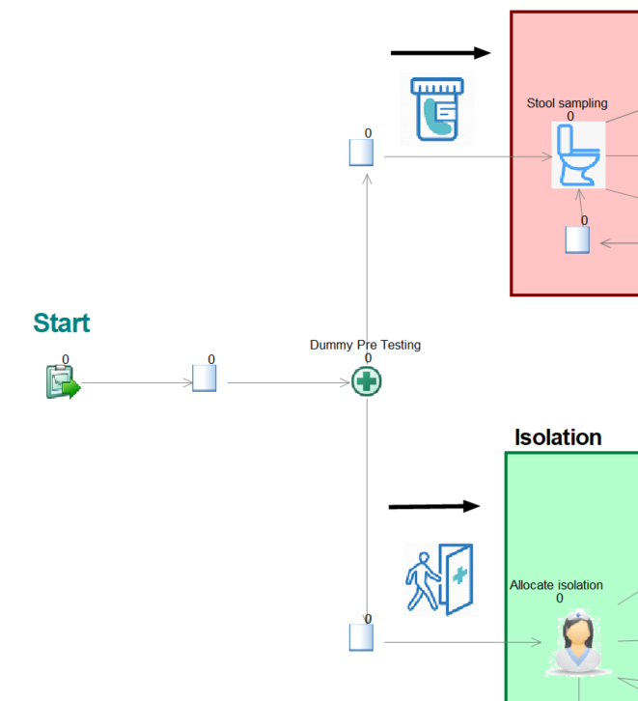
Figure 3
- Patients going into presumptive isolation while waiting for test results (Figure 4)
- LTHT clinical guidelines which recommend to place a patient into isolation within two hours from suspicion of infective diarrhoea [1, 2]. If results are back within the two-hours time window, in case of negative test result and clearance of symptoms, a patient might stay in general ward without being isolated. Isolating a patient for less than two hours might waste scarce resources (i.e. side rooms ) which could be used for other patients in need [3].
- In case results are not back within the two-hour window, there are three locations where patients could be placed in isolation:
- Single rooms: only one patient can enter a single room with no potential of infecting others. If there is a confirmation of infectious diarrhoea, a certain patient remains in isolation until the end of their hospital length of stay;
- Cohort bays: in case no single room is available, a maximum of 5 patients suspected with infective diarrhoea can be cohorted together. If there is a confirmed infective patient within the cohort, all patients remain in isolation until the end of their hospital length of stay;
- General ward: in case no single rooms nor cohort bays are available, patients suspected with infective diarrhoea might stay in general ward with a higher potential for in-hospital transmission.
- If a patient within General Ward is confirmed with infectious diarrhoea, it might be possible to transfer the patient into a free single room or cohort bay depending on current availability as this patient is considered high priority from an infection control perspective.
- If side rooms reach full capacity, clinicians might decide to start de-escalating infection-control measures for patients who are no longer infectious. Based on expert opinion, patients positive to other GI pathogens who are no longer symptomatic can be assigned a lower priority from an infection-control perspective. Once side rooms are occupied, the model has the functionality to de-isolate any asymptomatic patient positive to other GI pathogens to release additional side rooms.
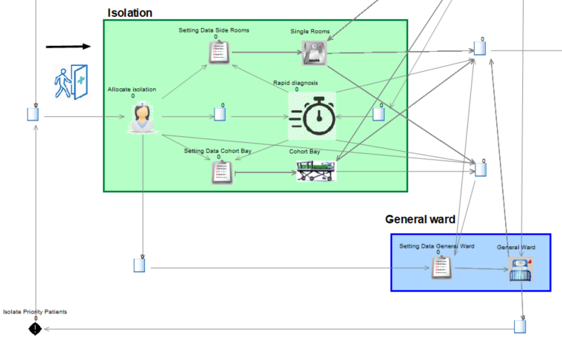
Figure 4

- Testing pathways (Figure 5)
- Stool sampling activity simulates the process of obtaining the sample, which takes on average half a day since clinicians have requested stool testing. Next, the sample is shipped to the laboratory or tested within the ward depending on the testing strategy under evaluation, be it either HT or LTHT testing algorithm. Samples are initially tested for the presence of CDI.
- The following features are common to both testing strategies:
- Test turnaround time is computed as the difference between time point stool sampling is obtained and when test results are back.
- Time-to-result is the time required for a test to yield results.
- If sample is CDI negative, the sample might be tested for other GI pathogens to rule out other causes of infective diarrhoea.
- Once test results are back, a dummy activity matches the sample ID with the patient ID. Each patient will then receive their test result; this, in turn, will help clinicians to decide whether a patient should remain in isolation considering both test results and clearance of symptoms. 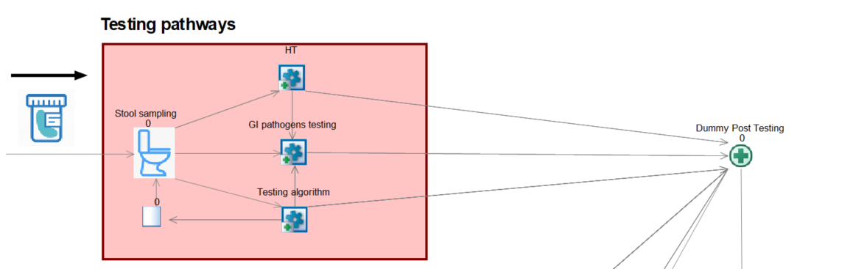
Figure 5
- Focusing on the testing strategies being evaluated:
- HT (Figure 6)
- HT is modelled as a ward-based point-of-care test (POCT) detecting toxins in stools. We assumed that there are 25 testing kits available. If none of the 25 testing kits is available, samples will wait to be processed.
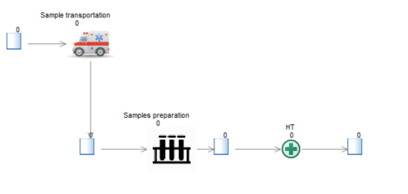
Figure 6
- LTHT Testing algorithm (Figure 7)
- Samples are prepared for testing at 10am and 4pm. Samples arriving in between are not getting tested.
- Only GDH positive samples are tested simultaneously with PCR and CCNA
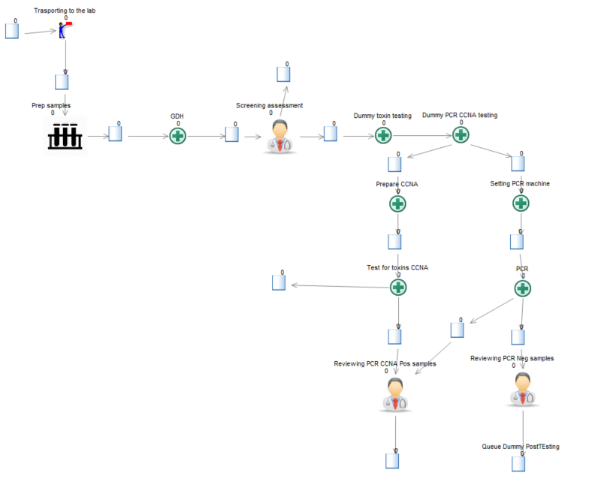
Figure 7
- Confirmatory GI testing (Figure 8)
- Only CDI negative samples are tested for other GI pathogens. This causes a delay on the overall testing turnaround time as patients will remain in presumptive isolation for longer while waiting test results for both CDI and other GI pathogens.
- A multiplex GI panel is run with 100% diagnostic accuracy, as the focus of this model is on CDI diagnostics.

Figure 8

- Review test results and symptoms (Figure 9)
  - This activity simulates clinicians receiving test results for infectious diarrhoea and deciding whether either to keep a patient in isolation, move them to general ward or to discharge them. This decision depends on the test results and clearance of symptoms.
- Test positive for C.difficile infection or other GI pathogens - Patients with confirmed CDI will stay in isolation for the whole duration of their hospital stay, as per LTHT clinical guidelines (7). Patients with other GI pathogens being detected will stay in isolation up to 2 days from symptoms resolution and then might enter general ward or be discharged;
- Test negative but symptoms persist - Patient will stay in isolation and additional testing might be requested depending on the chosen testing practice;
- Test negative without symptoms - Patient will be deisolated and subsequently enter general ward or be discharged.
  - Once a patient exits single room isolation, the given room must be decontaminated and deep cleaned to reduce likelihood of transmission [1, 2, 4]. New patients entering this side room might then wait an extra hour upon removal of the previous patient.
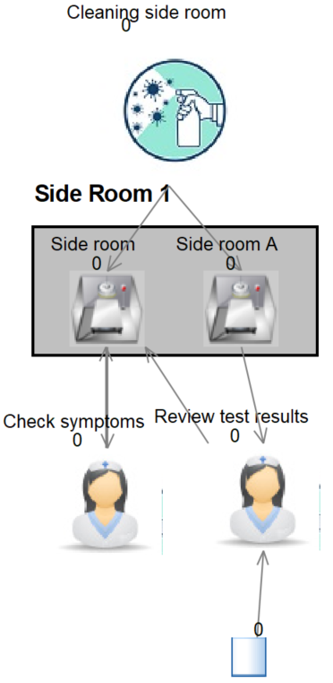
Figure 9

- Cohort bays (Figure 10)
  - If there is more than one patient within the cohort bay, it is necessary to wait until laboratory confirmation of infectious diarrhoea for each patient within the cohort bay causing patients to stay longer in isolation. In addition, if one or more patients in the cohort bay is positive to either CDI or other GI pathogens, all patients remain in isolation for their whole hospital stay to avoid infection spread regardless of their test result.
  - According to expert opinion, it is recommended against de-isolating patients who have been cohorted together with patient(s) who were infectious. This might cause extra pressure on cohort bays as new patients cannot enter that cohort bay.

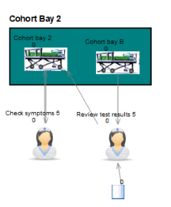
Figure 10
- General ward (Figure 11)
- Two patient subgroups can enter general ward
- Suspected infective patients waiting for test result who did not find a place in side rooms nor cohort bays
- Patients tested negative for either CDI or other GI pathogens: they will remain in General ward for the remaining hospital length of stay
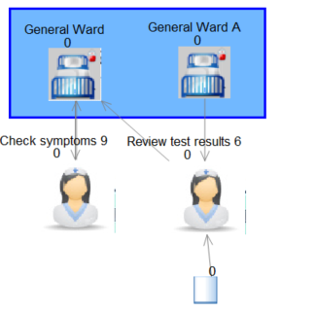
Figure 11
- Discharge (Figure 12)
  - Here patients are getting discharged from the hospital and their relevant outcomes are recorded if they have entered the simulation within the evaluation period (within two months following the end of warm-up period)
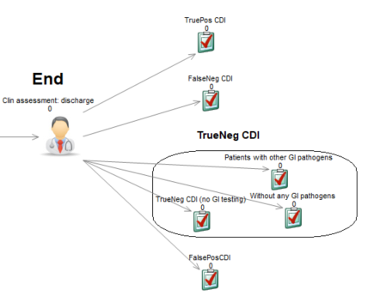
Figure 12

Model analysis

Analyses were based on running sixty replications (i.e. running the model 60 times, with each using a different random number sequence).
A warm-up period of 5 weeks was applied in the model, to initially populate the hospital system. Starting with the model ‘cold’ (i.e. all side rooms available) would overestimate the availability of side rooms; simulating a warm-up period therefore helps to appropriately capture the capacity constraints patients face once they enter a busy hospital.
This warm-up period and replication number were sufficient to stabilise the distribution of model outputs around a 1% difference as per good modelling practices for DES models.
Figure Each model replication records outcomes of interest for patients entering the hospital over a 60-day period (two months) following the end of the warm-up period. The model results collection period extends up to four months to ensure that each patient entering the model within the initial two-month entry period can have their full experience of the clinical pathway simulated. As clinical management of CDI patients usually lasts up to one month [5], a two-month extended results collection period was sufficient to capture outcomes for each patient entering the model. Whilst additional patients were allowed to enter the model after the initial warm-up and evaluation period, their outcomes were not recorded. Figure 13 gives a schematic of the timeline for model analysis.

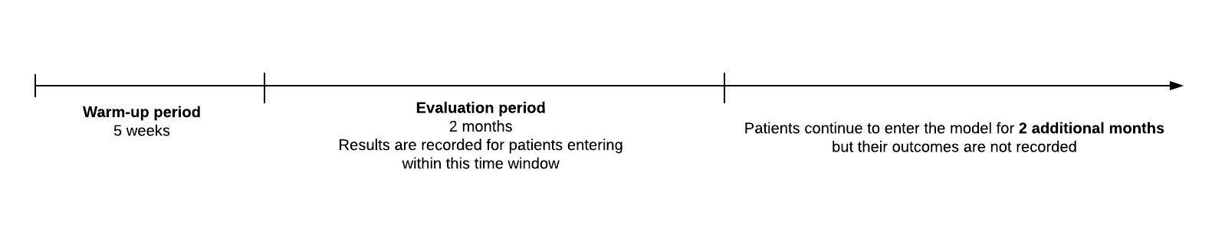
Figure 13 Timeline for model analysis

References

1. Leeds Teaching Hospitals NHS Trust. Clostridium Difficile Infection ( CDI ) in Adults ( 16 years of age ). 2008. http://www.lhp.leedsth.nhs.uk/detail.aspx?ID=1254. Accessed.
2. Leeds Teaching Hospitals NHS Trust. Clostridium Difficile - Prevention of Transmission - in Adults and Children > 2 years with Clostridium Difficile Infection ( CDI ). 2017. http://www.lhp.leedsth.nhs.uk/detail.aspx?ID=677. Accessed 26/10.
3. Goldenberg SD, Bisnauthsing KN, Patel A, Postulka A, Wyncoll D, Schiff R, et al. Point-of-Care Testing for Clostridium Difficile Infection: A Real-World Feasibility Study of a Rapid Molecular Test in Two Hospital Settings. Infectious Diseases and Therapy. 2014; doi: 10.1007/s40121-014-0038-6.
4. Leeds Teaching Hospitals NHS Trust. Isolation - Infection Prevention & Control. 2018. http://www.lhp.leedsth.nhs.uk/detail.aspx?ID=678. Accessed 26/10.
5. Jones WS, Rice S, Power HM, Maniatopoulos G, Suklan J, Beyer F, et al. Cost Consequences for the NHS of Using a Two-Step Testing Method for the Detection of Clostridium difficile with a Point of Care, Polymerase Chain Reaction Test as the First Step. Diagnostics. 2020; doi: 10.3390/diagnostics10100819.

