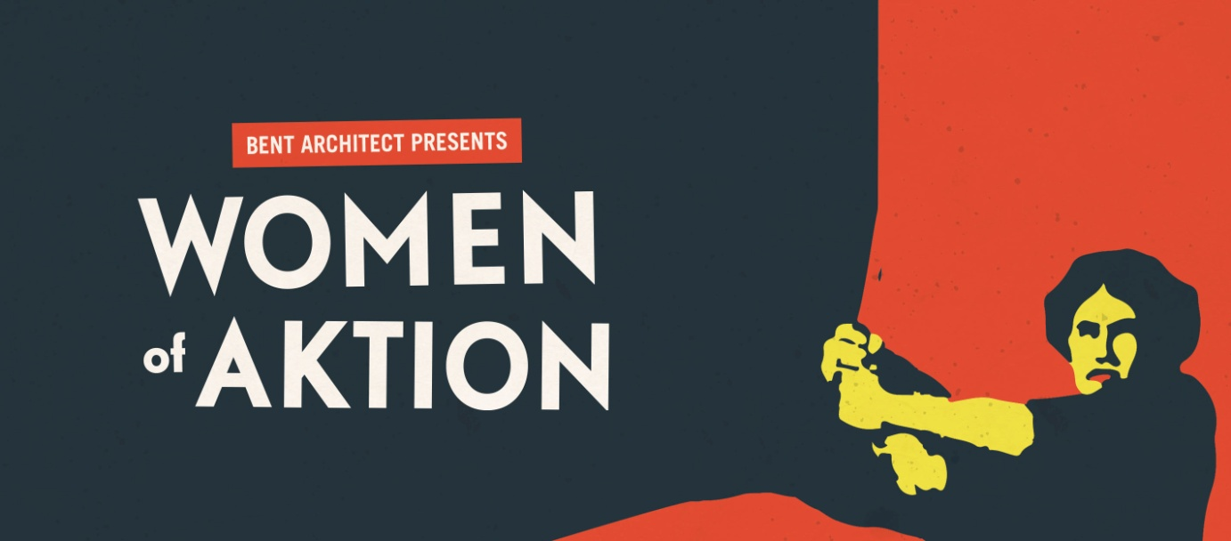

Marketing Pack

Contact:
Jude Wright
jude.producer@gmail.com
07968 165 744
CONTENTS:

• Promotional copy
• Tour Dates
• Box Office Brief
• Target audiences and previous attenders
• Digital marketing / social media
• Press Release
• Brief history of Events Surrounding the Play
• About the cast
• About the creative team
• The Characters
• Links

THE SHOW:

It's the 1930's and a young Joan Littlewood has walked out of RADA and stomped her way north, searching for the revolution. She reaches Manchester and finds kindred spirits, an industrial solidarity, and a determination to hear the voices of dissent – at the Rusholme Rep!

There she embarks on a production with Ernst Toller, German anarchist and ex political prisoner. His play, Draw The Fires tells of the story of the Kiel Uprising that brought the first world war to its knees. But Joan doesn't like the play, it’s all too male, where are the women she demands to know?!

As Joan’s rows with Toller shake the building, so from the factories of northern England to the mills of northern Germany, the voices of the women rise up from the depths. Together, they issue a revolutionary call that renounces militarism and brings the madness of war to an end.

In this imagined piece, Bent Architect expertly weave newly unearthed verbatim histories of the women of Kiel with the radical force of Littlewood in her early Manchester years, to hear those voices resound afresh, to reveal a new, hitherto barely considered truth about a war which engulfed the world, which was brought to an end when ordinary people rejected conflict in favour of peace.

TOUR DATES:
3 to 5 October
Stage @ Leeds
0113 343 8730

15 October
Lakeside Theatre,
University of Essex
01206 873261
18 October
Theatre Royal, Wakefield
01924 211311
20 October
Skipton Town Hall
01756 792 809
22 October
Harrogate Theatre
01423 502116
23 October
York Theatre Royal
01904 623568
26 & 28 October​
Kiel, Germany

6 November
Gulbenkian Theatre, Canterbury
01227 769075
8 November
Gallery Oldham
0161 770 4653
9 November
Square Chapel, Halifax
01422 349 422
14 November
Sheffield Hallam
Performance Lab
Special closed performance
for students
​
15 November
Wolverhampton Arena
01902 321 321
16 November
Partisan Collective, Manchester
skiddle.com
17 November
Theatre Deli, Sheffield
Book here

BOX OFFICE BRIEF:
This is the untold story of the women who took part in the ending of the First World War, which was brought about by a people's revolution in Kiel, Germany.
- Mick Martin has a reputation for writing sharp, witty comedy, so the piece will be funny as well as historical.

- The play is framed by theatre revolutionary, Joan Littlewood, who, at the very start of her career, staged a German play about the Kiel revolution.
- In this piece, Joan calls for the stories of the young, radical women, brought together by a shared belief in a better world.
- Therein, she discovers a wealth of amazing women who helped bring about peace - women who have since been written out of history.
- The show has a cast of three female performers who all sing and play original music written for the show.
- The play will have something for everyone – history, love, passion, politics and humour.
- It will be a production that both regular theatre goers and new audiences alike will love. It will be a great night out!
- There will be a series of events during the tour that will appeal to those with an interest in the history of the radical North and local history. There will be talks and events run by Prof. Ingrid Sharp Dr Corinne Painter, radical women in history and German specialists from the University of Leeds.
- It has an award-winning northern creative team producing the show, including Bradford-based writer Mick Martin (Once Upon a Time in Wigan), director Jude Wright (Dartington Arts, Northern Broadsides), artist and inventor Dave Lynch, a Cultural Fellow of the University of Leeds, and Keira Mari Martin, north based dance and movement artist.
TARGET AUDIENCES:
- Drama attenders
- Local History enthusiasts
- Left wing political activists
- Live music fans
- Previous attenders of Mick’s Once Upon a Time in Wigan and new writing.

SOCIAL MEDIA:
Web: www.bentarchitect.co.uk
Twitter: @BentArchitectCo
Facebook: www.facebook.com/bentarchitect
PRESS RELEASE
Bent Architect presents:

Women of Aktion

The stories of revolutionary women who brought about the end of WWI explored through the imagined collaboration between Joan Littlewood and anarchist German playwright Ernst Toller

Written by Mick Martin | Directed by Jude Wright & Mick Martin

INTERNATIONAL TOUR: 3 October - 17 November 2018

“Mick Martin’s cracking play... Nothing short of civil war in studs.” Alfred Hickling on Broken Time (the Guardian)

The documentation of history is an act of omission; certain stories are unjustly forgotten, usually those of women. As we approach the centenary of the 1918 Armistice, Bent Architect draws on two years of work with academics at the University of Leeds and across Germany to bring to light the hitherto untold stories of the women behind the Kiel Mutiny of 1918, a seismic act of rebellion that helped spark the end of the First World War and the beginning of the German Revolution, all through the imaged collaboration of a young Joan Littlewood and the anarchist playwright, Ernst Toller.
It’s the 1930s and Joan Littlewood has just arrived in Manchester with fire in her belly and revolution on her mind. When she and the left-wing playwright and ex-political prisoner Ernst Toller begin work on his play telling the story of the Kiel Mutiny of 1918, Littlewood demands to know, where are the women? Rallying the voices of the oppressed, from the factories of northern England to the mills of northern Germany, they embark on a journey to share the verbatim stories of the truly revolutionary women who changed the course of history.
Mick Martin and Jude Wright said, ‘That women helped drive the Kiel mutiny of 1918 is both airbrushed out of history and hugely important, now more than ever as tensions across Europe build and forces we thought vanquished rear their ugly heads again; these stories are vital to our understanding of ourselves and our history. Having researched the story of British opposition to WWI, we were struck by the lack of research into German peacemakers. It's been incredibly exciting to work alongside the researchers at the University of Leeds to uncover these hidden stories in the centenary year of the beginning of female suffrage in both the UK & Germany.’
Since 2006 Bent Architect, comprised of Jude Wright and Mick Martin, have created a substantial repertoire of original theatre, touring to numerous theatre and non-theatre venues and delivering a range of educational activities alongside. By working with a variety of partners, they have been able to deliver their shows to audiences who would not usually engage creatively with their work. Their main artistic and conceptual interests lie in platforming the voices of the voiceless and those historically ostracised by society. Although their work sits on the fringes of traditional theatre, they have worked closely with a number of artistic partners, including Manchester’s Contact Theatre (Darwin’s Worms residency & performance), Brick Box Collective (Wonderful World Of… residency and performance) and Lawrence Batley Theatre (England, Arise! R&D residency and performance prior to national tour).
@BentArchitectCo | #WomenofAktion | facebook.com/BentArchitect | www.bentarchitect.co.uk
Running Time: 85 mins | Suitable for ages 14+

Company Information
Directed by Jude Wright & Mick Martin Written by Mick Martin
Produced by Bent Architect Lighting design Sherry Coenen
Film/ visuals Dave Lynch Music Claire Marie Seddon
Sound design Mark Nesbitt Movement direction Keira Martin

Cast
Claire-Marie Seddon
Francesca Anderson
Rachel Gill Davis
ENDS

CLAIRE-MARIE SEDDON
CAST AND CREATIVE TEAM:
Actor & Musical Director
Claire trained at The Royal Conservatoire of Scotland and Mountview Academy of Theatre Arts.

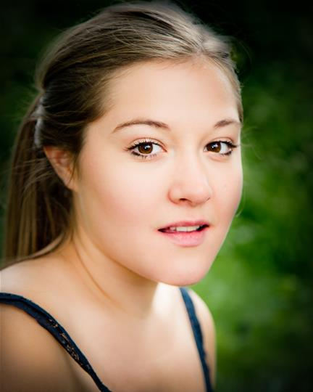

Theatre includes:
TARZANNE, Interplay Theatre, Steve Byrne; THIS SPACE IS OCCUPIED, Bent Architect, Mick Martin; MURDER ON THE MIDDLETON EXPRESS, Lawrence Batley Theatre/FrontRoom Productions, Olivia Race; LIFE IS SKETCHY, Hyde Park Book Club, Rod Dixon; BEST FOOT FORWARD, Mikron UK Tour, Marianne McNamara; THE NORTHERN SCHOOL, Bent Architect, Mick Martin

RACHAEL GILL DAVIS
Actor

Rachael trained at Manchester School of Theatre.

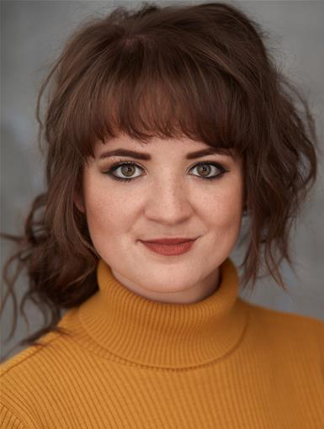

Theatre includes:
GREEK, The Flying Seagull Project, Isobel Wolff; D'EON, The Straight Acting Theatre Company, Renny Krupinski; UNSEEMLY WOMEN, Girl Gang, Chantell Walker; ADDICTED TO FOOTBALL STICKERS, UNILAD, Andrew Ellis; BLOOD WEDDING, The Manchester School Of Theatre, Alan Dunnett; ROMEO AND JULIET, Cambridge Shakespeare Festival, Simon Bell

FRANCESCA ANDERSON
Actor

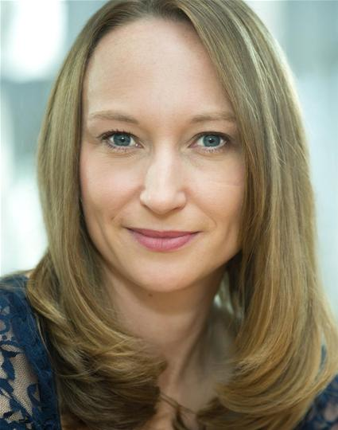

Theatre includes:
A WOMAN OF NO IMPORTANCE, DOT Productions, Micha Mirto; HANSEL & GRETEL, Lyngo Theatre Company, Patrick Lynch; WAKING BEAUTY, The Minerva Collective, Fiona Kingwill; WOMEN OF TWILIGHT, Jonathan Rigby; LITTLE VICTORIANS, Phileas Fogg Theatre Company, Peter Massey; AS YOU LIKE IT, Carousel Theatre Company, Emily Wade; PALS, Spin-Off Theatre Company, Honor Palant; WIND IN THE WILLOWS, Cambridge Touring Theatre, Barry Evans; A MIDSUMMER NIGHT'S DREAM, Spin-Off Theatre Company, Honour Palant
MICK MARTIN
Writer

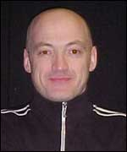

Mick Martin trained at Bretton Hall College and has been a professional writer ever since.

As a writer he has a string of theatre, radio and television credits ranging from The Life And Times Of Young Bob Scallion, The Immigrant Song, A Weekend In England, Once Upon A Time In Wigan, Son Rise, Worlds Apart, Spit Nolan, Broken Time and The Flamed Haired Dynamo which have all been produced at major theatre venues across the country.

Mick is co-Artistic Director of Bent Architect, who are supported by the Arts Council to create fresh, engaging, entertaining work.

On TV he has contributed episodes of Ballykissangel, Dream Team, Born & Bred and Crossroads. He has written a film script of Once Upon A Time In Wigan.

PROFESSOR INGRID SHARP

Project lead, University of Leeds

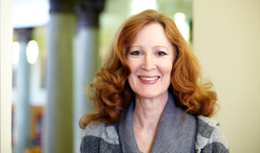

Ingrid is Professor of German Cultural and Gender History at the University of Leeds. She has dedicated many years of research exploring the roles of women, who have challenged dominant ideas and entrenched authority and sought change; at how moments of crisis and conflict can act as catalysts for these challenges, and how the aftermath of conflict offers a brief window during which societal and gender norms can be re-negotiated.
DR CORINNE PAINTER

Lead researcher, University of Leeds.

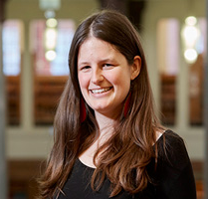

Corinne is a cultural historian and the Research and Project Officer for the Kiel Uprising project. Her current research focus is life writing by female revolutionaries. Both her MA and PhD examined the experiences of Jewish women at the start of the twentieth century and women’s history is a research focus for her. She has also worked in the Museums and Heritage sector and is involved with enabling public access to academic research.

The Kiel Revolution

The Kiel revolution of November 1918 directly led to the abdication of Kaiser Wilhelm III, the end to the First World War and the formation of a brand new republic in Germany - the Weimar Republic.

By the autumn of 1918, the German people were hungry - they had not had sufficient food for years, and food riots were becoming common place. Anti-war feeling was spreading fast, and people were beginning to organise.

Alongside this, the military and, in particular, the navy, were also sick and tired.

On 3 November 1918, they were ordered to sail out on what was considered a suicide mission. The men revolted, and were sent from Wilemshaven across the Kiel canal to Kiel. Once there, the mutineers were imprisoned.

Their colleagues left for shore and the sailors' councils met with the workers' councils from the town. Together, they formed a plan to bust out the mutineers from the prison, an act which triggered the German revolution which was to sweep aside the monarchy within a few days.

It ultimately led to the end of the German Empire and to the establishment of the Weimar Republic.

Women of Aktion tells the story of the women of Kiel, who stood in queues, suffered malnutrition, watched their children die, and yet still stood strong, organised, and risked their lives to bring an end to the war. Women who, until now, have been written out of history.

Friede, Brot, Freiheit! - Peace, Bread, Freedom!
The First World War ended at 11 o’clock on the 11th day of the 11th month of 1918 when the Germans surrendered. We won game, set and match.
Well, I don’t know about anyone else but that’s definitely what we were taught.
But what if it’s not actually true? What if we didn’t win the war at all?
Our 2014 project, England, Arise!, told the unknown story of Huddersfield's socialist conscientious objectors and their opposition to WW1. During this, we met Prof. Ingrid Sharp of Leeds University. Her specialist area is German women’s history, and she wondered if we could unearth similar stories from over there.
A couple of research trips later, we realised that the First World War is much less significant to Germans than to the British. We spoke to experts, historians and women's role in it was virtually non-existent, apparently.
We began to dig, and, via the power of Google translate, stumbled upon a collection of interviews of women from Kiel - a port town in the north of Germany - recollecting their lives and, importantly, dating back to WW1. The title of the interviews, unsurprisingly, was 'Grandpa was a Revolutionary' - the views and experiences of the women themselves was pushed to the background. Nevertheless, we started to scratch beneath the surface.
The 'Revolution' of which they referred to was the Kiel Revolution of 1918. A people's revolution which, it turned out, began a chain of events that, within days, led to the abdication of the Kaiser and the end of the First World War.
Traditionally, the story is told from an entirely male perspective. A group of sailors revolt, are sent to Kiel to prison, lots of men break them out of prison, take to the streets and thereby begins to end.
Look a little harder though, and you realise that conditions in Germany were much harsher than here. After the winter of 1916-17, people were surviving on just over 800 calories per day. Over 700,000 civilians died, not from fighting, but from lack of food during the war.
Riots were breaking out in food queues, people were beginning to organise, trade unions were getting more and more active and strikes were taking place. In January 1918, more than 4 million strikers were protesting in the streets.
That no women were involved in any of this is patently ridiculous. We travelled to Kiel to visit the archive where they had a set of Gertrude Vӧlker's memoirs, one of the interviewees who had worked in the trade union in Kiel. Having braved the nonplussed expression of the archivist who assured us there were no such memoirs ("please can you just check for me?") we were pleased (relieved!) when he found them.
And there began the most fascinating journey. A grant from the Arts & Humanities Research Council, along with the support of the University of Leeds, allowed us to uncover the stories of over 200 revolutionary women who were active in Germany at the time. And that's just the tip of the iceberg.
Theatre gives us a space to tell untold stories. Something a certain Joan Littlewood understood. Indeed, it turns out one of her first professional jobs was working on a play about the revolution in Kiel. When she first arrived in Manchester and met Jimmie Miller (aka Ewan MacColl), they worked on Draw the Fires prior to forming their Theatre of Action. Written by the German revolutionary Ernst Toller, the play is definitely left wing and definitely not about women. But something about it clearly inspired Joan.
The original script of 'Oh, What A Lovely War' in the Lord Chamberlain’s archive finishes by showing German soldiers and sailors rejecting the monarchy, forming soviets, and inviting the British to follow their example. This had to be changed, so that the play finishes with a medley of songs - a more palatable conclusion to the war for us loyal Brits?
Women of Aktion is a revolutionary play. Yes, it's about a revolution, but it also turns what we think we know on its head. Joan, Gertrude and their radical sisters challenge us to reconsider who makes history and, perhaps, hopefully, inspire us to recognise our own role in changing the world.
Jude Wright & Mick Martin, September 2018

'Tweet'-length biogs of
The Women of Kiel (and beyond):
GERTRUD VӦLCKER
1896-1979
During the revolution Gertrud worked in the Trade Union building in Kiel. She was a member of a radical social youth group and organised lectures and reading groups to share socialist material and ideas. She was involved in local politics for the rest of her life.
#WomenOfAktion

MARTHA RIEDL
1903-1992
She was only fifteen during the revolution and became a messenger. She ran through the streets of Kiel, risking her life to take messages to different groups. She was elected to the town council after WW2.
#WomenOfAktion

HILDE KRAMER
1900-1974
Hilde was the secretary to the Bavarian Soviet in April 1919. She was arrested and spent time in prison for her role. She worked as a journalist and translator in Moscow in the 1920s. She emigrated to the UK in 1937 and wrote documents for the founding of the NHS.
#WomenOfAktion

RAHEL STRAUS
1880-1963
She was one of the first women to qualify as a doctor in Germany. She was involved with the revolutionary women’s councils and the council of intellectuals. She saw the brutal repression of the Bavarian Soviet Republic
#WomenOfAktion

ROSA LEVINÉ-MEYER
1890-1979
She worked as an interpreter for the German army after the Russian revolution. Her husband was imprisoned in Munich and sentenced to death for his role in the Bavarian Soviet. She was active in the fight against the far right and wrote several books about her experiences while in exile in the UK.
#WomenOfAktion

GABRIELE KAETZLER
1872-1954
A teacher who ran a socialist foster home on the outskirts of Munich. She was monitored by the police for distributing anti-war material. She spent time in prison for participating in the revolution in 1918. She joined the communist party, moved to Switzerland and supported refugees from the Third Reich.
#WomenOfAktion

ROSA LUXEMBURG
1871-1919
A philosopher and economic theorist, she was in prison when the revolution started due to her anti-war activism. She led the revolution in Berlin in January 1919. She was murdered by the Freikorps.
#WomenOfAktion

CLARA ZETKIN
(1857 –1933)
One of the founders of the Spartacist league, she had been fighting for women’s suffrage and rights. She continued to work in left wing organisations throughout the Weimar Republic.
On the November Revolution:
“To our work, women, proletarians, in order that our message reaches even the most humble garret! To our work so that our message becomes an intention of preparedness and energy! No apprehension in front of the advancing, reactionary violence! Make no pacts with false friends! We arm ourselves with every weapon to take on our enemies on every stage. Be mindful that our creative power lies within women’s rights. Women are strong enough to stop the wheels of industry if we want to! We fight!”
#WomenOfAktion

KӒTHE KOLLWITZ
(1867-1945)
A German artist who created sculpture, drawings and woodcuts. She is known for her images of grieving mothers and starving children, showing the horror of the war at home.
From a diary entry in March 1918:
“That is what changes everything. The feeling that we were betrayed then, at the beginning. And perhaps Peter would still be living had it not been for this terrible betrayal. Peter and millions, many millions of other boys. All betrayed. That is why I cannot be calm. Within me all is upheaval, turmoil.”
#WomenOfAktion

MINNA FASSHAUER
(1875-1949)
She organised strikes and anti-war activities and she joined the revolutionary council in Braunschweig in November 1918. She became the first woman in Germany to be an elected minister. During the Third Reich she was arrested multiple times for treason.
In August 1917, she coordinated mass strikes in Braunschweig. This is the pamphlet she distributed:
“Enough of the mass murder, enough of the hunger, enough of the oppression! […] Peace! Bread! Freedom!”
#WomenOfAktion
CLӒRE JUNG
(1892-1981)
A journalist and member of a group of radical left-wing writers in Berlin. She was active in anti-war opposition from the outbreak of the war, spent time in prison for helping a deserter, and carried weapons for the revolution.
On being released from prison:
“I came out of prison as a decisive person, ready to fight.”
In 1916:
“We decided to join forces with a community which took up the fight against bourgeois convention, war and militarism. We fought for a new attitude towards life, for socialist ideas, for an art of activism, for the annulment of the contradictions between the whole and the part, the masses and the individual. We fought for the collective, the truth, beauty…”
During the revolution:
“I’ll go [and get the weapons]... a woman is always beyond suspicion”
“We don’t want to be thugs. We only want our rights!”

