Vehicle Specification
The vehicle tested in this project was a 2009 third generation Toyota Prius. The vehicle was purchased second hand from a registered Toyota dealer in 2014 with 26,000 miles on the odometer. A detailed vehicle specification is presented in Table ***.
The Prius has two motors as part of its powertrain. The larger motor which provides traction power during all electric mode driving will be referred to as the motor, and the smaller motor which normally transfers power from the engine to the battery will be called the generator. When the battery is discharging, the motor will contribute to traction power either neat or joint with the engine. This mode (Motoring) is denoted as positive power and vice versa, when the battery is charging (generating) by the engine, it is denoted as negative power.
Table : Test vehicle specification (Rask, Duoba, Lohse-Busch, & Bocci, 2010)
Parameter | Value
Vehicle Model | ?
Year of production | 2009
Engine Type | Aluminium double overhead cam (DOHC) 16-valve VVT-i 4-cylinder
Engine Displacement | 1.8 litres (1798 cc)
Engine Bore x Stroke | 3.17 in. x 3.48 in
Engine Compression Ratio | 13.0:1
Engine Valvetrain | Variable Valve Timing with intelligence (VVT-i)
Engine Induction System | Sequential multi-point EFI with Electronic Throttle Control System  with intelligence (ETCS-i)
Engine Power Output | 73 kW @ 5200 rpm
Engine Torque | 142 Nm @ 4000 rpm
Motor Type | Permanent magnet AC synchronous motor
Motor Power Output | 60 kW
Motor Torque | 207 Nm
Motor Voltage | 650 V
Generator Type | Permanent magnet AC synchronous motor
Generator Power Output | ?
Generator Torque | ?
Generator Voltage | 650 V
Traction Battery Type | Sealed Nickel-Metal Hydride (Ni-MH)
Traction Battery Power Output | 27 kW
Traction Battery Cell Number | 168
Traction Battery Cell Voltage | 1.2 V
Traction Battery Voltage | 201.6 V
Traction Battery Capacity | 6.5 Ah

Data Loggers
The vehicle was fitted with two vehicle activity and parameter measurement devices, one from Racelogic, and a second from HEM Data Corporation.

Racelogic
The Racelogic setup comprised a VBOX Lite II, connected to a CAN02 module, and an IMU03 module. All the modules are powered through the VBOX Lite II which is connected to a 12V cigarette lighter power socket in the car. Data collected by all the modules is logged by the VBOX Lite II onto a 2GB compact flash memory card. The CAN02 module is connected to the car CAN via a CAN GO Click connector that clips over the two CAN wires behind the dashboard. The VBOX Lite II, and CAN02 modules are stored in the central compartment between the front two seats as this compartment has a 12V power source. The IMU03 is bolted to a custom built frame that that is connected to the passenger seat running rails, this provides a firm connection between the module and the chassis. Figure *** shows how the Racelogic setup is connected and Table *** presents the parameters collected by each module (Racelogic, 2014).
Figure : Racelogic module setup
GPS Aerial
12V Power
CAN 02
IMU 03
VBOX Lite II
Memory Card
CAN GO Click
Vehicle CAN
Table : Racelogic parameters collected
Module | Parameters Collected | Units
VBOX Lite II | Number of Satellites | -
 | Time Elapsed | Seconds
 | Latitude | Minutes
 | Longitude | Minutes
 | Vehicle Velocity (based on satellite position data) | km/h
 | Heading | Degrees
 | Height | Meters
 | Vertical Velocity | m/s
 | Brake Pedal | -
 | Wheel Speed | km/h
 | Odometer Reading | Miles
 | Vehicle Velocity (based on CAN data) | km/h
 | Engine Speed | RPM
IMU 03 | Yaw Rate | °/s
 | Pitch Rate | °/s
 | Roll Rate | °/s
 | X Acceleration | g
 | Y Acceleration | g
 | Z Acceleration | g

HEM Data Logger
The HEM Data Corporation data logger used was the HEM Data DAWN OBD Mini Logger. This module plugs directly into the vehicle OBDII port, found under the steering wheel. It does not require a separate power source, and it logs data directly onto a 32GB microSD memory card. Along with the data logger, a database of Toyota Prius specific, enhanced OBD parameter ID’s, were purchased from HEM Data Corporation. The database contains *** parameter ID’s, the data logger was programed with 26 parameters from the database. The specific parameters collected in this study are presented in Table *** (HEM Data, 2016).
Table : HEM Mini Logger parameters collected
Parameters Collected | Units
Time Elapsed | Seconds
Throttle Position | %
Vehicle Velocity | km/h
Calculated Load | %
Vehicle Load | %
Road Surface Gradient | m/s²
Ambient Temperature | °C
Coolant Temperature | °C
Engine Warm Up Request | -
Catalyst Temperature | °C
Mass Air Flow (MAF) | g/s
Air Fuel Ratio | -
Fuel Injection Volume | ml
Fuel Cut Condition | -
Engine Speed | RPM
Engine Torque | Nm
Engine Power | kW
Generator Speed | RPM
Generator Torque | Nm
Motor Speed | RPM
Motor Torque | Nm
SOC | %
Traction Battery Current | Amps
Traction Battery Voltage | Volts
Air conditioning Request | -
Air conditioning Consumption Power | Watts

Test Routes
The routes driven for the study were chosen after discussion with taxi drivers. From these discussions we learned that a usual taxi drivers shift is 12 hours, consists of 10-15 jobs, 8-9 hours of driving, 3-4 hours of queuing, 50% of jobs travel to around band A, 25% of jobs travel to around band B, and the final 25% could be anywhere beyond band B, probably around band C, see Figure 1. Each route starts at a taxi drop off location, heads into the city centre to the train station, queues through the station taxi rank, and then head out of the city centre to a different drop off point. Figure 1 shows the routes used, with annotations showing the route start point (S), finish point (F), the location of the train station, and the distances for bands A, B and C.
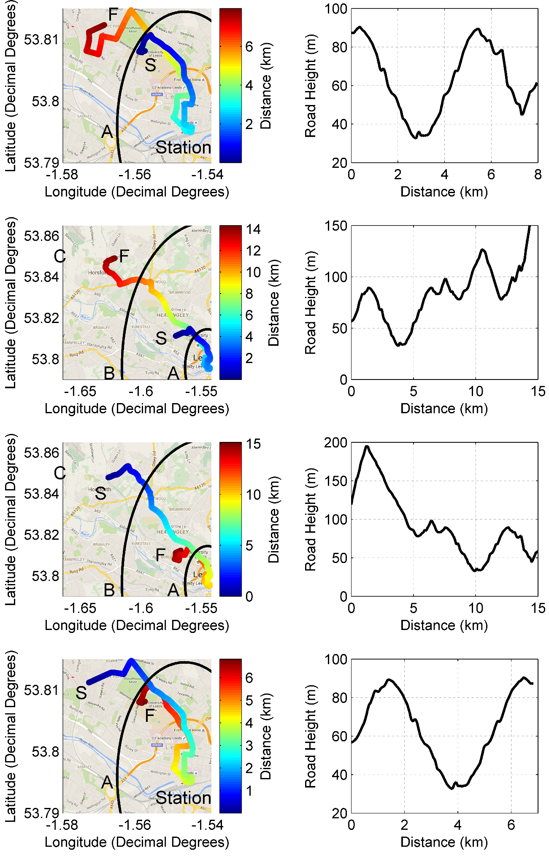
Figure : Four test routes with route height profile used for taxi project

Test Procedure
In this study driving tests were conducted between 28th April 2015, and 21st May 2015, this period was chosen as it does not include any school, or university holidays that may affect the traffic. Driving was conducted on Tuesdays, Wednesdays, and Thursdays, as Mondays, and Fridays were expected to be irregular. Each day 8 trips were driven, 4 in the morning, starting at 7.15am, and ending between 10.00 - 10.30am, and the same 4 trips in the afternoon, starting at 2pm, and ending between 5.15 – 6.00 pm. The vehicle test routes were chosen to include similar levels of urban, and suburban driving to real taxis. The test timings were chosen to include roughly equal amount of peak, and off peak traffic conditions, where peak times are estimated to between 7.30am, and 9.30am in the morning, and 4.00pm, and 6.00pm in the evening. Each day of testing is roughly half the number of hours, and trips, of a real taxi shift. All testing was conducted by one driver, a 25 year old male.
As we could not ensure that the test drivers driving style was similar to real taxi drivers, three driving styles were used to cover the full range of driving styles possible. Each day the driver tried to drive in a particular driving style; calm, normal, or aggressive. Each week contained three days of testing, and each day the driver followed one of the three different driving styles. Testing was conducted over three consecutive weeks so each driving style was repeated three times. In total 9 days of driving were conducted, this corresponds to 72 trips, 24 driving calmly, 24 driving normally, and 24 driving aggressively. In total over 50 hours corresponding to 780km (484 miles) were driven during testing.
During calm driving, the cars eco mode was selected, which provides the driver with feedback showing the power demanded, and suggests an optimum target level to minimise the use of the Internal Combustion Engine (ICE). The driver aims to keep the power demand close to this optimum level while accelerating up to the speed limit. The driver also aims to decelerate slowly so that the power from regeneration does not exceed the battery maximum charge rate.
During normal driving the car is left in its default mode, which is the mode the car is in when turned on. In this mode, the driver is given no feedback from the car about their driving style. The driver aims to follow the traffic, matching their driving with the acceleration, speed, and deceleration of the neighbouring cars.
During aggressive driving, the cars power mode is selected. In this mode, the driver is given no feedback from the car about their driving style. In these tests the driver aims to pull away from stops quickly, and break later coming up to stops. The driver also changes lane more regularly to be in the fastest lane, or to move further up the queue at traffic lights, while always obeying road speed limits.
Table : Taxi testing overview
Parameter | Calm | Normal | Aggressive
Number of Runs | 24 | 24 | 24
Total Time (hours) | 17.3 | 16.3 | 15.9
Total Distance (km) | 260 | 260 | 260
Route 1 Time (min) | 38.5 | 37.4 | 38.4
Route 1 Distance (km) | 7.68 | 7.69 | 7.69
Route 2 Time (min) | 51.8 | 48.6 | 50.0
Route 2 Distance (km) | 14.2 | 14.2 | 14.2
Route 3 Time (min) | 48.4 | 46.8 | 42.6
Route 3 Distance (km) | 14.8 | 14.8 | 14.8
Route 4 Time (min) | 34.8 | 29.7 | 28.6
Route 4 Distance (km) | 6.68 | 6.70 | 6.70
Peak Time (hours) | 9.36 | 9.12 | 8.30
Peak Distance (km) | 139 | 142 | 136
Off Peak Time (hours) | 7.98 | 7.13 | 7.65
Off Peak Distance (km) | 121 | 119 | 124
Idle Time (hours) | 6.72 | 6.63 | 6.76
Average Speed (km/h) | 15.0 | 16.0 | 16.3
Average Positive Acceleration (m/s/s) | 0.188 | 0.237 | 0.274
Average Negative Acceleration (m/s/s) | -0.221 | -0.255 | -0.268

