Mesh sensitivity study for idealised human intervertebral disc
Methods and Results are extracted from Chapter 3 of Computational simulation of the intervertebral disc. Luxmoore, B.J. (2013), PhD thesis, University of Leeds – released under CC-BY-NC-SA

Methods
An idealised finite element model of a bone-disc-bone unit was developed and a mesh convergence study for apparent stiffness and bulge was conducted. The disc and vertebral bodies were assumed cylindrical (Figure 1) with disc dimensions chosen to represent the upper lumbar spine of an average sized, skeletally mature human (Table 1). All tissues surfaces were fully bounded to their adjacent tissues.
Table 1 – Model geometry. D_{o} = outer diameter, H = height.  D_{o} (mm) H (mm)  annulus fibrosus 48 12  nucleus pulposus 24 12  vertebral bodies 48 6 | 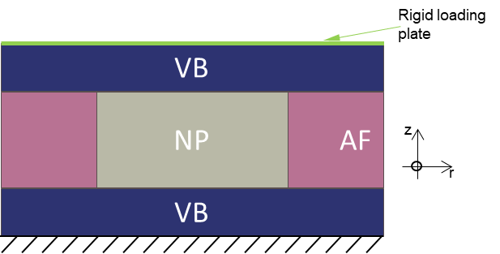  Figure 1: 2D view of the model, cut through the axial plane
The nodes on the base surface of the inferior vertebral body were constrained in all degrees of freedom. The model was loaded in uniaxial compression. A point load of 3.5 kN was applied to the centre of a rigid plate that was tied to the upper surface of the superior vertebral body, ensuring that the whole of the upper surface was compressed evenly. The rigid plate was restrained from movement in the radial direction.
Linear elastic material models were applied to each of the model components. The nucleus was assumed isotropic and incompressible with E = 1.5 MPa; the vertebral bodies were modelled as isotropic with E = 100 MPa and ν = 0.2. The annulus was modelled as an orthotropic linear material (Table 2).
Table 2 – Material properties derived for the orthotropic model of the annulus
 | E_{r} (MPa) | E_{z} (MPa) | E_{θ} (MPa) | ν_{rz} | ν_{rθ} | ν_{zθ} | G_{rz} (MPa) | G_{rθ} (MPa) | G_{zθ} (MPa)
annulus fibrosus | 0.4 | 70 | 16 | 0.023 | 0.075 | 1.38 | 0.1 | 0.1 | 0.1

The model was meshed with a mix of tetrahedral and hexahedral elements. Hybrid element formulation was applied to the elements of the nucleus to better represent the fully incompressible behaviour of the tissue. A mesh sensitivity analysis was conducted to assess the potential error encountered from mesh deficiencies on the values of interest (apparent stiffness, inner and outer annulus bulge values). Given the symmetry of the model, only the maximum (axially centred) value of bulge was extracted.

Results
The three outputs of interest reached convergence for a similar mesh size, of about 57 000 elements (Figure 2).
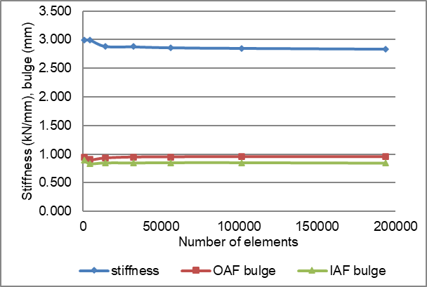
Figure 2: Mesh sensitivity analysis (OAF: outer annulus fibrosus; IAF: inner annulus fibrosus).

Discussion with respect to “Experimental and computational comparison of intervertebral disc bulge for specimen-specific model evaluation based on imaging” (Mengoni et al.)
The model in this idealised mesh convergence study has some similarities and differences with that of Mengoni et al. which uses an average of 1.15M tetrahedral elements (i.e. about 20 times more elements than the converged mesh in this study).
In terms of the material models, both approaches consider a pure elastic behaviour of each tissue. While the material models are linear in this mesh study and non-linear in Mengoni et al., the apparent stiffness in the current study is larger than the max apparent stiffness in Mengoni et al. (as the human tissue is stiffer than the bovine one). The softer model in Mengoni et al. is likely to require more elements than the number of elements used in this study. The model in this study however demonstrates bulge values of a similar order of magnitude than the max values obtained in Mengoni et al. (average max bulge of 1.2 mm), the finer mesh used in Mengoni et al. should be able to capture this level of deformation.
The model in this mesh study is purely circular with dimensions larger than those of the bovine bone-disc-bone models in Mengoni et al. (average bovine disc volume measured on images of 2475 mm³ compared to 21700 mm³ here). The disc in this study is therefore about 9 times larger than those in Mengoni et al. The model in this study is composed mainly of hexahedral elements, it requires less elements of a similar size than a model composed of tetrahedral elements.
In conclusion, the mesh size used in Mengoni et al. for a softer material model is likely to be appropriate to capture bulge values of similar magnitude as the model is 9 times smaller but contains 20 times more elements.

