Dose dependency of iatrogenic glucocorticoid excess and adrenal insufficiency and mortality: a cohort study in England
Teumzghi F. Mebrahtu, Ann W. Morgan, Adam Keeley, Paul D. Baxter, Paul M. Stewart, Mar Pujades-Rodriguez

SUPPLEMENTAL MATERIAL CONTENT

TABLES
Table 1. List of chronic inflammatory disease codes and terms used for data extraction in CPRD and HES
Table 2. List of adrenal insufficiency codes and terms used for data extraction in CPRD, ONS and HES
Table 3. List of Cushing’s syndrome codes and terms used for data extraction in CPRD, HES and ONS
Table 4. List of drugs that can induce drug related adrenal toxicity and were considered in the outcome algorithms
Table 5. Kaplan-Meier estimates of adrenal insuficiency per level of current daily and cumulative oral glucocorticoid prednisolone-equivalent dose in all patients and amongst patients prescribed non-oral glucocorticoids
Table 6. Kaplan-Meier estimates of glucocorticoid-induced Cushing’s syndrome per level of current daily and cumulative oral glucocorticoid prednisolone-equivalent dose in all patients and amongst patients prescribed non-oral glucocorticoids
Table 7. Time from diagnosis to death for patients with drug-induced adrenal dysfunction
Table 8. Description of recorded causes of deaths in patients with adrenal insufficiency
Table 9. Prescribed oral glucocorticoids and associated risks of outcomes using mixed-effects models
Table 10. Incidence of mortality following cessation of oral glucocorticoid therapy

FIGURES
Figure 1. Algorithm for identification of cases of glucocorticoid induced adrenal insufficiency in electronic health records
Figure 2. Algorithm for identification of cases of glucocorticoid induced Cushing’s syndrome in electronic health records
Figure 3. Identification of patients with study outcomes in the cohort through implementation of the outcome algorithms
Figure 4. Schematic view of confounding adjustment for the effects of oral glucocorticoids on glucocorticoid-induced adrenal insufficiency
Figure 5. Schematic view of confounding adjustment for the effects of oral glucocorticoids on glucocorticoid-induced Cushing’s syndrome
Figure 6. Schematic view of confounding adjustment for the effects of oral glucocorticoids on mortality

Table 1. List of chronic inflammatory disease codes and terms used for data extraction in CPRD and HES
Codes | Term | Disease
Read
N045300 | juvenile arthritis in crohn's disease | Inflammatory bowel disease
J40z.00 | regional enteritis nos | Inflammatory bowel disease
J400200 | crohn's disease of the terminal ileum | Inflammatory bowel disease
J40..12 | granulomatous enteritis | Inflammatory bowel disease
J401.00 | regional enteritis of the large bowel | Inflammatory bowel disease
J400500 | exacerbation of crohn's disease of small intestine | Inflammatory bowel disease
J401000 | regional enteritis of the colon | Inflammatory bowel disease
J400100 | regional enteritis of the jejunum | Inflammatory bowel disease
J400.00 | regional enteritis of the small bowel | Inflammatory bowel disease
J08z900 | orofacial crohn's disease | Inflammatory bowel disease
J401100 | regional enteritis of the rectum | Inflammatory bowel disease
ZR3S.11 | cdai - crohn's disease activity index | Inflammatory bowel disease
ZR3S.00 | crohn's disease activity index | Inflammatory bowel disease
J400z00 | crohn's disease of the small bowel nos | Inflammatory bowel disease
J40..11 | crohn's disease | Inflammatory bowel disease
J400300 | crohn's disease of the ileum unspecified | Inflammatory bowel disease
J402.00 | regional ileocolitis | Inflammatory bowel disease
Jyu4000 | [x]other crohn's disease | Inflammatory bowel disease
J400400 | crohn's disease of the ileum nos | Inflammatory bowel disease
J40z.11 | crohn's disease nos | Inflammatory bowel disease
J401z11 | crohn's colitis | Inflammatory bowel disease
J401z00 | crohn's disease of the large bowel nos | Inflammatory bowel disease
N031100 | arthropathy in crohn's disease | Inflammatory bowel disease
J40..00 | regional enteritis - crohn's disease | Inflammatory bowel disease
J4z2.00 | non-infective ileitis nos | Inflammatory bowel disease
J400000 | regional enteritis of the duodenum | Inflammatory bowel disease
J401200 | exacerbation of crohn's disease of large intestine | Inflammatory bowel disease
J57yA00 | ulceration of intestine nos | Inflammatory bowel disease
J57y900 | ulceration of colon | Inflammatory bowel disease
N031000 | arthropathy in ulcerative colitis | Inflammatory bowel disease
J41yz00 | other idiopathic proctocolitis nos | Inflammatory bowel disease
J41y100 | toxic megacolon | Inflammatory bowel disease
J410400 | exacerbation of ulcerative colitis | Inflammatory bowel disease
J41y.00 | other idiopathic proctocolitis | Inflammatory bowel disease
J410200 | ulcerative rectosigmoiditis | Inflammatory bowel disease
J41z.00 | idiopathic proctocolitis nos | Inflammatory bowel disease
J412.00 | ulcerative (chronic) ileocolitis | Inflammatory bowel disease
J410300 | ulcerative proctitis | Inflammatory bowel disease
J410z00 | ulcerative proctocolitis nos | Inflammatory bowel disease
Jyu4100 | [x]other ulcerative colitis | Inflammatory bowel disease
J410.00 | ulcerative proctocolitis | Inflammatory bowel disease
J410100 | ulcerative colitis | Inflammatory bowel disease
J410000 | ulcerative ileocolitis | Inflammatory bowel disease
J411.00 | ulcerative (chronic) enterocolitis | Inflammatory bowel disease
N045400 | juvenile arthritis in ulcerative colitis | Inflammatory bowel disease
J41..12 | ulcerative colitis and/or proctitis | Inflammatory bowel disease
J413.00 | ulcerative pancolitis | Inflammatory bowel disease
J41..00 | idiopathic proctocolitis | Inflammatory bowel disease
J4...12 | inflammatory bowel disease | Inflammatory bowel disease
8Cc5.11 | management of ibd (inflammatory bowel disease) | Inflammatory bowel disease
8CA4W00 | dietary education for inflammatory bowel disease | Inflammatory bowel disease
8Cc5.00 | management of inflammatory bowel disease | Inflammatory bowel disease
N20..00 | Polymyalgia rheumatica | PMR and/or GCA
N20..11 | Polymyalgia | PMR and/or GCA
N200.00 | Giant cell arteritis with polymyalgia rheumatica | PMR and/or GCA
2G27.00 | O/E-hands-rheumatoid spindling | Rheumatoid arthritis
66H..13 | Rheumatoid arthrit. monitoring | Rheumatoid arthritis
F371200 | Polyneuropathy in rheumatoid arthritis | Rheumatoid arthritis
F396400 | Myopathy due to rheumatoid arthritis | Rheumatoid arthritis
G5y8.00 | Rheumatoid myocarditis | Rheumatoid arthritis
G5yA.00 | Rheumatoid carditis | Rheumatoid arthritis
H570.00 | Rheumatoid lung | Rheumatoid arthritis
N005.00 | Adult Still's Disease | Rheumatoid arthritis
N040.00 | Rheumatoid arthritis | Rheumatoid arthritis
N040000 | Rheumatoid arthritis of cervical spine | Rheumatoid arthritis
N040100 | Other rheumatoid arthritis of spine | Rheumatoid arthritis
N040200 | Rheumatoid arthritis of shoulder | Rheumatoid arthritis
N040500 | Rheumatoid arthritis of elbow | Rheumatoid arthritis
N040600 | Rheumatoid arthritis of distal radio-ulnar joint | Rheumatoid arthritis
N040700 | Rheumatoid arthritis of wrist | Rheumatoid arthritis
N040800 | Rheumatoid arthritis of MCP joint | Rheumatoid arthritis
N040900 | Rheumatoid arthritis of PIP joint of finger | Rheumatoid arthritis
N040A00 | Rheumatoid arthritis of DIP joint of finger | Rheumatoid arthritis
N040B00 | Rheumatoid arthritis of hip | Rheumatoid arthritis
N040D00 | Rheumatoid arthritis of knee | Rheumatoid arthritis
N040F00 | Rheumatoid arthritis of ankle | Rheumatoid arthritis
N040G00 | Rheumatoid arthritis of subtalar joint | Rheumatoid arthritis
N040H00 | Rheumatoid arthritis of talonavicular joint | Rheumatoid arthritis
N040J00 | Rheumatoid arthritis of other tarsal joint | Rheumatoid arthritis
N040K00 | Rheumatoid arthritis of 1st MTP joint | Rheumatoid arthritis
N040N00 | Rheumatoid vasculitis | Rheumatoid arthritis
N040P00 | Seronegative rheumatoid arthritis | Rheumatoid arthritis
N040Q00 | Rheumatoid bursitis | Rheumatoid arthritis
N040R00 | Rheumatoid nodule | Rheumatoid arthritis
N040S00 | Rheumatoid arthritis - multiple joint | Rheumatoid arthritis
N040T00 | Flare of rheumatoid arthritis | Rheumatoid arthritis
N041.00 | Felty's syndrome | Rheumatoid arthritis
N042.00 | Other rheumatoid arthropathy + visceral/systemic involvement | Rheumatoid arthritis
N042100 | Rheumatoid lung disease | Rheumatoid arthritis
N042200 | Rheumatoid nodule | Rheumatoid arthritis
N042z00 | Rheumatoid arthropathy + visceral/systemic involvement NOS | Rheumatoid arthritis
N047.00 | Seropositive errosive rheumatoid arthritis | Rheumatoid arthritis
N04X.00 | "Seropositive rheumatoid arthritis, unspecified" | Rheumatoid arthritis
N04y000 | Rheumatoid lung | Rheumatoid arthritis
N04y011 | Caplan's syndrome | Rheumatoid arthritis
N04y012 | Fibrosing alveolitis associated with rheumatoid arthritis | Rheumatoid arthritis
N04y200 | Adult-onset Still's disease | Rheumatoid arthritis
Nyu1100 | [X]Other seropositive rheumatoid arthritis | Rheumatoid arthritis
Nyu1200 | [X]Other specified rheumatoid arthritis | Rheumatoid arthritis
Nyu1G00 | [X]Seropositive rheumatoid arthritis, unspecified | Rheumatoid arthritis
N040L00 | rheumatoid arthritis of lesser mtp joint | Rheumatoid arthritis
N040C00 | rheumatoid arthritis of sacro-iliac joint | Rheumatoid arthritis
N040400 | rheumatoid arthritis of acromioclavicular joint | Rheumatoid arthritis
Nyu1000 | [x]rheumatoid arthritis+involvement/other organs or systems | Rheumatoid arthritis
N040M00 | rheumatoid arthritis of ip joint of toe | Rheumatoid arthritis
N040E00 | rheumatoid arthritis of tibio-fibular joint | Rheumatoid arthritis
N040300 | rheumatoid arthritis of sternoclavicular joint | Rheumatoid arthritis
M154.00 | Lupus erythematosus | Systemic lupus erythematosus
M154z00 | Lupus erythematosus NOS | Systemic lupus erythematosus
N000.00 | Systemic lupus erythematosus | Systemic lupus erythematosus
N000400 | Systemic lupus erythematosus with pericarditis | Systemic lupus erythematosus
N000000 | Disseminated lupus erythematosus | Systemic lupus erythematosus
K01x411 | Lupus nephritis | Systemic lupus erythematosus
M154700 | Subacute cutaneous lupus erythematosus | Systemic lupus erythematosus
N000300 | Systemic lupus erythematosus with organ or sys involv | Systemic lupus erythematosus
H57y400 | Lung disease with systemic lupus erythematosus | Systemic lupus erythematosus
N000200 | Drug-induced systemic lupus erythematosus | Systemic lupus erythematosus
K0B4000 | Renal tubulo-interstitial disorder in SLE | Systemic lupus erythematosus
N000z00 | Systemic lupus erythematosus NOS | Systemic lupus erythematosus
F371000 | Polyneuropathy in disseminated lupus erythematosus | Systemic lupus erythematosus
ZRq9.00 | Systemic lupus erythematosus disease activity index | Systemic lupus erythematosus
K01x400 | Nephrotic syndrome in systemic lupus erythematosus | Systemic lupus erythematosus
ZRq8.00 | Systemic lupus activity measure | Systemic lupus erythematosus
N000100 | Libman-Sacks disease | Systemic lupus erythematosus
Nyu4300 | [X]Other forms of systemic lupus erythematosus | Systemic lupus erythematosus
ZRq9.11 | SLEDAI-Sys lup ery dis act ind | Systemic lupus erythematosus
G757.00 | takayasu's disease | Vasculitis
G757.12 | pulseless disease | Vasculitis
G751000 | kawasaki disease | Vasculitis
G758.00 | churg-strauss vasculitis | Vasculitis
G754.11 | granulomatosis with polyangiitis | Vasculitis
G754.00 | wegener's granulomatosis | Vasculitis
G752112 | anti gbm disease - antiglomerular basement membrane disease | Vasculitis
G752111 | antiglomerular basement membrane disease | Vasculitis
C332100 | cryoglobulinaemic vasculitis | Vasculitis
D310100 | henoch-schonlein nephritis | Vasculitis
D310000 | henoch-schonlein purpura | Vasculitis
D310011 | anaphylactoid purpura | Vasculitis
G750.00 | polyarteritis nodosa | Vasculitis
F371100 | polyneuropathy in polyarteritis nodosa | Vasculitis
F396300 | myopathy due to polyarteritis nodosa | Vasculitis
K01x300 | nephrotic syndrome in polyarteritis nodosa | Vasculitis
G75..00 | polyarteritis nodosa and allied conditions | Vasculitis
G75z.00 | polyarteritis nodosa and allied conditions nos | Vasculitis
F421E00 | retinal vasculitis nos | Vasculitis
G76B.00 | vasculitis | Vasculitis
N040N00 | rheumatoid vasculitis | Vasculitis
N012700 | arthropathy in behcet's syndrome of the ankle and foot | Vasculitis
N012011 | behcet's syndrome arthropathy | Vasculitis
N012000 | arthropathy in behcet's syndrome of unspecified site | Vasculitis
N012.00 | arthropathy in behcet's syndrome | Vasculitis
K425200 | ulceration of vulva in behcet's disease | Vasculitis
N012x00 | arthropathy in behcet's syndrome of multiple sites | Vasculitis
AD61.00 | behcet's syndrome | Vasculitis
ICD-10
K50.0 | Crohn's disease of small intestine | Inflammatory bowel disease
K50.1 | Crohn's disease of large intestine | Inflammatory bowel disease
K50.8 | Other Crohn's disease | Inflammatory bowel disease
K50.9 | Crohn's disease, unspecified | Inflammatory bowel disease
M07.4 | Arthropathy in Crohn's disease | Inflammatory bowel disease
M09.1 | Juvenile arthritis in Crohn's disease | Inflammatory bowel disease
K51.0 | Ulcerative (chronic) enterocolitis | Inflammatory bowel disease
K51.1 | Ulcerative (chronic) ileocolitis | Inflammatory bowel disease
K51.2 | Ulcerative (chronic) proctitis | Inflammatory bowel disease
K51.3 | Ulcerative (chronic) rectosigmoiditis | Inflammatory bowel disease
K51.5 | Mucosal proctocolitis | Inflammatory bowel disease
K51.8 | Other ulcerative colitis | Inflammatory bowel disease
K51.9 | Ulcerative colitis, unspecified | Inflammatory bowel disease
M07.5 | Arthropathy in ulcerative colitis | Inflammatory bowel disease
M09.2 | Juvenile arthritis in ulcerative colitis | Inflammatory bowel disease
M35.3 | Polmyalgia rheumatica | PMR and/or GCA
M31.5 | Giant cell arteritis with polymyalgia rheumatica | PMR and/or GCA
I52.8 | Rheumatoid carditis | Rheumatoid arthritis
J99.0 | Rheumatoid lung disease | Rheumatoid arthritis
M05.0 | Felty's syndrome | Rheumatoid arthritis
M05.1 | Rheumatoid lung disease | Rheumatoid arthritis
M05.2 | Rheumatoid vasculitis | Rheumatoid arthritis
M05.3 | Rheumatoid arthritis with involvement of oth organs and sys | Rheumatoid arthritis
M05.8 | Other seropositive rheumatoid arthritis | Rheumatoid arthritis
M05.9 | Seropositive rheumatoid arthritis, unspecified | Rheumatoid arthritis
M06.0 | Seronegative rheumatoid arthritis | Rheumatoid arthritis
M06.1 | Adult-onset Still's disease | Rheumatoid arthritis
M06.2 | Rheumatoid bursitis | Rheumatoid arthritis
M06.3 | Rheumatoid nodule | Rheumatoid arthritis
M06.8 | Other specified rheumatoid arthritis | Rheumatoid arthritis
M06.9 | Rheumatoid arthritis, unspecified | Rheumatoid arthritis
M32.0 | Drug-induced SLE | Systemic lupus erythematosus
M32.1 | SLE with organ or system involvement | Systemic lupus erythematosus
M32.8 | Other forms of SLE | Systemic lupus erythematosus
M32.9 | SLE unspecified | Systemic lupus erythematosus
M31.4 | aortic arch syndrome [takayasu] | Vasculitis
M30.3 | mucocutaneous lymph node syndrome [kawasaki] | Vasculitis
M30.1 | polyarteritis with lung involvement [churg-strauss] | Vasculitis
M31.3 | wegener's granulomatosis | Vasculitis
D69.0 | allergic purpura | Vasculitis
M30 | polyarteritis nodosa and related conditions | Vasculitis
M30.0 | polyarteritis nodosa | Vasculitis
M30.8 | other conditions related to polyarteritis nodosa | Vasculitis
M31.7 | microscopic polyangiitis | Vasculitis
H35.0 | background retinopathy and retinal vascular changes | Vasculitis
M05.29 | rheumatoid vasculitis | Vasculitis
M05.24 | rheumatoid vasculitis | Vasculitis
M05.27 | rheumatoid vasculitis | Vasculitis
M05.21 | rheumatoid vasculitis | Vasculitis
M05.28 | rheumatoid vasculitis | Vasculitis
M05.26 | rheumatoid vasculitis | Vasculitis
M05.2 | rheumatoid vasculitis | Vasculitis
M05.23 | rheumatoid vasculitis | Vasculitis
M05.22 | rheumatoid vasculitis | Vasculitis
M05.25 | rheumatoid vasculitis | Vasculitis
M05.20 | rheumatoid vasculitis | Vasculitis
M35.2 | behcet's disease | Vasculitis
Table 2. List of adrenal insufficiency codes and terms used for data extraction in CPRD, ONS and HES
Codes | Term | Adrenal insufficiency grouping
Read
C154400 | Drug-induced adrenocortical insufficiency | Drug-induced
C154.00 | Corticoadrenal insufficiency | Unclassified
C154000 | Acute adrenal insufficiency | Unclassified
C154011 | Addisonian crisis | Unclassified
C154012 | Adrenal crisis | Unclassified
C154600 | Addisonian crisis | Unclassified
C154z00 | Corticoadrenal insufficiency nos | Unclassified
C154z12 | Adrenal insufficiency nec | Unclassified
C155000 | Adrenal medullary insufficiency | Unclassified
Cyu4900 | [x]other+unspecified primary adrenocortical insufficiency | Unclassified
A176.00 | Tuberculosis of adrenal glands - Addison’s disease | Addison’s disease
C154100 | Addison’s disease | Addison’s disease
D010.11 | Addison’s anaemia | Addison’s disease
F395000 | Myopathy due to Addison’s disease | Addison’s disease
M210.11 | Addison’s keloid | Addison’s disease
C152812 | Congenital adrenal hyperplasia necrosis | Other adrenal insufficiency
C152813 | Congenital adrenal gland hypertrophy nec | Other adrenal insufficiency
PK1y000 | Congenital cyst of adrenal gland | Other adrenal insufficiency
PK1yz00 | Other congenital anomaly of adrenal gland nos | Other adrenal insufficiency
BB5h000 | [m]adrenal cortical adenoma nos | Other adrenal insufficiency
BB5h400 | [m]adrenal cortical adenoma, clear cell type | Other adrenal insufficiency
BB5h600 | [m]adrenal cortical adenoma, mixed cell type | Other adrenal insufficiency
B7H2.11 | pituitary adenoma | Other adrenal insufficiency
BB5V.00 | [m]pituitary adenomas and carcinomas | Other adrenal insufficiency
BB5Vz00 | [m]pituitary adenoma or carcinoma nos | Other adrenal insufficiency
C132.12 | Sheehan’s syndrome | Other adrenal insufficiency
B510400 | Malignant neoplasm of hypothalamus | Other adrenal insufficiency
C13..00 | Disorders of pituitary gland | Other adrenal insufficiency
C13..11 | Hypothalamus disorders | Other adrenal insufficiency
C13X.00 | Hypothalamic dysfunction, not elsewhere classified | Other adrenal insufficiency
Cyu4N00 | [x]hypothalamic dysfunction, not elsewhere classified | Other adrenal insufficiency
K5B1.00 | Female infertility of pituitary - hypothalamic origin | Other adrenal insufficiency
K5B1000 | Primary pituitary - hypothalamic infertility | Other adrenal insufficiency
K5B1100 | Secondary pituitary - hypothalamic infertility | Other adrenal insufficiency
K5B1z00 | Female infertility of pituitary - hypothalamic cause nos | Other adrenal insufficiency
P229.00 | anomalies of hypothalamus | Other adrenal insufficiency
ICD-10
E27.3 | drug-induced adrenocortical insufficiency | Drug-induced
E27.2 | addisonian crisis | Unclassified
E27.4 | other and unspecified adrenocortical insufficiency | Unclassified
E27.9 | disorder of adrenal gland, unspecified | Unclassified
Q89.1 | congenital malformations of adrenal gland | Other adrenal insufficiency
C74 | malignant neoplasm of adrenal gland | Other adrenal insufficiency
C74.0 | malignant neoplasm: cortex of adrenal gland | Other adrenal insufficiency
C74.1 | malignant neoplasm: medulla of adrenal gland | Other adrenal insufficiency
C74.9 | malignant neoplasm: adrenal gland, unspecified | Other adrenal insufficiency
C79.7 | secondary malignant neoplasm of adrenal gland | Other adrenal insufficiency
D35.0 | benign neoplasm: adrenal gland | Other adrenal insufficiency
D44.1 | neoplasm of uncertain or unknown behaviour: adrenal gland | Other adrenal insufficiency
C75.1 | malignant neoplasm: pituitary gland | Other adrenal insufficiency
D35.2 | benign neoplasm: pituitary gland | Other adrenal insufficiency
D44.3 | neoplasm of uncertain or unknown behaviour: pituitary gland | Other adrenal insufficiency
E89.6 | postprocedural adrenocortical(-medullary) hypofunction | Other adrenal insufficiency
E27.1 | primary adrenocortical insufficiency | Other adrenal insufficiency
E23.3 | hypothalamic dysfunction, not elsewhere classified | Other adrenal insufficiency
E27 | other disorders of adrenal gland | Other adrenal insufficiency
E27.8 | other specified disorders of adrenal gland | Other adrenal insufficiency
E35.1 | disorders of adrenal glands in diseases classified elsewhere | Other adrenal insufficiency
A39.1 | waterhouse-friderichsen syndrome | Other adrenal insufficiency
A18.7 | tuberculosis of adrenal glands | Other adrenal insufficiency
ICD-9
255.42 | other and unspecified adrenocortical insufficiency | Unclassified
255.9 | disorder of adrenal gland, unspecified | Unclassified
255.41 | primary adrenocortical insufficiency | Other adrenal insufficiency
255.8 | other specified disorders of adrenal gland | Other adrenal insufficiency

Table 3. List of Cushing’s syndrome codes and terms used for data extraction in CPRD, HES and ONS
Codes | Term | Cushing’s syndrome grouping
Read
C150111 | drug-induced cushings syndrome | Drug-induced
2226.11 | o/e - cushingoid facies | Unclassified
C150.00 | cushing's syndrome | Unclassified
C150100 | iatrogenic cushing's syndrome | Unclassified
C150z00 | cushing's syndrome nos | Unclassified
F395100 | myopathy due to cushing's syndrome | Unclassified
C150000 | idiopathic cushing's syndrome | Unclassified
Cyu4500 | [x]other cushing's syndrome | Unclassified
C150200 | pituitary dependent cushing's syndrome | Other Cushing’s syndrome
C150300 | ectopic acth secretion causing cushing's syndrome | Other Cushing’s syndrome
C150500 | alcohol-induced pseudo-cushing's syndrome | Other Cushing’s syndrome
ICD-10
E24.2 | drug-induced Cushing’s syndrome | Drug-induced
E24 | Cushing’s syndrome | Unclassified
E24.8 | other Cushing’s syndrome | Unclassified
E24.9 | Cushing’s syndrome, unspecified | Unclassified
E24.0 | pituitary-dependent Cushing’s disease | Other Cushing’s syndrome
E24.4 | alcohol-induced pseudo-Cushing’s syndrome | Other Cushing’s syndrome
E24.3 | ectopic ACTH syndrome | Other Cushing’s syndrome
ICD-9
255.0 | drug-induced Cushing’s syndrome | Drug-induced
255.0 | Cushing’s syndrome | Unclassified
255.0 | other Cushing’s syndrome | Unclassified
255.0 | Cushing’s syndrome, unspecified | Unclassified
255.0 | pituitary-dependent Cushing’s disease | Other Cushing’s syndrome
255.0 | alcohol-induced pseudo-Cushing’s syndrome | Other Cushing’s syndrome

Table 4. List of drugs that can induce drug related adrenal toxicity and were considered in the outcome algorithms
Adrenal insufficiency | Cushing’s syndrome
Mifepristone | Megestrol acetate
Chlorpromazine (antipsychotic) | Medroxyprogesterone acetate
Imipramine (antidepressants) | Troleandomycin
Anticoagulants (heparin, warfarin) | Erythromycin
Tyrosine-kinase inhibitors (sunitinib) | Clarithromycin
Aminoglutethimide
Ketoconazole
Fluconazole
Etomidate
Phenobarbital
Phenytoin
Rifampicin
Trilostane
Troglitazone

Table 5. Kaplan-Meier estimates of adrenal insufficiency per level of current daily and cumulative oral glucocorticoid prednisolone-equivalent dose in all patients and amongst patients prescribed non-oral glucocorticoids
 | All oral GC | Non-oral GC use
 | users | Intramuscular GC | Inhaled GC | Rectal GC | Topical GC
No. of patients with incident ADI, n (%) | 183 (0.3) | 47 (0.6) | 76 (0.4) | 48 (0.3) | 54 (0.4)
Cumulative incidence (95% CI) at 5 years | 0.2 (0.2-0.3) | 0.4 (0.2-0.5) | 0.3 (0.2-0.4) | 0.2 (0.1-0.3) | 0.3 (0.2-0.4)
Current daily PED
no-use | 0.02 (0.01-0.02) | 0.02 (0.01-0.04) | 0.2 (0.1-0.3) | 0.2 (0.1-0.3) | 0.02 (0.01-0.3)
>0-4.9 mg | 0.4 (0.2-0.6) | 0.1 (0.03-0.02) | 0.9 (0.4-1.8) | 0.3 (0.07-1.2) | 0.9 (0.5-1.7)
5.0-7.49 mg | 0.3 (0.2-0.6) | 0.1 (0.1-2.4) | 0.7 (0.3-1.6) | 0.5 (0.1-2.0) | 0.14 (0.02-1.0)
≥7.5 mg | 0.5 (0.3-0.7) | 0.9 (0.4-2.0) | 0.5 (0.2-0.9) | 0.3 (0.1-0.8) | 0.2 (0.1-0.5)
Cumulative PED in last year
no-use | 0 | 0 | 0 | 0 | 0
>0-959.9 mg | 0.9 (0.6-1.4) | 3.6 (1.7-7.4) | 1.3 (0.6-2.7) | 1.4 (0.6-3.2) | 1.0 (0.37-2.8)
960.0-3,054.9 mg | 5.0 (3.9-6.4) | 12.0 (7.1-20.0) | 7.7 (5.2-11.4) | 6.5 (3.7-11.0) | 8.9 (5.6-13.8)
≥3,055.0 mg | 17.0 (11.7-24.4) | 15.9 (5.1-44.0) | 27.7 (17.0-43.2) | 23.4 (10.9-46.2) | 33.6 (18.3-56.4)
Overall cumulative PED
no-use | 0 | 0 | 0 | 0 | 0
>0-959.9 mg | 0.04 (0.02-0.07) | 0.01 (0.02-0.4) | 0.1 (0.02-0.1) | 0.03 (0.01-0.1) | 0.01 (0.0-0.1)
960.0-3,054.9 mg | 0.1 (0.06-0.2) | 0.2 (0.1-0.5) | 0.1 (0.1-0.2) | 0.1 (0.04-0.2) | 0.1 (0.1-0.3)
≥3,055mg | 0.5 (0.4-0.6) | 0.8 (0.5-1.3) | 0.7 (0.5-0.9) | 0.5 (0.3-0.9) | 0.6 (0.4-1.0)
Cumulative incidence (95% CI) at 10 years | 0.4 (0.3-0.5) | 0.7 (0.5-1.0) | 0.5 (0.4-0.6) | 0.3 (0.2-0.5) | 0.5 (0.4-0.7)
Current daily PED
no-use | 0.3 (0.2-0.4) | 0.05 (0.03-0.1) | 0.4 (0.3-0.5) | 0.3 (0.2-0.4) | 0.35 (0.2-0.5)
>0-4.9 mg | 0.6 (0.3-0.9) | 1.1 (0.5-2.9) | 0.9 (0.4-1.8) | 0.3 (0.1-1.2) | 1.1 (0.6-2.2)
5.0-7.49 mg | 0.8 (0.4-1.4) | 1.2 (0.3-3.9) | 1.3 (0.7-2.8) | 1.3 (0.5-3.4) | 0.5 (0.1-2.3)
≥7.5 mg | 0.9 (0.6-1.2) | 2.0 (1.1-3.7) | 0.9 (0.5-1.6) | 0.8 (0.3-1.8) | 1.0 (0.5-2.1)
Cumulative PED in last year
no-use | 0 | 0 | 0 | 0 | 0
>0-959.9 mg | 1.9 (1.3-2.9) | 5.8 (3.1-10.7) | 2.4 (1.3-4.4) | 2.3 (1.1-4.8) | 2.0 (0.8-4.5)
960.0-3,054.9 mg | 10.2 (8.2-12.5) | 21.9 (14.9-31.4) | 13.3 (9.7-18.0) | 11.0 (7.0-17.1) | 16.1 (11.4-22.5)
≥3,055.0 mg | 23.5 (16.5-32.6) | 40.2 (19.2-71.2) | 34.5 (22.6-50.3) | 33.0 (17.6-56.3) | 42.5 (25.4-64.7)
Overall cumulative PED
no-use | 0 | 0 | 0 | 0 | 0
>0-959.9 mg | 0.05 (0.02-0.1) | 0.1 (0.02-0.4) | 0.05 (0.02-0.1) | 0.03 (0.01-0.1) | 0.1 (0.02-0.5)
960.0-3,054.9 mg | 0.1 (0.06-0.2) | 0.2 (0.1-0.5) | 0.01 (0.1-0.2) | 0.1 (0.04-0.2) | 0.1 (0.1-0.3)
≥3,055.0 mg | 0.8 (0.6-0.9) | 1.5 (1.0-2.1) | 1.0 (0.8-1.4) | 0.8 (0.5-1.2) | 1.0 (0.7-1.4)
Note: CI, confidence intervals; GC, glucocorticoids; PED, prednisolone equivalent dose. Estimates are shown cumulative risks of the outcomes per 100

Table 6. Kaplan-Meier estimates of glucocorticoid-induced Cushing’s syndrome per level of current daily and cumulative oral glucocorticoid prednisolone-equivalent dose in all patients and amongst patients prescribed non-oral glucocorticoids
 | All oral GC | Non-oral GC use
 | users | Intra-muscular GC | Inhaled GC | Rectal GC | Topical GC
Incident ADI, n (%) | 248 (0.4) | 39 (0.5) | 96 (0.5) | 76 (0.4) | 74 (0.5)
Cumulative incidence (95% CI) at 5 years | 0.3 (0.3-0.4) | 0.4 (0.2-0.5) | 0.4 (0.3-0.5) | 0.4 (0.3-0.5) | 0.4 (0.3-0.5)
Current daily PED
no-use | 0.2 (0.2-0.3) | 0.3 (0.2-0.5) | 0.3 (0.2-0.4) | 0.2 (0.2-0.3) | 0.3 (0.2-0.5)
>0-4.9 mg | 0.2 (0.1-0.3) | 0.3 (0.1-1.1) | 0.4 (0.2-1.1) | 0.2 (0.2-0.9) | 0.3 (0.1-0.8)
5.0-7.49 mg | 0.4 (0.2-0.7) | 0 | 0.6 (0.2-1.4) | 0.7 (0.2-1.8) | 0.1 (0.0-0.9)
≥7.5 mg | 1.1 (0.9-1.4) | 1.0 (0.5-2.0) | 1.4 (0.9-2.0) | 1.5 (1.0-2.2) | 1.2 (0.8-1.9)
Cumulative PED in last year
no-use | 0.0 (0.0-0.0) | 0 | 0.0 (0.0-0.0) | 0 | 0.0 (0.0-0.1)
>0-959.9 mg | 1.1 (0.7-1.6) | 3.4 (1.7-7.0) | 2.4 (1.4-4.1) | 2.1 (1.0-4.1) | 2.7 (1.5-4.8)
960.0-3,054.9 mg | 6.7 (5.5-8.1) | 9.4 (5.3-16.4) | 11.3 (8.4-15.2) | 11.2 (7.9-15.9) | 11.7 (8.2-16.6)
≥3,055.0 mg | 47.1 (38.6-56.5) | 35.1 (12.1-76.4) | 28.8 (18.8-42.7) | 39.4 (26.5-55.6) | 49.5 (31.3-71.1)
Overall cumulative PED
no-use | 1.0 (0.1-6.7) | 0 | 3.0 (0.4-19.3) | 0 | 4.0 (0.6-25.2)
>0-959.9 mg | 0.1 (0.06-0.1) | 0.1 (0.1-0.3) | 0.1 (0.1-0.2) | 0.1 (0.1-0.2) | 0.17 (0.09-0.3)
960.0-3,054.9 mg | 0.3 (0.3-0.4) | 0.4 (0.2-0.9) | 0.5 (0.4-0.8) | 0.36 (0.2-0.6) | 0.4 (0.3-0.7)
≥3,055mg | 0.7 (0.5-0.9) | 0.4 (0.1-0.2) | 1.4 (1.0-1.9) | 1.1 (0.7-1.6) | 1.0 (0.6-1.7)
Cumulative incidence (95% CI) at 10 years | 0.5 (0.4-0.5) | 0.6 (0.4-0.9) | 0.6 (0.5-0.8) | 0.6 (0.5-0.8) | 0.5 (0.4-0.7)
Current daily PED
no-use | 0.3 (0.2-0.3) | 0.4 (0.3-0.7) | 0.3 (0.2-0.4) | 0.3 (0.2-0.5) | 0.4 (0.3-0.6)
>0-4.9 mg | 0.2 (0.1-0.5) | 0.3 (0.1-1.1) | 0.7 (0.3-1.7) | 0.2 (0.2-0.9) | 0.3 (0.1-0.8)
5.0-7.49 mg | 0.6 (0.3-1.0) | 0.5 (0.1-3.5) | 0.8 (0.4-2.0) | 1.4 (0.6-3.5) | 0.8 (0.2-2.6)
≥7.5 mg | 2.0 (1.6-2.5) | 2.2 (1.2-3.9) | 3.0 (2.1-4.2) | 2.9 (1.9-4.3) | 2.8 (1.9-4.2)
Cumulative PED in last year
no-use | 0.0 (0.0-0.0) | 0 | 0.0 (0.0-0.0) | 0 | 0.01 (0.0-0.1)
>0-959.9 mg | 1.4 (1.0-2.1) | 3.4 (1.7-7.0) | 3.0 (1.8-4.9) | 2.1 (1.0-4.1) | 3.1 (1.8-5.4)
960.0-3,054.9 mg | 9.0 (7.4-10.9) | 14.9 (9.4-23.4) | 14.4 (10.9-18.9) | 14.9 (10.7-20.6) | 14.8 (10.6-20.4)
≥3,055.0 mg | 47.1 (38.6-56.5) | 68.0 (43.5-89.7) | 52.3 (39.7-66.2) | 70.8 (55.1-85.0) | 72.5 (56.4-86.6)
Overall cumulative PED
no-use | 1.0 (0.1-6.7) | 0 | 0 | 0 | 4.0 (0.6-25.2)
>0-959.9 mg | 0.1 (0.1-0.1) | 0.1 (0.1-0.3) | 0.1 (0.1-0.2) | 0.1 (0.1-0.2) | 0.17 (0.1-0.3)
960.0-3,054.9 mg | 0.4 (0.3-0.5) | 0.5 (0.3-1.0) | 0.6 (0.4-0.9) | 0.4 (0.2-0.6) | 0.4 (0.3-0.7)
≥3,055.0 mg | 0.9 (0.7-1.1) | 0.8 (0.5-1.2) | 1.4 (1.0-1.9) | 1.5 (1.1-2.0) | 1.4 (0.9-2.1)
Note: CI, confidence intervals; GC, glucocorticoids; PED, prednisolone equivalent dose. Estimates are shown cumulative risks of the outcomes per 100

Table 7. Time from diagnosis to death for patients with drug-induced adrenal dysfunction
Time to death in months | Drug-induced ADI  (N=74) | Drug-induced CS  (112)
<1 month | 20 (27.0) | 7 (6.3)
≥1 to <2 months | 2 (2.7) | 4 (3.6)
≥2 to <3 months | 4 (5.4) | 3 (2.7)
≥3 to <4 months | 2 (2.7) | 2 (1.8)
≥4 to <6 months | 5 (6.8) | 2 (1.8)
≥6 to <12 months | 5 (6.8) | 10 (8.9)
≥12 to <13 months | 0 (0) | 2 (1.8)
≥13 to <24 months | 11 (14.9) | 10 (8.9)
≥24 to <36 months | 8 (10.8) | 15 (13.4)
≥36 months | 17 (23.0) | 57 (50.9)
Note: ADI, adrenal insufficiency; CS, Cushing’s syndrome; †, a total of 15%, 15% and 34% had records of cardio-vascular, cancer and infection, as causes of death, respectively

Table 8. Description of recorded causes of deaths in patients with adrenal insufficiency (n=74)
Recorded causes of death | No. of patients (%)
Infection without recorded adrenal insufficiency: 1 with cancer, 2 with cardiovascular disease, 8 with non-infectious respiratory disease, 2 with non-infectious renal disease | 25 (33.8)
Adrenal insufficiency: 8 associated with infections | 14 (18.9)
Cancer only | 11 (14.9)
Cardiovascular disease only | 11 (14.9)
Non-infectious respiratory disease | 6 (8.1)
Renal disease only | 2 (2.7)
Fall | 2 (2.7)
Hepatic disease | 1 (1.4)
Pancreatic disease | 1 (1.4)

Table 9. Prescribed oral glucocorticoids and associated risks of outcomes using mixed-effects models
 | Adjusted hazard ratios with 95% CI *
 | Adrenal insufficiency† | Cushing’s syndrome‡
Current dose per 5 mg/day | 1.07 (1.04–1.09) | 1.07 (1.06–1.08)
Overall cumulative dose (per 1000 mg) | 1.07 (1.05–1.08) | 1.07 (1.06–1.08)
Cumulative dose in past year (per 1000 mg) | 2.27 (2.15–2.40) | 2.53 (2.38–2.67)
Note: *, models adjusted for inhaled, intra-articular, intra-muscular, nasogastric, topical and rectal use of glucocorticoids; †, exponential distribution mixed effect models; ‡, Weibull distribution mixed effect models.

Table 10. Incidence of mortality following cessation of oral glucocorticoid therapy (N=57,099)*
Period after oral glucocorticoid cessation | Incidence rate per 1000 person years (95% CI)
(0-1] month | 28.9 (25.6 to 30.4)
(1-2] months | 53.4 (51.4 to 55.4)
(2-3] months | 36.3 (34.6 to 38.1)
(3-6] months | 16.4 (15.7 to 17.1)
(6-12] months | 6.7 (6.3 to 7.0)
>12 months | 4.3 (4.2 to 4.4)
*Mortality rates are calculated amongst patients who stopped taking oral glucocorticoids before the end of follow-up and did not re-start treatment

Figure 1. Algorithm for identification of cases of glucocorticoid induced adrenal insufficiency in electronic health records
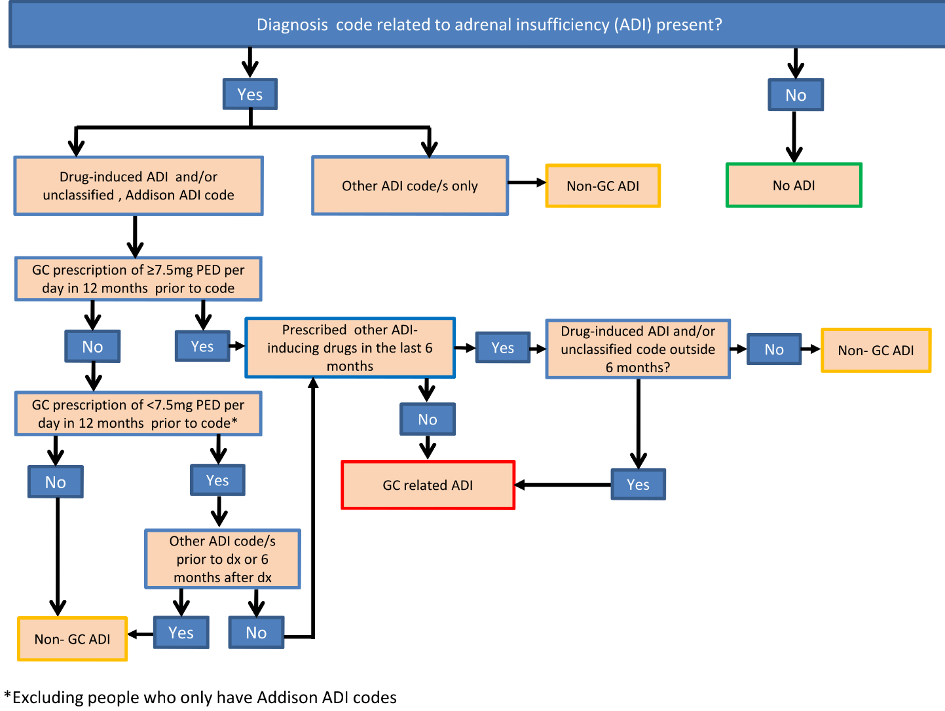
Note: ADI, adrenal insufficiency; GC, glucocorticoids; dx, diagnosis; PED, prednisolone equivalent dose
Figure 2. Algorithm for identification of cases of glucocorticoid induced Cushing’s syndrome in electronic health records
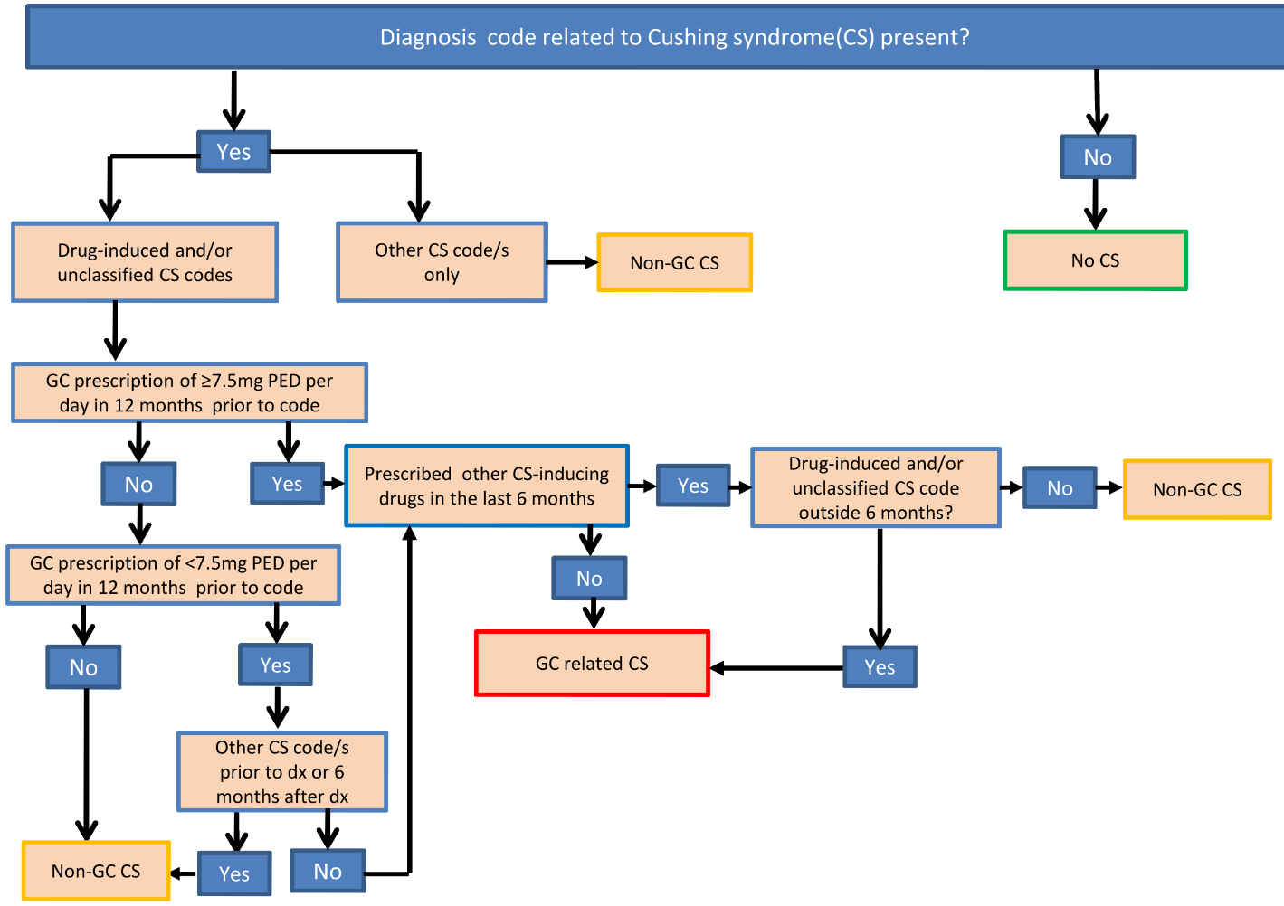
Note: CS, Cushing’s syndrome; dx, diagnosis; GC, glucocorticoids; PED, prednisolone equivalent dose

Figure3. Schematic view of confounding adjustment for the effects of oral glucocorticoids on glucocorticoid-induced adrenal insufficiency
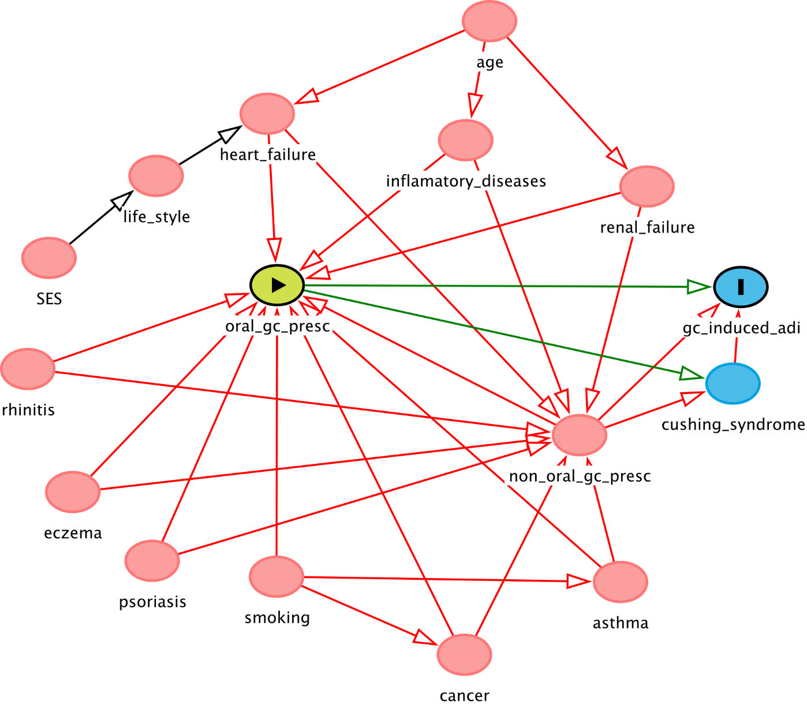
Note: , Exposure variable; ,outcome variable; ,ancestor of outcome variable; ancestor of exposure and outcome variable; causal path; , biasing path; gc_induced_adi, glucocorticoid-induced adrenal insufficiency; oral_gc_presc, oral glucocorticoids prescribed; SES, socioeconomic status.

Figure 3 includes all possible links between the exposure variable (oral glucocorticoid prescription), outcome variable (oral glucocorticoid induced ADI) and potential confounders. Variables on the causal pathway, also referred as mediators (e.g. Cushing’s syndrome in Figure 3), are automatically dropped. Based on the concept of parsimony (preferring less complex model with minimum number of parameters to complex model with many parameters), minimal number of confounders were then selected using the DAGitty software. Hence, non-oral glucocorticoid (inhaled, intra-articular, intra-muscular, nasal, topical and rectal routes) were considered sufficiently enough to block the confounding effect and were therefore selected for adjusting models.
Figure 4. Schematic view of confounding adjustment for the effects of oral glucocorticoids on glucocorticoid-induced Cushing’s syndrome
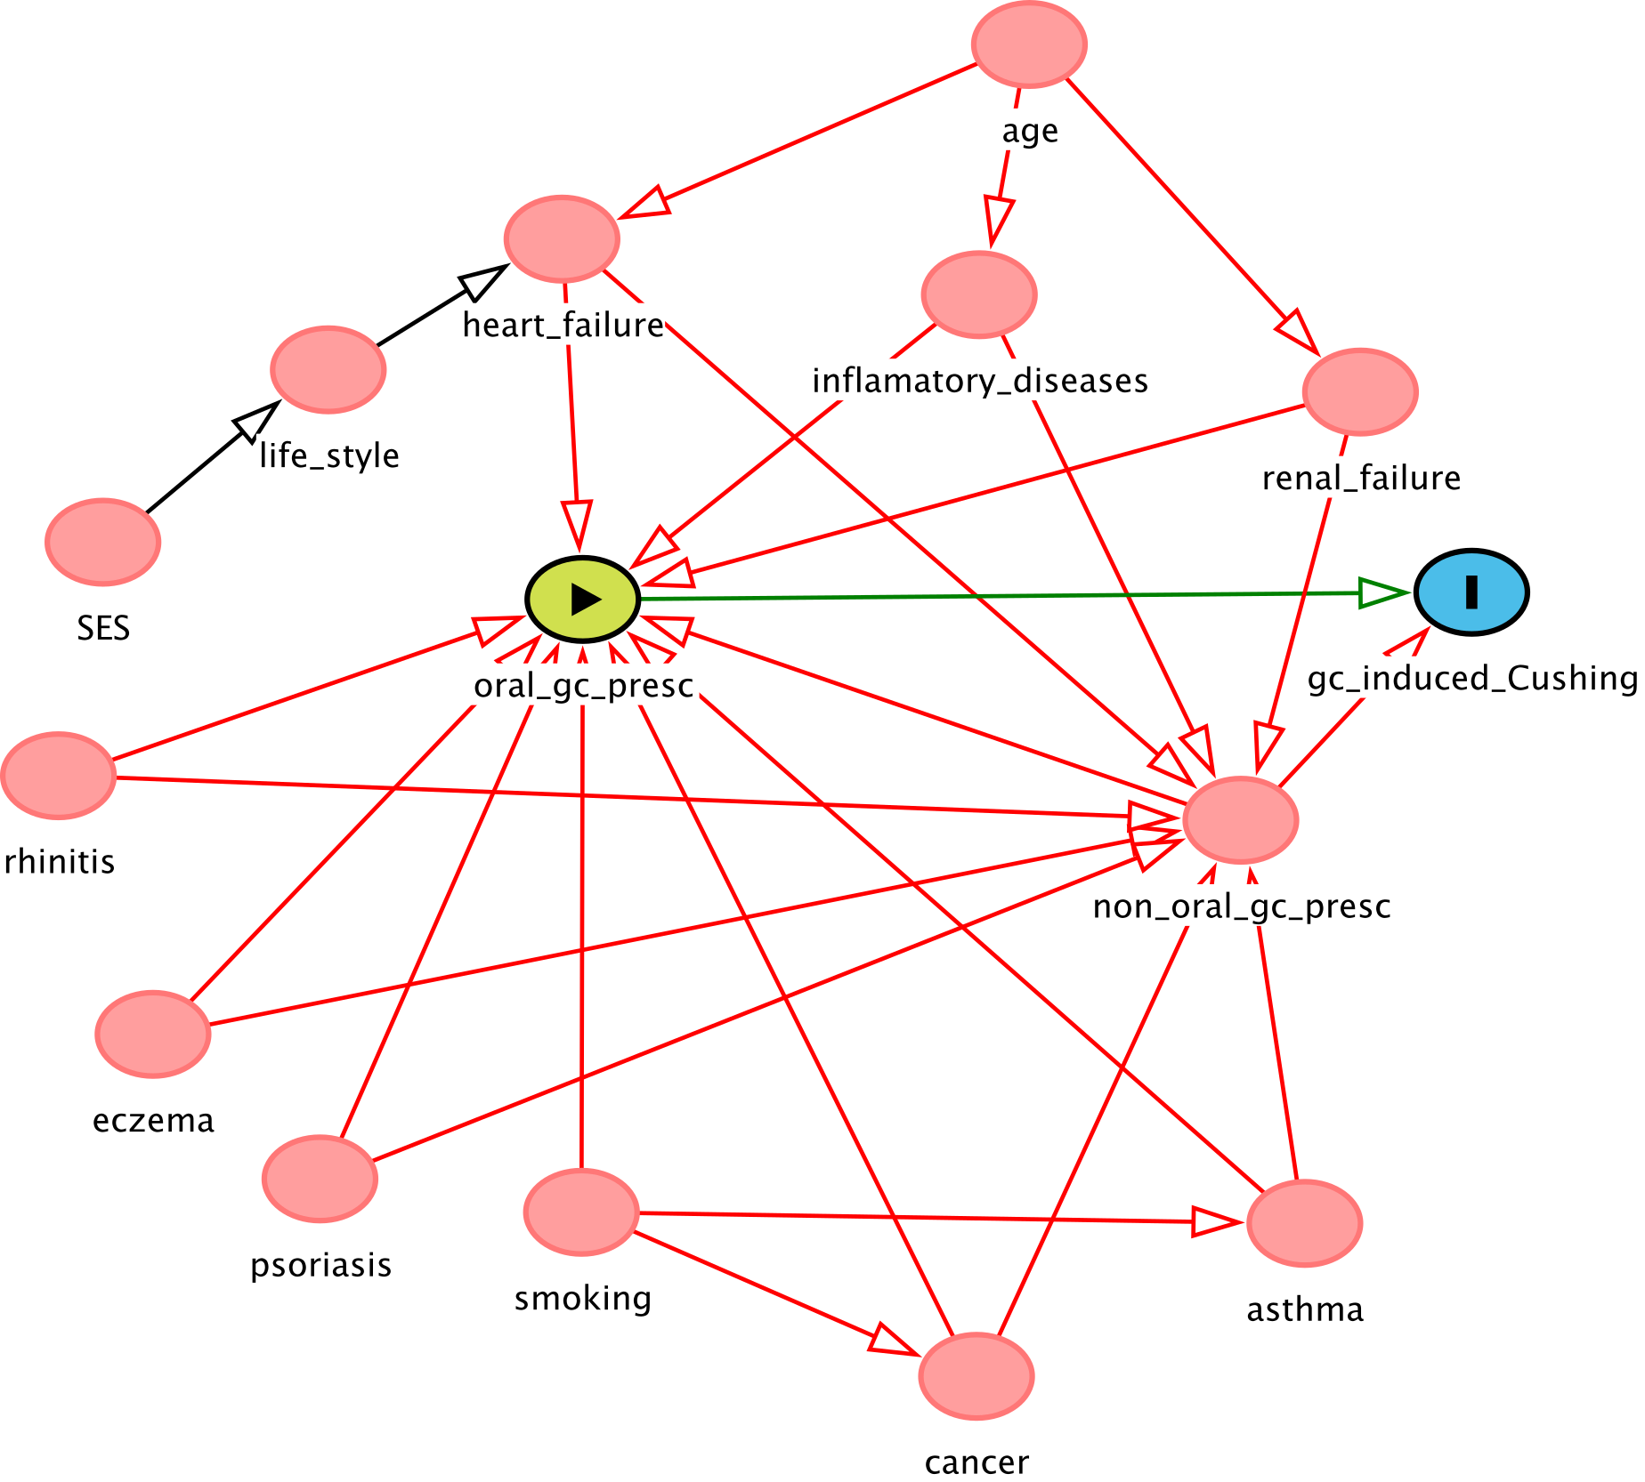

Note: , Exposure variable; ,outcome variable; ,ancestor of outcome variable; ancestor of exposure and outcome variable; causal path; , biasing path; gc_induced_adi, glucocorticoid-induced adrenal insufficiency; oral_gc_presc, oral glucocorticoids prescribed; SES, socioeconomic status.

Figure 4 includes all possible links between the exposure variable (oral glucocorticoid prescription), outcome variable (oral glucocorticoid induced Cushing) and potential confounders. Based on the DAGitty model, non-oral glucocorticoid (inhaled, intra-articular, intra-muscular, nasal, topical and rectal routes) were considered sufficiently enough to block the confounding effect and were therefore selected for adjusting models.
Figure 5. Schematic view of confounding adjustment for the effects of oral glucocorticoids on mortality
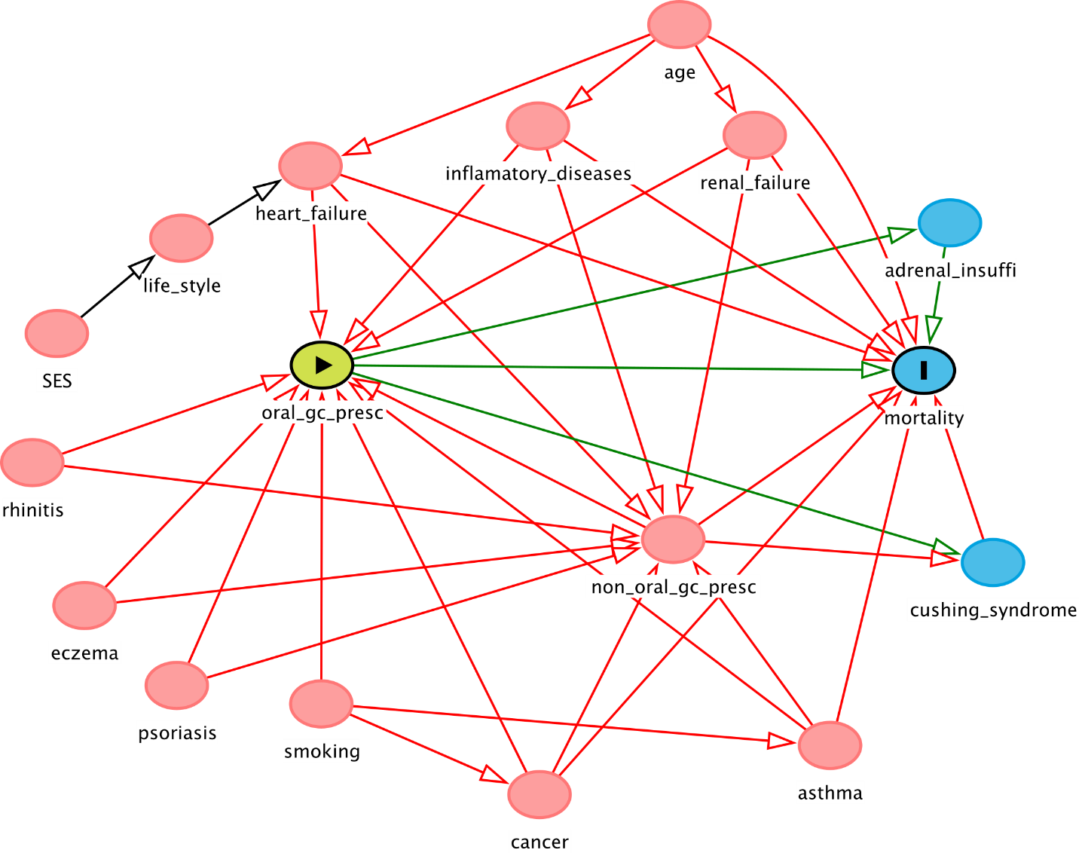
Note: , Exposure variable; ,outcome variable; ,ancestor of outcome variable; ancestor of exposure and outcome variable; causal path; , biasing path; gc_induced_adi, glucocorticoid-induced adrenal insufficiency; oral_gc_presc, oral glucocorticoids prescribed; renal failure, stage IV/V renal failure; SES, socioeconomic status.

Figure 5 includes all possible links between the exposure variable (oral glucocorticoid prescription), outcome variable (oral glucocorticoid induced mortality) and potential confounders. Based on DAGitty model, non-oral glucocorticoid (inhaled, intra-articular, intra-muscular, nasal, topical and rectal routes), asthma, cancer, heart failure, renal failure (stage 3/4) and inflammatory diseases were considered sufficiently enough to block the confounding effect and were therefore selected for adjusting models.

