Supplementary Material

Rapid Preparation of Highly Reliable PDMS Double Emulsion Microfluidic Devices

Shunbo Liª*, Xiuqing Gongª, Ciara S. Mc Nallyª, Muling Zengª, Thembaninkosi Gaule^{a,b}, Clara Anduix-Cantoª, Alexander N. Kulakª, Lukmaan Abbas Bawazerª, Michael J. McPherson^{b} and Fiona C. Meldrumª*

S1. Microfluidic chip design for smaller double emulsion droplets generation

Figure S1. A microfluidic chip that is fabricated to generate smaller double emulsion droplets.

S2. Solvent Extraction of the PDMS
Solvent extraction of the cured PDMS sections was performed using Soxhlet extraction against 2-propanol (Figure S1). The PDMS sections were placed in a Soxhlet thimble, and the solvent raised to its boiling point. Condensation of the vapour causes the solvent to fill the section containing the solid material, washing the PDMS and extracting the uncured oligomers. Once this section is full, the solvent empties into the still pot via a siphon action and the cycle continues. This extraction process was run for 4 days.

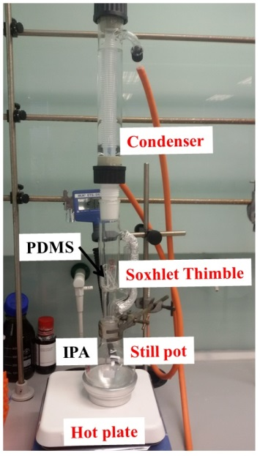

Figure S2. Set-up for PDMS extraction: hot plate, still pot, Soxhlet thimble and condenser. PDMS was put in Soxhlet thimble and 2-propanol (IPA) was used as the solvent.

S3. Statistical analysis of the patterning and coating results
In order to show the reliability of our chip fabrication method, 12 chips were patterned with epoxy and were then plasma-treated for 2.5 mins. Drops of 0.24 wt% Rhodamine 6G solution were then placed in zones 1 and 3. The region filled with red color is hydrophilic, while the white region is hydrophobic. The results are illustrated in Fig. S3.

Figure S3. Optical microscope images of 12 chips after patterning, coating and filling with 0.24 wt% Rhodamine 6G solution.

S4. Statistical analysis of the double emulsion formation

The reproducibility of double emulsion generation was also investigated. Five old chips (channel sizes of depth 110 µm, and widths 85 µm, 150 µm and 250 µm for the first, second and third channel zones) and five new chips (channel size of depth 23 µm, and widths 40 µm, 60 µm and 110 µm for the first, second and third channel zones) were used to generate double emulsion droplets under flow rate of 40 µl h-1 – 50 µl h-1 – 500 µl h-1 and 30 µl h-1 – 50 µl h-1 – 700 µl h-1 (inner water – oil phase – outer water). The droplets were collected and the size distributions were shown below.

Figure S4. The histogram of droplets generated by 5 old chips (a) for big double emulsion droplets and 5 new chips (b) for small double emulsion droplets. “core” and “shell” represent the core and shell of double emulsion droplets, and “single” means the failure of generating double emulsion droplets. The flow rate were kept at 40 µl h⁻¹ – 50 µl h⁻¹ – 500 µl h⁻¹ and 30 µl h⁻¹ – 50 µl h⁻¹ – 700 µl h⁻¹ (inner water – oil phase – outer water) for (a) and (b) respectively.

