话剧《赵氏孤儿》（2009年首演）
浙江大学黑白剧社

浙江大学是一所有逾百年历史的著名中国大学，它的戏剧活动从1937年就已开展并传承至今。黑白剧社1990年成立以来演出了近五十部不同剧场形式的剧目，大部分参与者都是来自大学不同学科、对戏剧有着共同兴趣的学生。

排演这台戏是为了让更多学子走进剧场，在舞台上深入理解中国经典戏剧。我们呈现了当代中国大学生所认识的《赵氏孤儿》。

戏集中表现一介草民程婴一诺千金的诚信。从孤儿的成人礼展开，以程婴的视角，倒叙屠杀和拯救的过程。孤儿得知真相决意报仇，可是他的仇人却是他的义父。他陷入两难的抉择中：做一个杀父的魔鬼，或是做一个任亲人枉死的叛徒……

本剧的舞台设计仅用三条红绸和四个木块，勾勒出不同的场景，体现了中国元素和东方美学的神韵。
――桂迎（导演）

The Orphan of Zhao (spoken Drama or huaju, premiered 2009)
Heibai Drama Society, Zhejiang University

Modern drama in China is known as huaju or spoken drama, distinguishing it from the traditional song-dance theatre. It emerged in the 1910s, following the style of Western theatre and was considerably influenced by students’ activities.

Zhejiang University, a prestigious Chinese university with a history of over a century, started its drama activities as early as 1937. The Heibai Drama Society (‘heibai’ is the transliteration of the written Chinese characters ‘black/ white’) was founded in 1990 and has performed around fifty productions in various styles. The majority of the participants are students from different disciplines, sharing a great interest in theatre.

Our performance of The Orphan of Zhao aimed at drawing more students to the theatre, and helping them to obtain a deeper understanding of Chinese classic theatre on the stage. We have presented the play from the perspective of contemporary Chinese university students.

The drama focuses on portraying Cheng Ying, an ordinary man, as a righteous person who keeps his word. The production begins with the orphan’s coming-of-age ceremony, and then adopts flashback to recount the massacre and the salvation of the orphan. After learning the truth, the orphan is determined to seek revenge. However, his enemy is his foster father. He faces a dilemma: either to be a patricide, or to be a traitor, turning a blind eye to the persecution of his family.

The stage design is simple: three red silk ribbons and four wood blocks make up our set. Nonetheless it embodies Chinese elements and oriental aesthetics.

-- Gui Ying (Director)

Spoken Drama Gui Ying 1 | 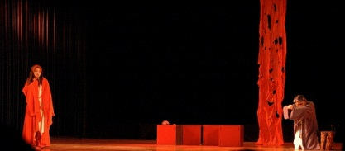 | 公主恳求程婴帮助把婴儿带出宫，程婴跪地相拒。  When the Princess first begs Cheng Ying to take her son out of the palace, Cheng kneels down to refuse the request.
Spoken Drama Gui Ying 2 | 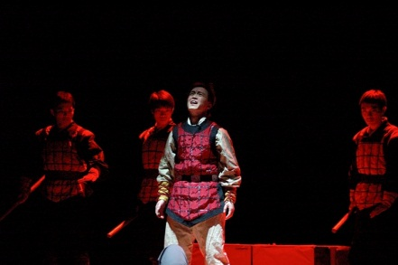 | 孤儿得知真相后，陷入弑父还是报仇的两难境地。  Having learnt his true life story, the orphan faces the dilemma: to kill his foster father or to avenge the Zhao clan.
Spoken Drama Gui Ying 3 |  | 黑白剧社《赵氏孤儿》2009年首演广告。  Poster for the premiere of The Orphan of Zhao in 2009.
照片由浙江大学黑白剧社提供
Courtesy of Heibai Drama Society, Zhejiang University

