The Orphan of Zhao (2012)
The Royal Shakespeare Company

Staging The Orphan of Zhao is part of a commitment at the RSC to engage with Shakespeare’s global peers and bring less known international classics to a British audience.

James Fenton adapted the play from a range of Chinese sources; allowing us to choose the threads of the story that would work best for this production. We discovered a version where the Princess does not die in giving up her son, and therefore survives into the second half of the play where she is reunited with the Orphan and this felt like a great development of the plot and is something we have retained in this version. We have also made one major addition to the play, a final scene that acts as a kind of ‘epilogue’ and completes the story of Cheng Ying. We felt that especially to a Western audience this sacrifice is perhaps the hardest to understand and needed a sense of closure, beyond the end of the Orphan’s story of revenge. This epilogue allows us to retain the structure of previous versions, and the traditional arc of the Orphan’s story, whilst creating a space at the end of the play to complete Cheng Ying’s journey.
Greg Doran, the director, did a lot of research into Chinese theatre traditions and visited China with Niki Turner the designer to get ideas for the production; this was very useful in terms of understanding the culture from which the story comes. A key part of our process was then to filter the elements of this rich and fascinating culture that were useful to us – and a company of Western trained actors – in the telling of our story. The range of voices and experiences in the rehearsal room meant we as a company were asking the same questions our audience would in approaching the play for the first time, allowing us to ensure that this complex story was clear and exciting for an audience who, on the whole, do not know it.

-- Zoe Waterman (Assistant Director)

《赵氏孤儿》（英语演出，2012年）
皇家莎士比亚剧团

皇家莎士比亚剧团一直致力于着眼全球，并向观众呈现在英国不太为人知晓的世界戏剧经典。《赵氏孤儿》便是我们努力的成果之一。

詹姆斯·芬顿从多种中国版本《赵氏孤儿》中取材改编，为我们选取了最适合这台制作的故事线索。有一个版本中，公主在托孤后并未死去，因此得以在下半场与孤儿（公主亲生子）重聚。这在我们看来是是个极好的情节发展，因而在我们的版本中采用了。我们也对原剧本做了一项大改动，即增加了最后一场戏来完成了结程婴的故事，似一个“尾声”，因为我们感到对西方观众来说程婴的自我牺牲可能是最难理解的部分，因此需要一个复仇故事结局之外的归结感。这个尾声保留了原版的叙事结构和传统孤儿故事弧线型的发展，同时得以在剧终时创造了空间来终结程婴的人生历程。

导演格雷格·多兰对中国戏剧传统进行了广泛研究，并与舞台设计师尼基·特纳一起访问中国，为该剧寻找感觉，这对于了解《赵氏孤儿》所根植的文化非常有用。我们工作的重点之一就是从这丰富、生动的文化中提取对我们西方培训的演员有用的元素，来演出我们创作的故事。排练场里大家的经验及表述显示，我们这个团体面临的问题，与观众初次接触这个戏时会产生的疑问是相同的，这就促使我们一定要让这个复杂的故事清晰、动人，来献给对它并不熟悉的观众。

――佐伊·华特曼（副导演）
Captions:
RSC 1 | 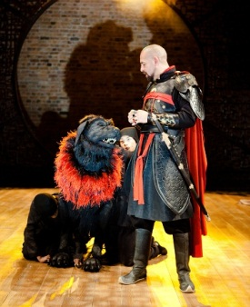 | Tu’an Gu trains the Demon Mastiff in his compound.  屠岸贾在训练灵獒神犬。
RSC 2 | 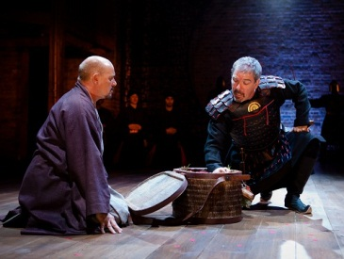 | Han Jue (right) decides whether to save the Orphan, brought to him by Cheng Ying (left) at the city gate.  城门口，韩厥（右）面临抉择：该不该放走程婴（左）以及药箱里的婴儿?
RSC 3 | 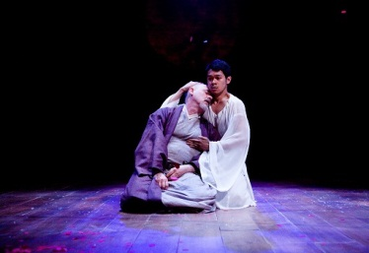 | The ghost of Cheng Ying’s son (right) cradles his dead father at the end of the play.  程婴之子的鬼魂（右）将自杀了的父亲拥入自己的怀里。此为全剧结尾。
Courtesy of Royal Shakespeare Company, photograph by Kwarme Lestrade.
照片由皇家莎士比亚剧团提供

