话剧《赵氏孤儿》（2003年）
北京人民艺术剧院

关于《赵氏孤儿》，我从一开始就是要导个现实主义的话剧。我只是在叙述故事情节、结构上有些改变，没有在“善”和“恶”上下功夫，我要求演员扮演一个叙事的角色，不做道德的批判，我只是给每个人物在特定环境下一个特定的选择。

在一般人眼中反面的屠岸贾复仇具有其合理性，赵氏孤儿因为养育之恩不愿复仇也是他个人正确的抉择，我们只是让人物做出了符合其自身情况的选择。

关于舞台，我做了空舞台的处理，但是虽然舞台上看上去空空荡荡，其实有很多细节。我在上面铺了4-5万块窑砖，这个虽然看不出来却是给自己加了很多工作量，我希望一切都写实，包括拉上两匹活马，真实的城墙砖，真实的马，两匹马对穿跑的时候，就是当时真实的声音，另外，两匹马的马蹄声也能营造战时的氛围。

在表演上，我一直要求演员遵循“提线木偶”的表演方式，即，在舞台上你是那个表演的木偶，也应该是那只提着木偶的手，能随时在角色和自我之间抽离，立于舞台上空审视自己的演出，保持清醒。濮存昕（程婴的扮演者）现在已经抓住了这种状态。

――林兆华（导演）

The Orphan of Zhao (spoken drama or huaju, 2003)
Beijing People's Art Theatre

From the very beginning of working on this piece, I had realism in mind. In this production only a small number of plots and structures were altered, and no perspective of ‘good’ or ‘evil’ was emphasized. Instead, the cast were asked to play a narrative character without being morally judgmental. As a director, I only provided a specific choice for a character under a specific circumstance.

For example, it seems sensible for the traditional villain Tu’an Gu to take revenge, and for the orphan not to take revenge because of his gratitude to his foster father Tu’an. We let the characters make their own choices which best fit in their circumstances.

As for the scenography, I went for ‘emptiness’, but the seemingly empty stage actually contains numerous details. For example, about 50,000 bricks were laid on the floor. It was mountainous work indeed, yet I was determined to create a kind of realistic mise en scène for the production. What I meant by ‘real’ includes two actual horses and city-wall bricks. People can hear the sound of the gallop; it produces a wartime atmosphere.

As for the acting, the cast were asked to be ‘marionettes’. When on stage, one should be both the puppet that performs, and the hand which operates it. Therefore, an actor can hopefully distinguish the different roles of the character and the self, and stay clear-headed by monitoring his or her own performance. Pu Cunxin who plays Cheng Ying has successfully done so.

-- Lin Zhaohua (Director)

Captions:
Spoken Drama Lin 1 | 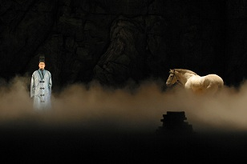 | 马的自然与恬静与程婴内心的焦躁形成鲜明的对比。这是全剧开场时程婴自述的场景。  The tranquillity of the horse is in distinct contrast to Cheng Ying’s anxiety in an act one monologue.
Spoken Drama Lin 2 | 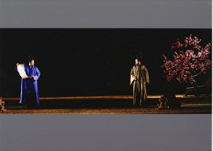 | 程婴告诉长大成人的孤儿其身世真相，期盼孤儿报仇雪恨，但是孤儿拒绝了他的要求。  Cheng Ying tells the orphan who he really is, expecting him to take his revenge. Yet, the orphan refuses to do so.
Spoken Drama Lin 3 | 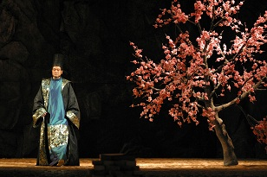 | 屠岸贾没有想到全心抚育成人的养子竟然是被自己灭族的赵家的孤儿。  Tu’an Gu, who murdered the Zhao clan years ago, now realizes that his adopted son is in fact the orphan of Zhao.
照片由北京人民艺术剧院提供
Courtesy of Beijing People’s Art Theatre

