How the Institutional Data Repository helped me promote my data
Guest post from James Mooney, Lecturer in Music Technology, University of Leeds
As part of International Data Week, Sept 11-17 2016, James Mooney reflects on his experience of using the Research Data Leeds institutional data repository.

Background
I have recently completed a project that involved curating, researching and staging three performances of live electronic music compositions by the English composer Hugh Davies (1943-2005). Staging these concerts has, in many cases, involved building the equipment required to perform them from scratch, based on incomplete or ambiguous information gleaned from archival documents. In addition, these are experimental pieces, with scores that comprise text-based instructions and descriptions rather than standard notation, as well as other inherently unpredictable elements that mean that the pieces turn out differently every time they are performed. These were, in other words, pieces that could only be fully understood by performing them. In this situation, the practice-based elements of the project - that is, the performances - are a valuable project output in their own right, since they convey much more about the nature of the pieces than could ever be understood from any abstract or theoretical description of them.

Rationale
I was interested in using the Research Data Leeds Repository because it offered the possibility of rendering these performances as outputs - entities as concrete, readily identifiable, and as easy to reference as, say, a journal article would be.
Using the Repository allowed each of these three concerts to be packaged as an output, complete with title, abstract, DOI, and authorial information, as well as video-recordings of the pre-concert talk and each of the pieces themselves, and programme notes in PDF format. In this way they could be: (a) preserved for posterity; (b) viewed and auditioned by individuals who were not able to attend the original events; and (c) used and referenced in future research.

Preparation of Materials
In anticipation of their inclusion in the Repository, all three performances were video recorded. Detailed pre-concert lectures delivered in advance of each of the three concerts were also video-recorded. Extensive programme notes - prepared in hard copy for the performances themselves - were also retained in PDF format for inclusion in the Repository.
Decisions also needed to be made in relation to the 'granularity' of the materials to be presented. Would we, for example, package each individual piece as a separate entity within the Repository, or would one entity per concert be preferable? Would we include separate video files for each individual piece performed, or a single continuous video file for each concert? Or both? Ultimately, we opted for one entity per concert but with separate files for each individual piece. This configuration, we felt, represented the best balance between representing the original aims of the project (which had specified three concerts as outputs), and catering the potential needs of future researchers (who might appreciate being able to refer to individual pieces quickly and easily).
Having made these decisions, the video-files naturally had to be prepared accordingly. The videos of the concerts were edited so as to provide an individual video-file for each piece performed. Titles and credits for each individual piece were added using Final Cut Pro.
Readying these materials for the Repository also necessitated gaining permission from the various rights-holders, including composers (or their next of kin, if deceased), performers, and in some cases, publishers. If carried out methodically, this need not represent too onerous an administrative burden. In this case, a standard email was drafted, and responses recorded in a spreadsheet, which was then uploaded to the Repository along with the other materials.
Access the Hugh Davies data online.
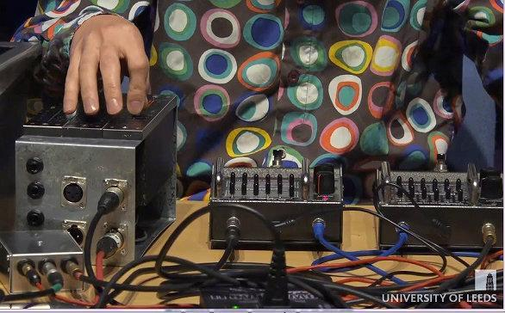

Benefits and Applicability
Packaging the concerts as outputs in this way represents a more sustainable option than using websites like YouTube and Vimeo, where the continued availability of the videos is contingent upon the integrity of one individual's user account (which could cease to be maintained for a variety of different reasons), and upon third-party terms and conditions that may change unpredictably. It also represents a preferable option to hosting such outputs on an individual's personal website, or on a bespoke institutionally-hosted one, since these options will only be effective for as long as somebody is ready and able to maintain them. In contrast with these less-than-ideal options, the Repository allows these outputs to be preserved in perpetuity, theoretically at least.
Depositing materials in this way would potentially be beneficial for any research-based activity that incorporates a practice-based element. For the current project, similar repositories are planned as documentation for the project exhibition, and as a 'video proceedings' for the project conference. So long as appropriate materials (e.g. video and other digital formats) are gathered while the practice is under-way, such materials can be combined with a title and abstract at a later date, and packed as an output, complete with digital object identifier (DOI).
Colleagues writing funding proposals may wish to build plans for packaging outputs in the Repository into their grant applications. This would doubtless be attractive to funders, who will welcome any efforts to assure the sustainability of digital outputs.
James Mooney
Lecturer in Music Technology
School of Music
Faculty of Performance, Visual Arts and Communications
University of Leeds
http://music.leeds.ac.uk/people/james-mooney/

Related links
- International Data Week 11-17 Sept 2016
- Research Data Leeds repository
- The Hugh Davies data in the Research Data Leeds repository

