Fail Fraction: ArcGIS Pro and QGIS tools to calculate the probability of roof collapse under tephra fall loading

This tool allows GIS users to calculate the probability of roof collapse under tephra fall loading for different eruption scenarios based on buildings’ roof type and condition properties and published typical failure loads (Jenkins et al., 2014). There are versions of the tool for coarse and fine tephra as experimental results show fine tephra can be stable at higher roof pitches (Osman et al. 2023) and the user must select the one that is most appropriate for the scenario being considered. The output is a map that shows the tephra load as a fraction of the failure load (the Fail fraction, F) and for values of F ≥ 1 the roof is at high risk of collapse.

GIS requirements
QGIS: the tool was developed in Version 3.28.12. It requires the Saga Next Gen plug-in to run Add raster values to points, which enables tephra fall load values to be interpolated to building point locations.
ArcGIS Pro: the tool was developed in Version 3.1.0. It requires Python to be activated to run functions during the calculations of Fail load and Roof shape factor (RSF).

Procedure overview
The following files are provided:
- For ArcGIS Pro: the Fail_fraction_toolbox which contains the models (Fail_fraction_coarse_tephra and Fail_fraction_fine_tephra) and the Fail fraction layer file.
- For QGIS: Two Fail fraction models, one for coarse and one for fine tephra, and the Fail fraction style file.
Start by creating a GIS Project and choose a projected coordinate system (so tephra load raster values can be interpolated to building data points). Save the model toolbox (ArcGIS Pro) or models (QGIS) and the symbology file in the same folder as the map document.
Add 3 data files to the project (detailed further in the Input data section):
- Tephra load raster.
- Building data.
- Table of typical roof failure loads.
Select the appropriate tool to use (for coarse or fine tephra), based on knowledge of the volcano of interest. The grain size distributions used in the tool are from Osman et al. 2023. The model for fine-grained tephra provides a more conservative estimate of roof loads and this should be used if the likely grain-size distribution for the scenario being considered is unknown.
Flow charts of the geoprocessing steps are shown in Fig. 1 and details of the steps and calculations are shown in the Appendix.

a)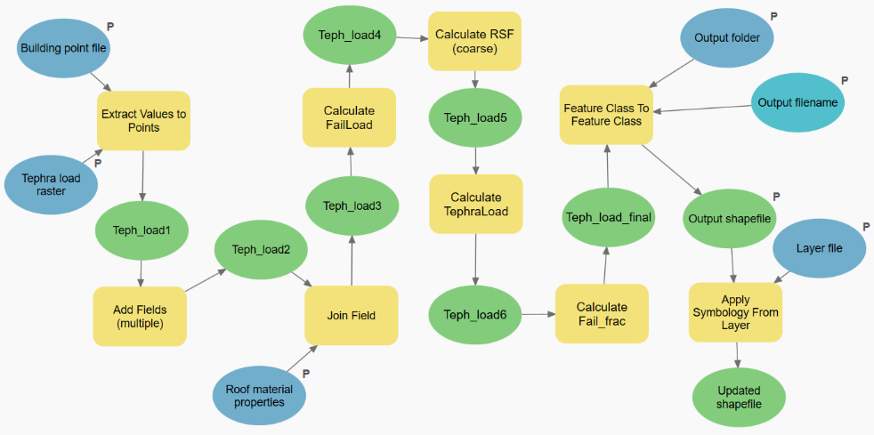
b)
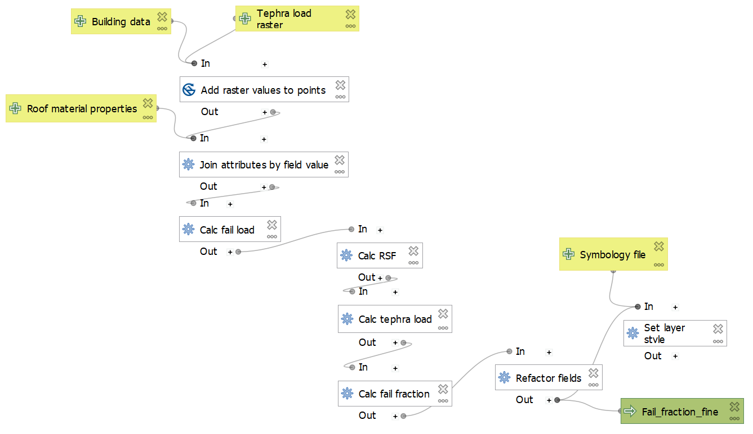

Fig. 1 Model flow chart for a) ArcGIS Pro, b) QGIS

Open the model and select the relevant input files (Fig. 2). The drop-down list will show the layers you have loaded in your project.
For ArcGIS Pro also select the folder and filename where the output shapefile will be saved.
For QGIS, the default is for the output shapefile to be created as a temporary layer, although you can choose to save the file if you wish.
Run the model. The output is loaded as a map layer.

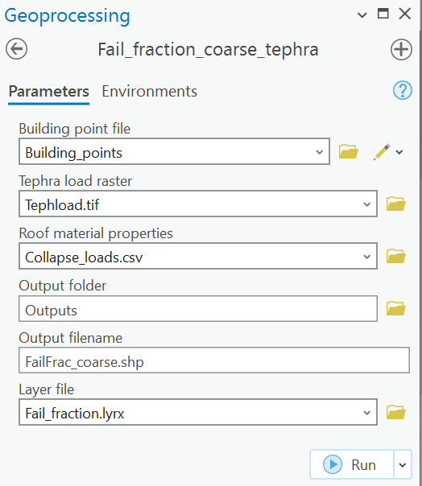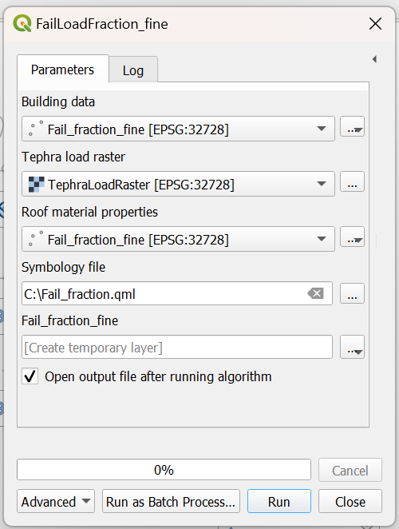

Fig. 2 Fail fraction input form for a) ArcGIS Pro, b) QGIS

Input data formatting
Input data must be formatted as shown in Table 1 and Fig. 3.

Output data
The output map shows the tephra load on the building as a fraction of its collapse load, symbolised as < 0.7 (low risk), 0.7 – 1.0 (at risk) and > 1.0 (failure possible). An example using synthetic data for model testing purposes only is shown in Fig. 4a (the map) and Fig. 4b (the attribute table).

Table 1 Input data for the Fail fraction tool
Input file and data type | Description
Tephra load  Raster | Ground tephra load, typically output from tephra dispersal model ​(e.g. Biass et al., 2016)​.  For the QGIS tool this raster must be called TephraLoadRaster.tif.
Building data  Vector – point  Example shown in Fig 3a | Point data representing buildings with the following fields in the attribute table (all numerical fields):  - RoofType - value assigned according to roof material in the roof failure loads table.  - RoofPitch - pitch (slope) of roof in degrees.  - RoofCondit – values of 1 for good condition and 0 for poor condition roofs.  - Longspan – values of 1 for long span roofs (> 5 m between supports) and 0 all other roofs.
Typical roof failure loads  Table  Example shown in Fig 3b | Typical failure loads by roof material, including the following fields:  - Roof_type – numerical field with number allocated to each roof material.  - Typical_load – numerical field with typical collapse loads (in kg m-2) for each roof material.  - Roof_material - text field of roof material.  We use mean collapse loads from Jenkins et al. (2014).

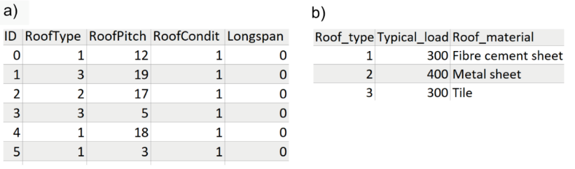
Fig. 3 Example input data used for model testing purposes only a) Building data, b) Typical failure loads by roof material type

a)
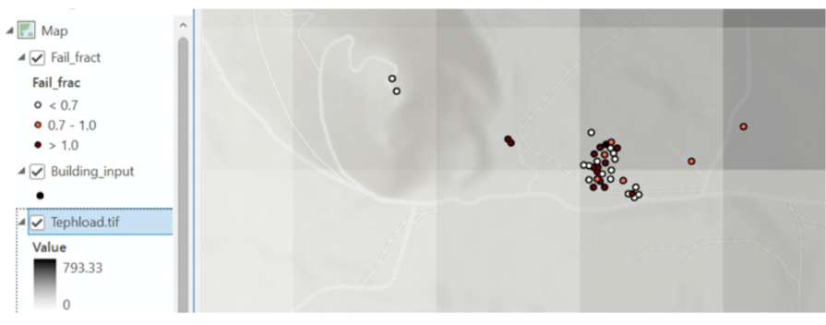
b)
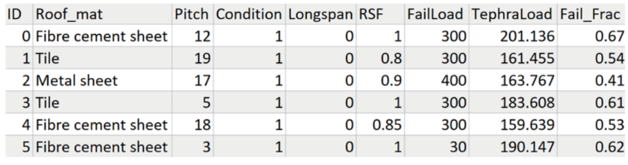
Fig. 4 Example output data used for model testing purposes only a) Output map layer, a) Output attribute table

References
Biass S, Bonadonna C, di Traglia F, Pistolesi M, Rosi M, Lestuzzi P (2016) Probabilistic evaluation of the physical impact of future tephra fallout events for the Island of Vulcano, Italy. Bull Volcanol 78:37. https://doi.org/10.1007/s00445-016-1028-1
Jenkins SF, Spence RJS, Fonseca JFBD, Solidum RU, Wilson TM (2014) Volcanic risk assessment: quantifying physical vulnerability in the built environment. J Volcanol Geotherm Res 276:105–120. https://doi.org/10.1016/j.jvolgeores.2014.03.002
Osman S, Thomas M, Crummy J, Sharp A, Carver S (2023) Laboratory tests to understand tephra sliding behaviour on roofs. J Appl Volcanology 12:11. https://doi.org/10.1186/s13617-023-00137-2

Appendix Tool summary
// This code calculates Fail Fraction which is tephra load on a roof as a fraction of that roof's failure load. The output map shows which buildings are at risk of roof failure under the tephra loading scenario being considered. There are 2 options for the sliding calculations, for coarse and fine tephra and the user must select the most appropriate based on knowledge of the volcano of interest.

// Inputs are: a raster file of tephra fall loading on the ground, a point file of building data and a table of typical roof failure loads. The tool uses tephra sliding data (Osman et al. 2023) to estimate tephra load on each roof (the fraction of tephra load on the ground that is not removed by sliding) and combines typical roof failure loads with building data to estimate roof failure loads for each building. It calculates FailFraction (tephra roof load as a fraction of building failure load) and displays values symbolised to highlight buildings at risk.

// Details of sliding equations in: Osman et al. (2023) Laboratory tests to understand tephra sliding behaviour on roofs. J Appl Volcanol https://doi.org/10.1186/s13617-023-00137-2

SELECT appropriate tool for Coarse tephra or Fine tephra
INPUT TephraLoadRaster, BuildingPointFile, RoofPropertiesTable, SymbologyFile

// Fields required in RoofPropertiesTable are:
Roof_type: numerical field with number allocated to each roof material
Typical_load: numerical field with typical collapse loads (in kg m⁻²) for each roof material
Roof_material: text field of roof material

// Fields required in BuildingPointFile are:
RoofType: numerical field matching Roof_type in RoofPropertiesTable
RoofPitch: numerical field for angle of pitch (in degrees)
RoofCondit: 1 for good condition and 0 for poor condition
Longspan: 1 for long span roofs (over 5 m between supports) and 0 for short span roofs

// TephraLoadRaster requires tephra loads in kg m⁻²

// Symbology file has categories for FailFraction of less than 0.7 (low risk), between 0.7 and 1 (at risk) and between 1 and 10 (failure possible)

EXTRACT value from TephraLoadRaster into new RasterValue field in BuildingPointFile interpolating between raster values to account for thinning of tephra deposit.
JOIN RoofPropertiesTable to BuildingPointFile using Rooftype as the key

FUNCTION FailLoad
// Calculates building-specific failure loads
Pass In: Longspan, TypicalLoad, Condition
IF Condition = 0 THEN multiplier = 0.5
ELSE multiplier = 1
ENDIF

IF Longspan = 0 THEN calculate FailLoad as TypicalLoad times multiplier
ELSE calculate FailLoad as 200 times multiplier
ENDIF

Pass Out: FailLoad
ENDFUNCTION

FUNCTION RSF
// Calculates RoofShapeFactor to take account of sliding based on Osman et al. 2023
Pass In: TephraType, Pitch

CASE TephraType of
Coarse:
IF Pitch is less than 16 THEN RoofShapeFactor is 1
ELSEIF Pitch is greater than 35 THEN RoofShapeFactor is 0
ELSE calculate RoofShapeFactor as (35 -Pitch) / 20
ENDIF
Fine:
IF Pitch is less than 21 THEN RoofShapeFactor = 1
ELSEIF Pitch is greater than 35 THEN RoofShapeFactor = 0
ELSE calculate RoofShapeFactor as (35 -Pitch) / 15
ENDIF
ENDCASE

Pass Out: RoofShapeFactor
ENDFUNCTION

CALL FailLoad with Longspan, Typical_load, RoofCondit RETURNING new FailLoad field in BuildingPointFile
CALL RSF with RoofPitch and TephraType of Coarse or Fine as appropriate RETURNING new RoofShapeFactor field in BuildingPointFile
CALCULATE new TephraLoad field in BuildingPointFile as RasterValue times RoofShapeFactor
CALCULATE new FailFraction field in BuildingPointFile as TephraLoad divided by FailLoad

IF FailFraction is greater than 10 THEN set FailFraction to 10
// Ensures datapoints are symbolised consistently

DISPLAY on map, with value of FailFraction symbolised with SymbologyFile

