Digital database for nasal prosthesis design with 3D Morphable Face Model approach: A database guide

 | Images |  | Subjective description |  | Measurements (mm) |  |  | Ratio
ID | Lateral view | Anterior view | Bridge profile | Tip projection | Nose length | Nasal bridge length | Nose width | Nose length: width
1 | 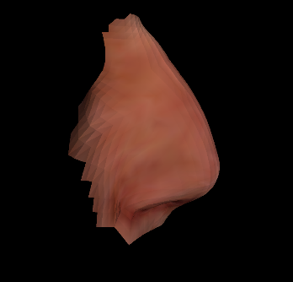 | 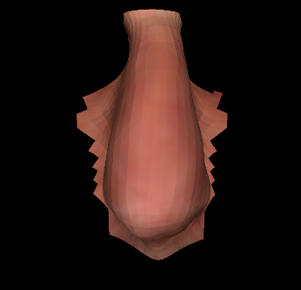 | convex | downturned | 73.8 | 58.9 | 34.1 | 2.2
2 | 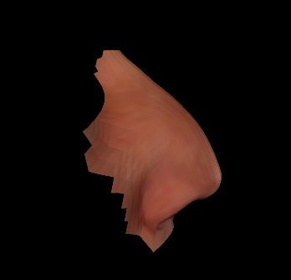 | 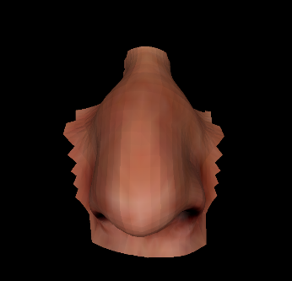 | convex | downturned | 64.2 | 58.8 | 36.1 | 1.8
3 | 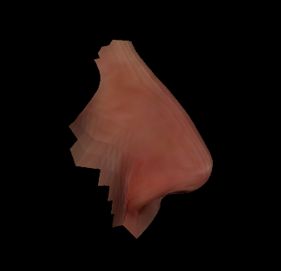 | 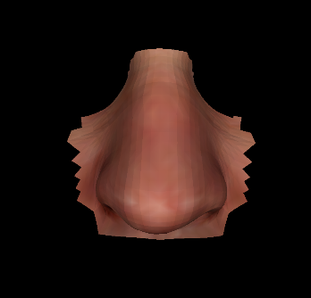 | straight | straight | 53.2 | 48.2 | 38.5 | 1.4
4 | 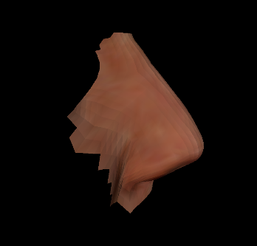 | 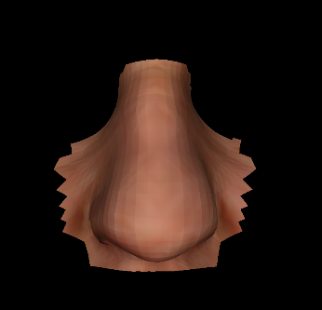 | straight | straight | 52.7 | 48.5 | 34.5 | 1.5
 | Images |  | Subjective description |  | Measurements (mm) |  |  | Ratio
ID | Lateral view | Anterior view | Bridge profile | Tip projection | Nose length | Nasal bridge length | Nose width | Nose length: width
5 | 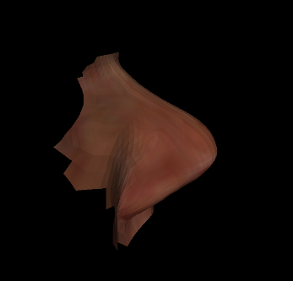 | 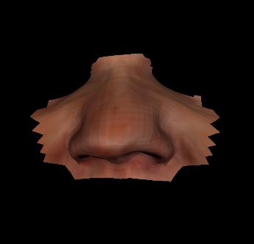 | convex | upturned | 44.8 | 43.0 | 38.7 | 1.2
6 | 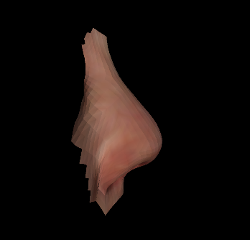 | 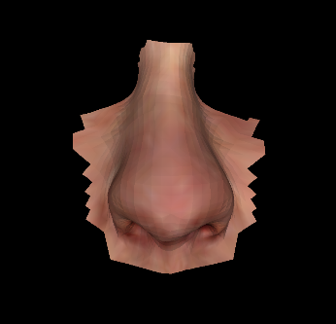 | convex | upturned | 64.6 | 51.6 | 38.2 | 1.7
7 | 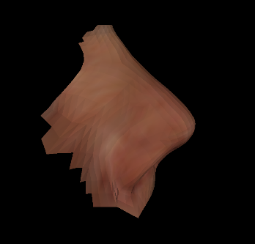 | 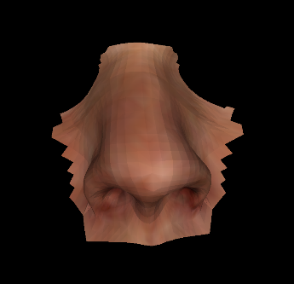 | straight | upturned | 55.6 | 45.0 | 37.9 | 1.5
8 | 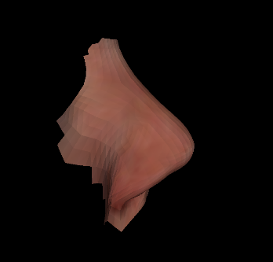 | 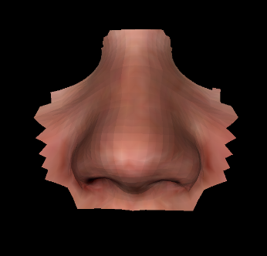 | straight | upturned | 48.3 | 40.7 | 35.8 | 1.3
 | Images |  | Subjective description |  | Measurements (mm) |  |  | Ratio
ID | Lateral view | Anterior view | Bridge profile | Tip projection | Nose length | Nasal bridge length | Nose width | Nose length: width
9 | 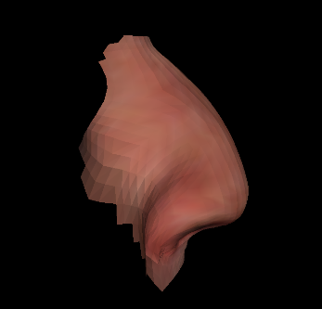 | 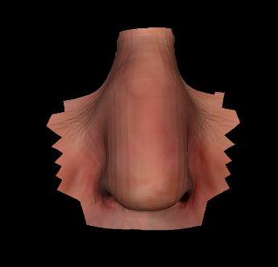 | convex | downturned | 54.0 | 48.0 | 25.9 | 2.1
10 | 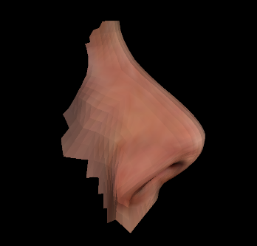 | 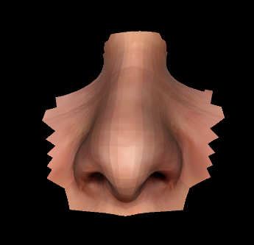 | straight | upturned | 52.9 | 42.9 | 32.6 | 1.6
11 | 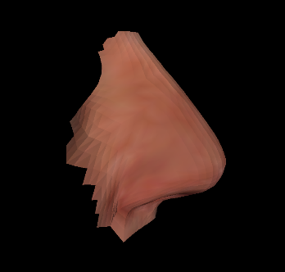 | 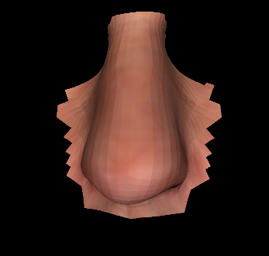 | straight | straight | 55.1 | 49.0 | 31.3 | 1.8
12 | 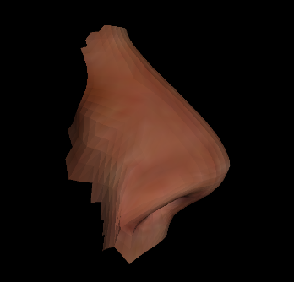 | 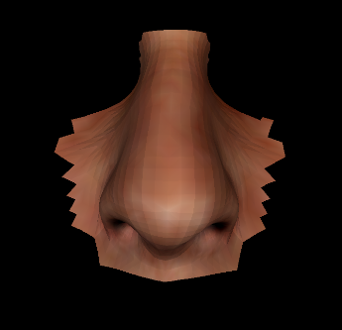 | straight | upturned | 54.4 | 46.5 | 32.8 | 1.7
 | Images |  | Subjective description |  | Measurements (mm) |  |  | Ratio
ID | Lateral view | Anterior view | Bridge profile | Tip projection | Nose length | Nasal bridge length | Nose width | Nose length: width
13 | 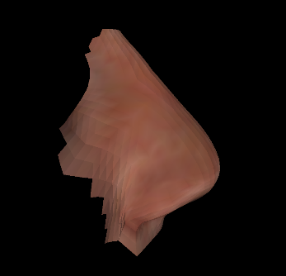 | 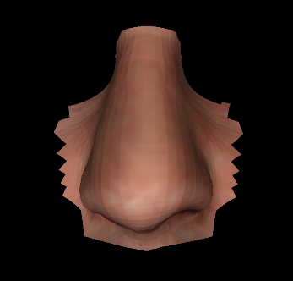 | straight | upturned | 61.4 | 53.1 | 38.4 | 1.6
14 | 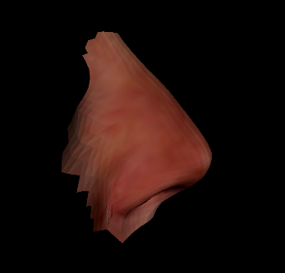 | 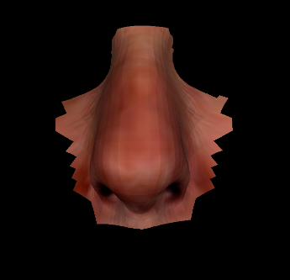 | straight | upturned | 54.4 | 46.0 | 28.7 | 1.9
15 | 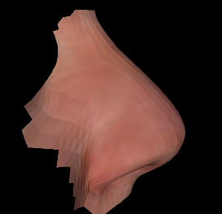 | 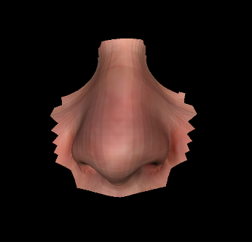 | straight | upturned | 53.4 | 45.5 | 35.0 | 1.5
16 | 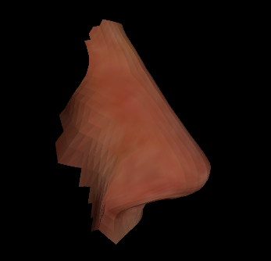 | 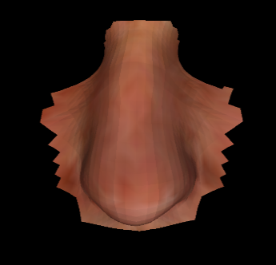 | straight | straight | 55.8 | 51.4 | 33.6 | 1.7
 | Images |  | Subjective description |  | Measurements (mm) |  |  | Ratio
ID | Lateral view | Anterior view | Bridge profile | Tip projection | Nose length | Nasal bridge length | Nose width | Nose length: width
17 | 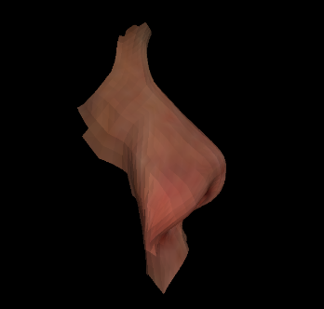 | 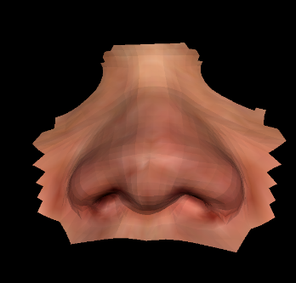 | straight | upturned | 50.2 | 36.8 | 48.6 | 1.0
18 | 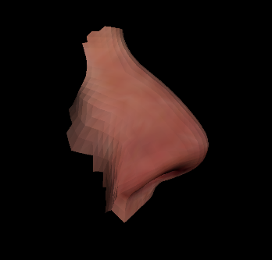 | 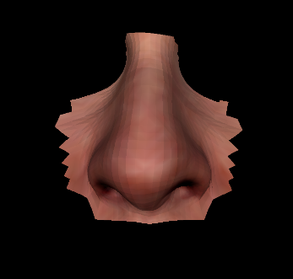 | convex | straight | 49.8 | 42.6 | 34.3 | 1.5
19 | 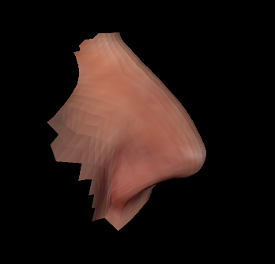 | 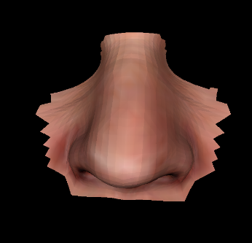 | convex | downturned | 46.3 | 42.3 | 35.5 | 1.3
20 | 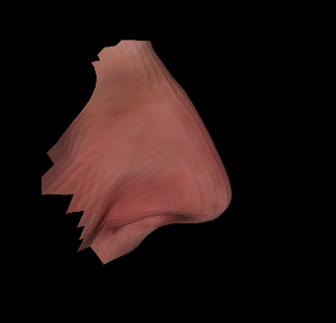 | 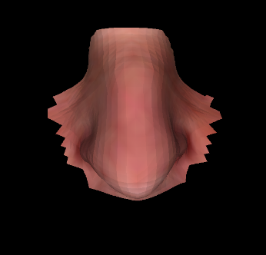 | straight | downturned | 45.4 | 41.2 | 30.6 | 1.5
 | Images |  | Subjective description |  | Measurements (mm) |  |  | Ratio
ID | Lateral view | Anterior view | Bridge profile | Tip projection | Nose length | Nasal bridge length | Nose width | Nose length: width
21 | 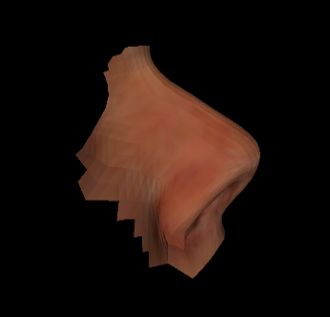 | 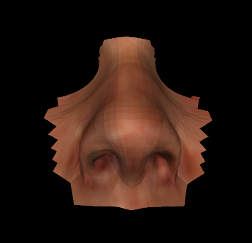 | straight | upturned | 49.1 | 37.6 | 31.2 | 1.6
22 | 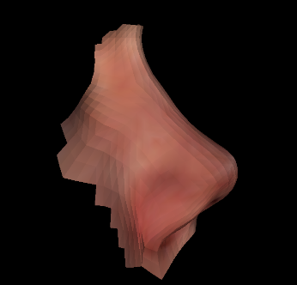 | 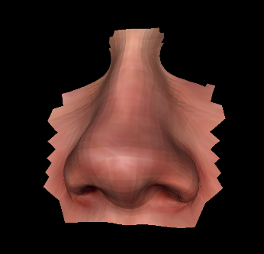 | concave | upturned | 53.6 | 41.3 | 39.3 | 1.4
23 | 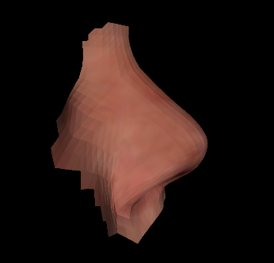 | 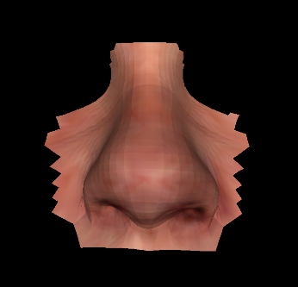 | straight | upturned | 51.3 | 40.4 | 37.7 | 1.4
24 | 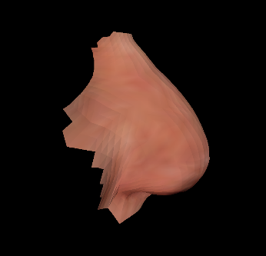 | 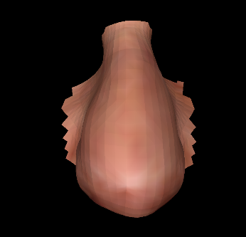 | convex | downturned | 66.4 | 59.6 | 40.9 | 1.6
 | Images |  | Subjective description |  | Measurements (mm) |  |  | Ratio
ID | Lateral view | Anterior view | Bridge profile | Tip projection | Nose length | Nasal bridge length | Nose width | Nose length: width
25 | 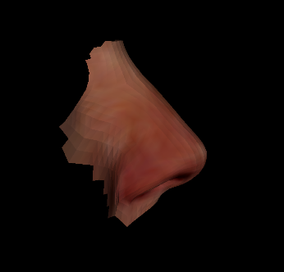 | 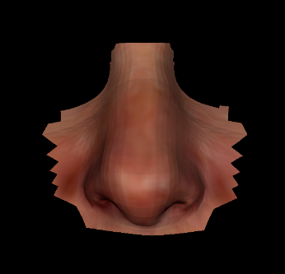 | straight | straight | 45.8 | 39.5 | 28.4 | 1.6
26 | 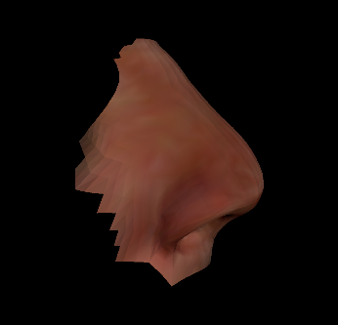 | 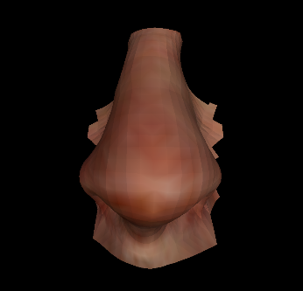 | straight | straight | 67.1 | 55.2 | 41.8 | 1.6
27 | 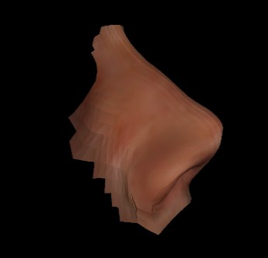 | 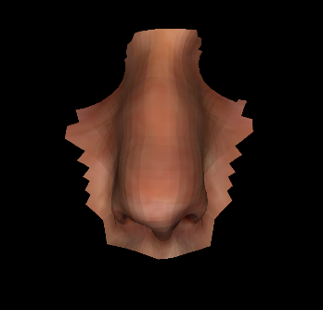 | concave | upturned | 57.5 | 44.9 | 26.3 | 2.2
28 | 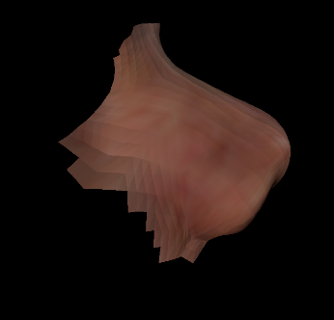 | 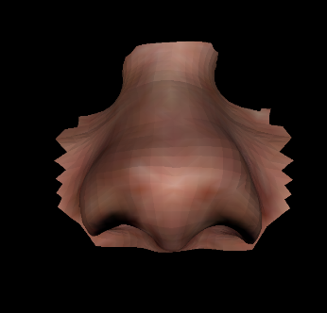 | straight | upturned | 54.3 | 46.7 | 42.5 | 1.3
 | Images |  | Subjective description |  | Measurements (mm) |  |  | Ratio
ID | Lateral view | Anterior view | Bridge profile | Tip projection | Nose length | Nasal bridge length | Nose width | Nose length: width
29 | 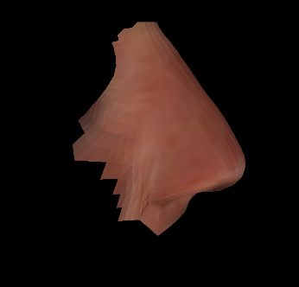 | 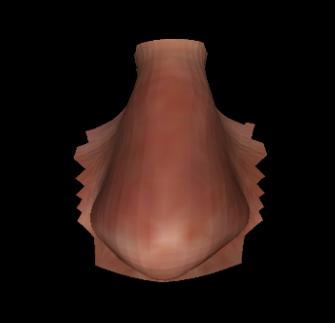 | straight | straight | 56.1 | 49.8 | 39.2 | 1.4
30 | 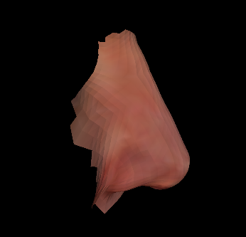 | 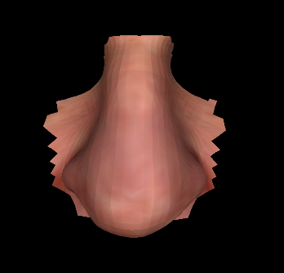 | straight | downturned | 62.7 | 58.6 | 50.5 | 1.2
31 | 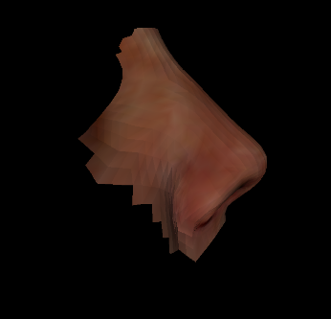 | 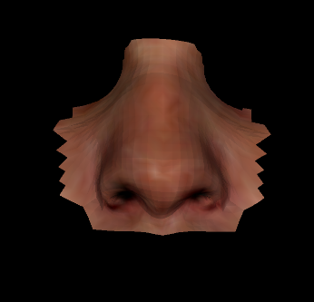 | straight | upturned | 46.6 | 39.2 | 30.3 | 1.5
32 | 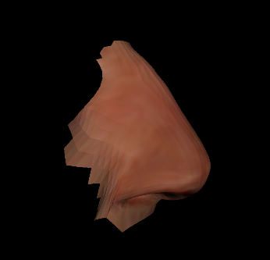 | 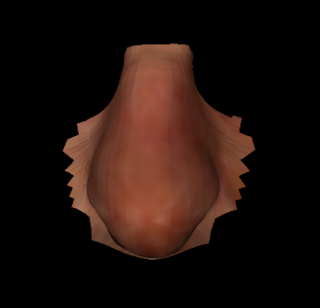 | convex | downturned | 56.1 | 50.5 | 36.7 | 1.5
 | Images |  | Subjective description |  | Measurements (mm) |  |  | Ratio
ID | Lateral view | Anterior view | Bridge profile | Tip projection | Nose length | Nasal bridge length | Nose width | Nose length: width
33 | 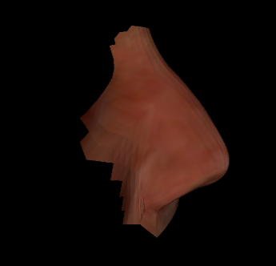 | 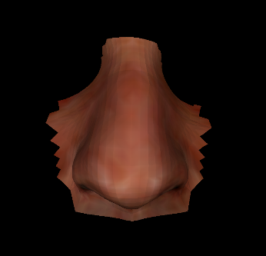 | convex | straight | 54.1 | 45.5 | 37.3 | 1.5
34 | 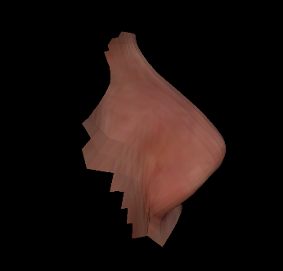 | 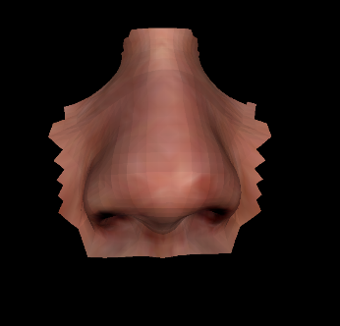 | straight | upturned | 55.3 | 46.6 | 40.2 | 1.4
35 | 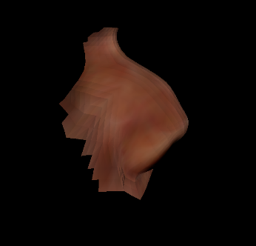 | 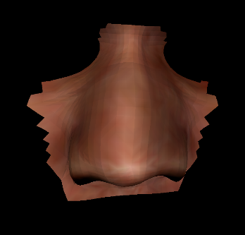 | convex | upturned | 47.2 | 39.3 | 37.2 | 1.3
36 | 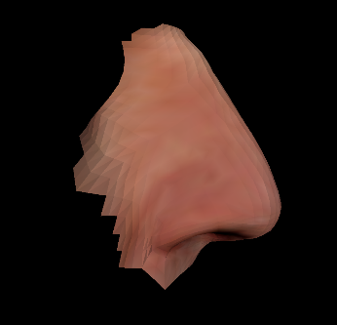 | 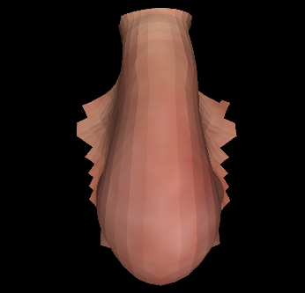 | straight | downturned | 70.0 | 63.7 | 40.2 | 1.7
 | Images |  | Subjective description |  | Measurements (mm) |  |  | Ratio
ID | Lateral view | Anterior view | Bridge profile | Tip projection | Nose length | Nasal bridge length | Nose width | Nose length: width
37 | 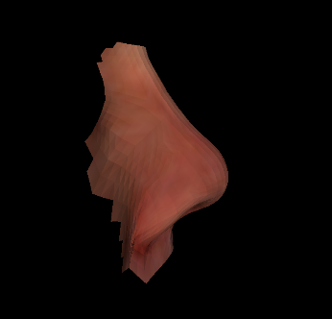 | 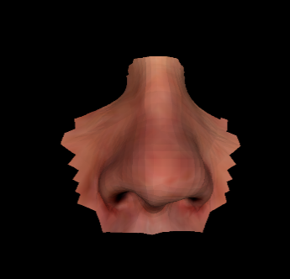 | concave | upturned | 53.2 | 44.4 | 37.3 | 1.4
38 | 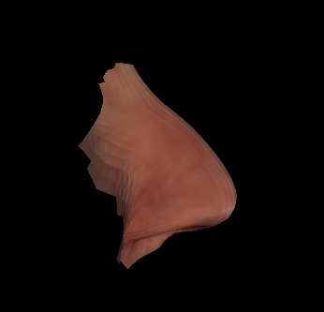 | 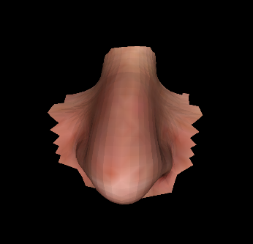 | convex | downturned | 59.2 | 55.6 | 38.2 | 1.5
39 | 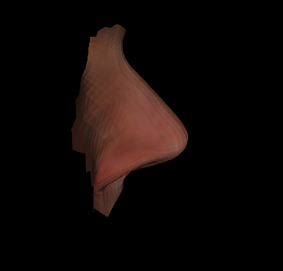 | 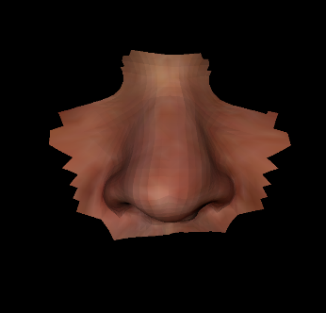 | straight | straight | 47.7 | 40.3 | 37.1 | 1.3
40 | 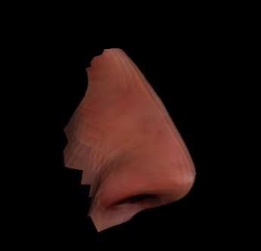 | 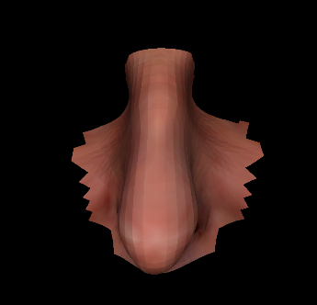 | straight | downturned | 59.3 | 51.8 | 23.6 | 2.5
 | Images |  | Subjective description |  | Measurements (mm) |  |  | Ratio
ID | Lateral view | Anterior view | Bridge profile | Tip projection | Nose length | Nasal bridge length | Nose width | Nose length: width
41 | 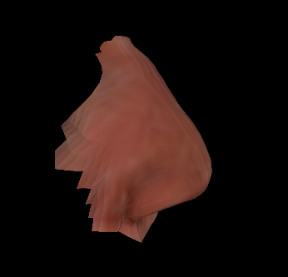 | 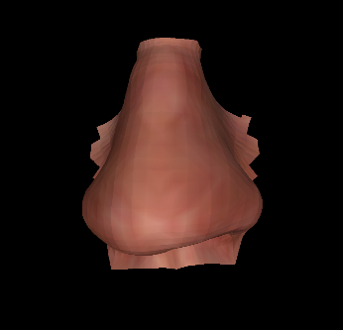 | straight | downturned | 59.1 | 54.0 | 49.7 | 1.2
42 | 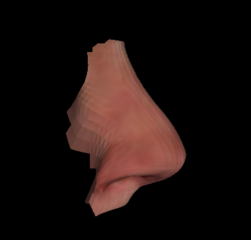 | 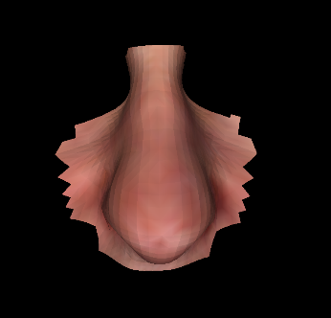 | straight | downturned | 56.2 | 48.9 | 30.8 | 1.8
43 | 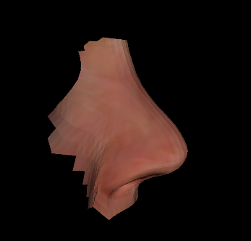 | 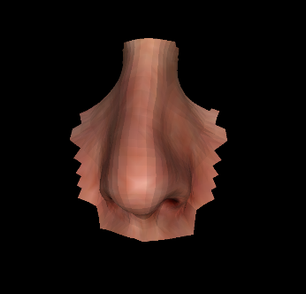 | concave | upturned | 53.1 | 43.6 | 28.1 | 1.9
44 | 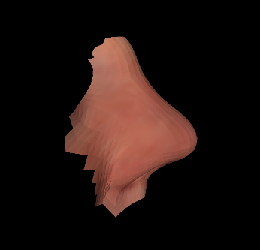 | 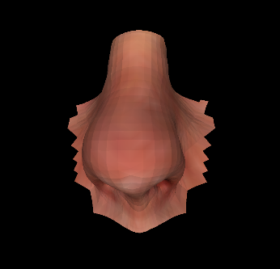 | concave | upturned | 62.5 | 51.0 | 35.4 | 1.8

