PLATE#1
WORKSHEET 1
One-way ANOVA: Cell number versus Treatment

Method
Null hypothesis | All means are equal
Alternative hypothesis | Not all means are equal
Significance level | α = 0.05
Rows unused | 2
Equal variances were not assumed for the analysis.
Factor Information
Factor | Levels | Values
Treatment | 3 | LDH1, Manual, Uncontrolled
Welch’s Test
Source | DF Num | DF Den | F-Value | P-Value
Treatment | 2 | 32.2569 | 37.05 | 0.000
Model Summary
R-sq | R-sq(adj) | R-sq(pred)
67.21% | 66.06% | 63.66%
Means
Treatment | N | Mean | StDev | 95% CI
LDH1 | 20 | 268312 | 38713 | (250193, 286430)
Manual | 20 | 229941 | 21636 | (219815, 240067)
Uncontrolled | 20 | 100453 | 77329 | (64262, 136645)
Games-Howell Pairwise Comparisons
Grouping Information Using the Games-Howell Method and 95% Confidence
Treatment | N | Mean | Grouping
LDH1 | 20 | 268312 | A
Manual | 20 | 229941 |  | B
Uncontrolled | 20 | 100453 |  |  | C
Means that do not share a letter are significantly different.
Games-Howell Simultaneous Tests for Differences of Means
Difference of Levels | Difference  of Means | SE of  Difference | 95% CI | T-Value | Adjusted  P-Value
Manual - LDH1 | -38370 | 9917 | (-62843, -13898) | -3.87 | 0.002
Uncontrolled - LDH1 | -167858 | 19337 | (-215715, -120001) | -8.68 | 0.000
Uncontrolled - Manual | -129488 | 17955 | (-174560, -84416) | -7.21 | 0.000
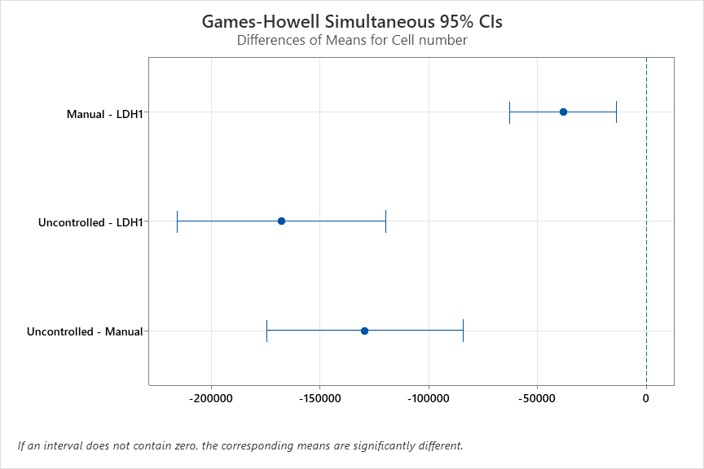

PLATE#2

WORKSHEET 1
One-way ANOVA: Cell number versus Treatment

Method
Null hypothesis | All means are equal
Alternative hypothesis | Not all means are equal
Significance level | α = 0.05
Rows unused | 2
Equal variances were not assumed for the analysis.
Factor Information
Factor | Levels | Values
Treatment | 3 | LDH1, Manual, Uncontrolled
Welch’s Test
Source | DF Num | DF Den | F-Value | P-Value
Treatment | 2 | 35.8289 | 22.02 | 0.000
Model Summary
R-sq | R-sq(adj) | R-sq(pred)
52.61% | 50.94% | 47.49%
Means
Treatment | N | Mean | StDev | 95% CI
LDH1 | 20 | 279564 | 43250 | (259322, 299806)
Manual | 20 | 267768 | 52374 | (243257, 292280)
Uncontrolled | 20 | 132751 | 89477 | (90875, 174627)
Games-Howell Pairwise Comparisons
Grouping Information Using the Games-Howell Method and 95% Confidence
Treatment | N | Mean | Grouping
LDH1 | 20 | 279564 | A
Manual | 20 | 267768 | A
Uncontrolled | 20 | 132751 |  | B
Means that do not share a letter are significantly different.
Games-Howell Simultaneous Tests for Differences of Means
Difference of Levels | Difference  of Means | SE of  Difference | 95% CI | T-Value | Adjusted  P-Value
Manual - LDH1 | -11796 | 15188 | (-48848, 25256) | -0.78 | 0.720
Uncontrolled - LDH1 | -146813 | 22222 | (-201811, -91816) | -6.61 | 0.000
Uncontrolled - Manual | -135017 | 23183 | (-192064, -77970) | -5.82 | 0.000
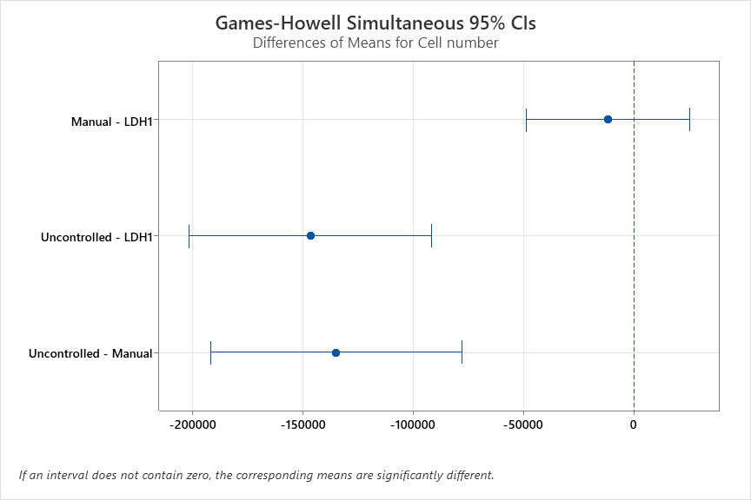

PLATE#3
WORKSHEET 1
One-way ANOVA: Cell number versus Treatment

Method
Null hypothesis | All means are equal
Alternative hypothesis | Not all means are equal
Significance level | α = 0.05
Rows unused | 2
Equal variances were not assumed for the analysis.
Factor Information
Factor | Levels | Values
Treatment | 3 | LDH1, Manual, Uncontrolled
Welch’s Test
Source | DF Num | DF Den | F-Value | P-Value
Treatment | 2 | 36.7607 | 106.32 | 0.000
Model Summary
R-sq | R-sq(adj) | R-sq(pred)
78.22% | 77.44% | 75.81%
Means
Treatment | N | Mean | StDev | 95% CI
LDH1 | 20 | 247725 | 52344 | (223227, 272223)
Manual | 19 | 287346 | 61086 | (257903, 316788)
Uncontrolled | 20 | 58486 | 48732 | (35679, 81294)
Games-Howell Pairwise Comparisons
Grouping Information Using the Games-Howell Method and 95% Confidence
Treatment | N | Mean | Grouping
Manual | 19 | 287346 | A
LDH1 | 20 | 247725 | A
Uncontrolled | 20 | 58486 |  | B
Means that do not share a letter are significantly different.
Games-Howell Simultaneous Tests for Differences of Means
Difference of Levels | Difference  of Means | SE of  Difference | 95% CI | T-Value | Adjusted  P-Value
Manual - LDH1 | 39621 | 18259 | (-5051, 84293) | 2.17 | 0.090
Uncontrolled - LDH1 | -189239 | 15992 | (-228251, -150226) | -11.83 | 0.000
Uncontrolled - Manual | -228860 | 17752 | (-272292, -185428) | -12.89 | 0.000
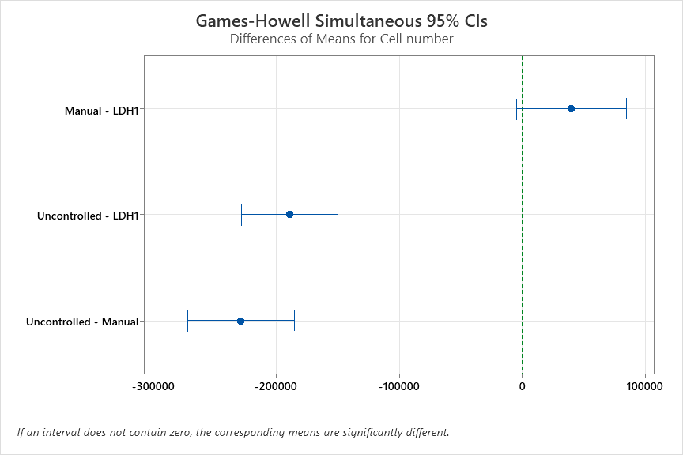

PLATE#4

WORKSHEET 1
One-way ANOVA: Cell number versus Treatment

Method
Null hypothesis | All means are equal
Alternative hypothesis | Not all means are equal
Significance level | α = 0.05
Rows unused | 2
Equal variances were not assumed for the analysis.
Factor Information
Factor | Levels | Values
Treatment | 3 | LDH1, Manual, Uncontrolled
Welch’s Test
Source | DF Num | DF Den | F-Value | P-Value
Treatment | 2 | 36.1166 | 23.28 | 0.000
Model Summary
R-sq | R-sq(adj) | R-sq(pred)
50.38% | 48.64% | 45.02%
Means
Treatment | N | Mean | StDev | 95% CI
LDH1 | 20 | 289729 | 88473 | (248323, 331136)
Manual | 20 | 235273 | 57928 | (208162, 262384)
Uncontrolled | 20 | 100491 | 92182 | (57348, 143633)
Games-Howell Pairwise Comparisons
Grouping Information Using the Games-Howell Method and 95% Confidence
Treatment | N | Mean | Grouping
LDH1 | 20 | 289729 | A
Manual | 20 | 235273 | A
Uncontrolled | 20 | 100491 |  | B
Means that do not share a letter are significantly different.
Games-Howell Simultaneous Tests for Differences of Means
Difference of Levels | Difference  of Means | SE of  Difference | 95% CI | T-Value | Adjusted  P-Value
Manual - LDH1 | -54456 | 23646 | (-112476, 3564) | -2.30 | 0.069
Uncontrolled - LDH1 | -189239 | 28570 | (-258936, -119541) | -6.62 | 0.000
Uncontrolled - Manual | -134783 | 24345 | (-194688, -74877) | -5.54 | 0.000
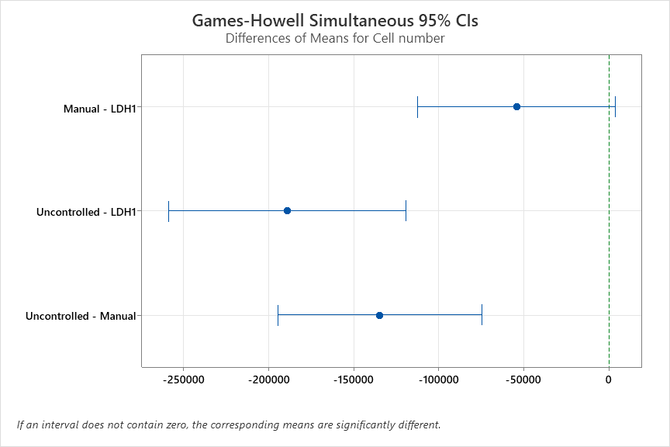

PLATE#5
WORKSHEET 1
One-way ANOVA: Cell number versus Treatment

Method
Null hypothesis | All means are equal
Alternative hypothesis | Not all means are equal
Significance level | α = 0.05
Rows unused | 2
Equal variances were not assumed for the analysis.
Factor Information
Factor | Levels | Values
Treatment | 3 | LDH1, Manual, Uncontrolled
Welch’s Test
Source | DF Num | DF Den | F-Value | P-Value
Treatment | 2 | 31.3195 | 85.44 | 0.000
Model Summary
R-sq | R-sq(adj) | R-sq(pred)
71.54% | 70.48% | 68.15%
Means
Treatment | N | Mean | StDev | 95% CI
LDH1 | 17 | 237692 | 79605 | (196763, 278621)
Manual | 20 | 260032 | 37295 | (242577, 277486)
Uncontrolled | 20 | 57891 | 58126 | (30688, 85095)
Games-Howell Pairwise Comparisons
Grouping Information Using the Games-Howell Method and 95% Confidence
Treatment | N | Mean | Grouping
Manual | 20 | 260032 | A
LDH1 | 17 | 237692 | A
Uncontrolled | 20 | 57891 |  | B
Means that do not share a letter are significantly different.
Games-Howell Simultaneous Tests for Differences of Means
Difference of Levels | Difference  of Means | SE of  Difference | 95% CI | T-Value | Adjusted  P-Value
Manual - LDH1 | 22340 | 21031 | (-30452, 75133) | 1.06 | 0.547
Uncontrolled - LDH1 | -179800 | 23274 | (-237236, -122364) | -7.73 | 0.000
Uncontrolled - Manual | -202140 | 15443 | (-240031, -164249) | -13.09 | 0.000
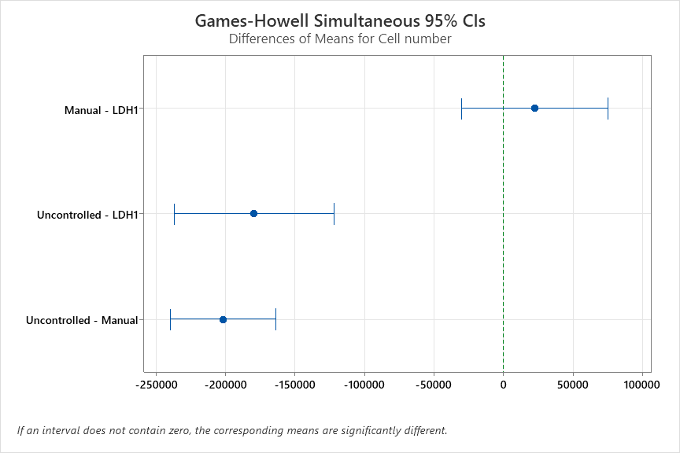

PLATE#6
WORKSHEET 1
One-way ANOVA: Cell number versus Treatment

Method
Null hypothesis | All means are equal
Alternative hypothesis | Not all means are equal
Significance level | α = 0.05
Rows unused | 2
Equal variances were not assumed for the analysis.
Factor Information
Factor | Levels | Values
Treatment | 3 | LDH1, Manual, Uncontrolled
Welch’s Test
Source | DF Num | DF Den | F-Value | P-Value
Treatment | 2 | 31.8160 | 114.57 | 0.000
Model Summary
R-sq | R-sq(adj) | R-sq(pred)
66.33% | 65.13% | 62.55%
Means
Treatment | N | Mean | StDev | 95% CI
LDH1 | 19 | 151930 | 78554 | (114068, 189791)
Manual | 20 | 233994 | 26288 | (221690, 246297)
Uncontrolled | 20 | 54172 | 46071 | (32610, 75734)
Games-Howell Pairwise Comparisons
Grouping Information Using the Games-Howell Method and 95% Confidence
Treatment | N | Mean | Grouping
Manual | 20 | 233994 | A
LDH1 | 19 | 151930 |  | B
Uncontrolled | 20 | 54172 |  |  | C
Means that do not share a letter are significantly different.
Games-Howell Simultaneous Tests for Differences of Means
Difference of Levels | Difference  of Means | SE of  Difference | 95% CI | T-Value | Adjusted  P-Value
Manual - LDH1 | 82064 | 18956 | (34346, 129782) | 4.33 | 0.001
Uncontrolled - LDH1 | -97758 | 20758 | (-148985, -46531) | -4.71 | 0.000
Uncontrolled - Manual | -179822 | 11861 | (-209092, -150551) | -15.16 | 0.000
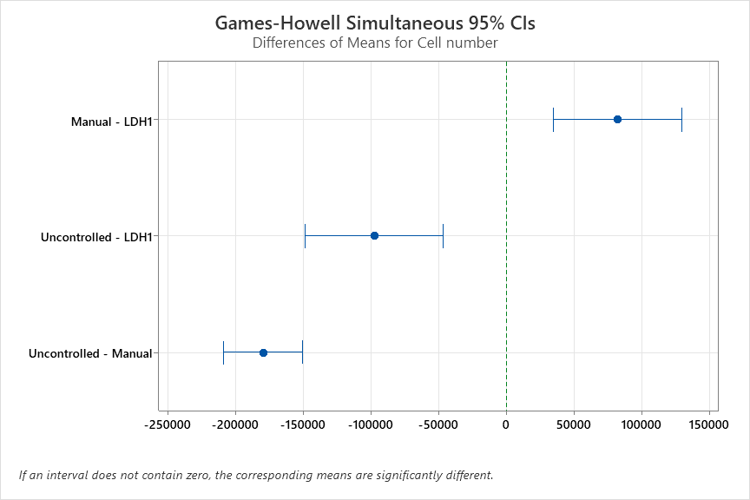

PLATE#7

One-way ANOVA: Cell number versus Treatment

Method
Null hypothesis | All means are equal
Alternative hypothesis | Not all means are equal
Significance level | α = 0.05
Rows unused | 2
Equal variances were not assumed for the analysis.
Factor Information
Factor | Levels | Values
Treatment | 3 | LDH1, Manual, Uncontrolled
Welch’s Test
Source | DF Num | DF Den | F-Value | P-Value
Treatment | 2 | 37.8444 | 51.39 | 0.000
Model Summary
R-sq | R-sq(adj) | R-sq(pred)
62.36% | 61.04% | 58.30%
Means
Treatment | N | Mean | StDev | 95% CI
LDH1 | 20 | 129423 | 29937 | (115412, 143434)
Manual | 20 | 88405 | 34768 | (72133, 104677)
Uncontrolled | 20 | 32207 | 30351 | (18002, 46412)
Games-Howell Pairwise Comparisons
Grouping Information Using the Games-Howell Method and 95% Confidence
Treatment | N | Mean | Grouping
LDH1 | 20 | 129423 | A
Manual | 20 | 88405 |  | B
Uncontrolled | 20 | 32207 |  |  | C
Means that do not share a letter are significantly different.
Games-Howell Simultaneous Tests for Differences of Means
Difference of Levels | Difference  of Means | SE of  Difference | 95% CI | T-Value | Adjusted  P-Value
Manual - LDH1 | -41018 | 10259 | (-66045, -15990) | -4.00 | 0.001
Uncontrolled - LDH1 | -97216 | 9533 | (-120472, -73961) | -10.20 | 0.000
Uncontrolled - Manual | -56199 | 10320 | (-81374, -31023) | -5.45 | 0.000
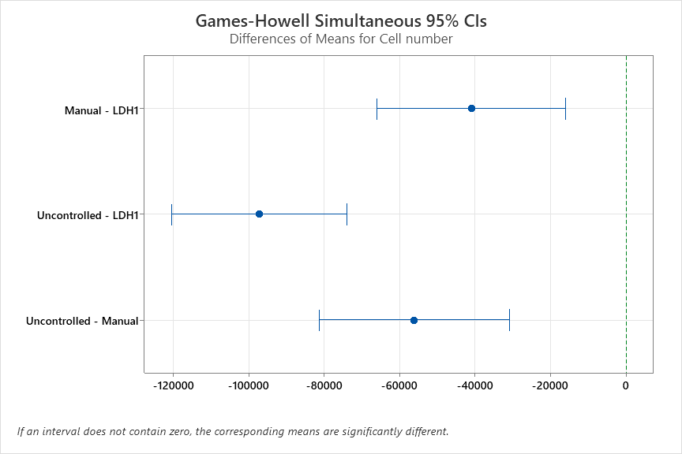

PLATE#8
One-way ANOVA: Cell number versus Treatment

Method
Null hypothesis | All means are equal
Alternative hypothesis | Not all means are equal
Significance level | α = 0.05
Rows unused | 2
Equal variances were not assumed for the analysis.
Factor Information
Factor | Levels | Values
Treatment | 3 | LDH1, Manual, Uncontrolled
Welch’s Test
Source | DF Num | DF Den | F-Value | P-Value
Treatment | 2 | 34.5815 | 26.73 | 0.000
Model Summary
R-sq | R-sq(adj) | R-sq(pred)
61.72% | 60.38% | 57.59%
Means
Treatment | N | Mean | StDev | 95% CI
LDH1 | 20 | 211365 | 26267 | (199072, 223658)
Manual | 20 | 214716 | 21655 | (204581, 224851)
Uncontrolled | 20 | 96756 | 68774 | (64569, 128943)
Games-Howell Pairwise Comparisons
Grouping Information Using the Games-Howell Method and 95% Confidence
Treatment | N | Mean | Grouping
Manual | 20 | 214716 | A
LDH1 | 20 | 211365 | A
Uncontrolled | 20 | 96756 |  | B
Means that do not share a letter are significantly different.
Games-Howell Simultaneous Tests for Differences of Means
Difference of Levels | Difference  of Means | SE of  Difference | 95% CI | T-Value | Adjusted  P-Value
Manual - LDH1 | 3351 | 7612 | (-15219, 21921) | 0.44 | 0.899
Uncontrolled - LDH1 | -114609 | 16462 | (-155699, -73519) | -6.96 | 0.000
Uncontrolled - Manual | -117960 | 16123 | (-158318, -77602) | -7.32 | 0.000
