Sensitivity study on the effect of cyst material model properties on tibiotalar joint contact behaviour
Harriet G. Talbott, Marlène Mengoni – University of Leeds
Supplementary material to “The Relationship between Subchondral Bone Cysts and Cartilage Health in the Tibiotalar Joint: A Finite Element Analysis”: Talbott et al, 2022, accepted to Clinical Biomechanics

Methods
Utilising one model with tibial SBCs only, a sensitivity analysis was carried out on the cystic properties (Table 1) as these have not been characterised. The sensitivity study considered a range of Youngs’ Moduli and Poisson’s Ratio, from those used in literature to combinations giving Bulk Moduli similar to that anticipated in cystic fluid. Finite Element models were derived in the same way as described in the associated paper.
Whether the FE outputs would be at all influenced by the properties used for the SBC region was investigated for the peak and mean contact pressures, and the percentage contact area. One-Sample T-Tests were carried out to see how the value from the baseline properties (used in the main study) varied from the averages across the group.

Table 1 Sensitivity test parameters for cyst properties (baseline properties from main study highlighted)
Youngs’ Modulus (MPa) | Poisson’s Ratio | Bulk modulus (MPa)
1 | 0.45 | 3.3
1 | 0.49 | 16.7
1 | 0.499 | 166.7
1.32 | 0.499 | 220
132 | 0.45 | 440
1 | 0.4999 | 1,666.7
13.2 | 0.499 | 2,200
132 | 0.49 | 2,200
660 | 0.45 | 2200
200 | 0.49 | 3,333.3
1000 | 0.45 | 3,333.3
660 | 0.49 | 11,000
132 | 0.499 | 22,000

Results
When comparing the baseline properties to the various cystic properties, there were statistically significant differences in both peak (p < 0.0001) and mean bone outputs (p < 0.0005). While there was no statistical significance between the mean contact pressures (p = 0.214 and 0.152 in the tibial and talar cartilage respectively) (Figure 1B); the peak contact pressures saw significant differences (p < 0.0001) , as did the contact areas (p < 0.0001), but when looking at the percentage error for the contact areas, this was only 2.3% in the tibial contact area, and 1.8% in the talar cartilage.
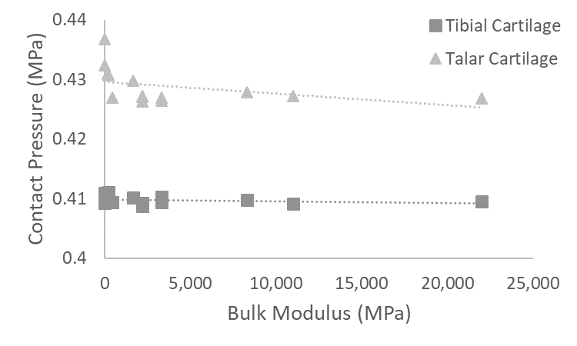
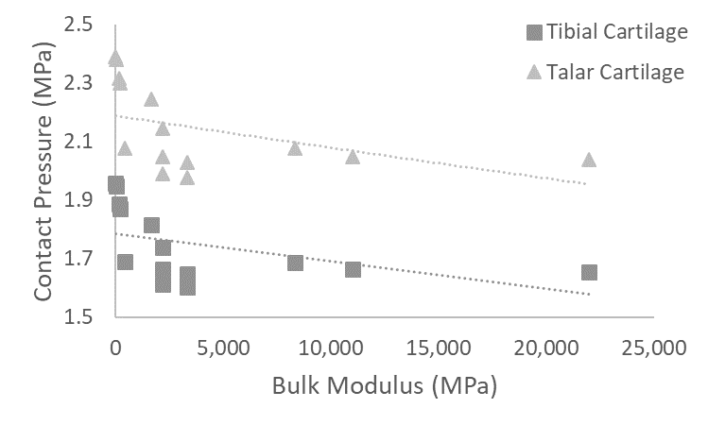
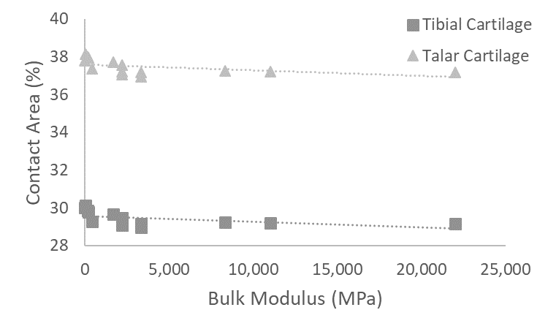
Discussion
Figure 1 Sensitivity Study results for A) peak contact pressure, B) mean contact pressure, and C) % area in contact against bulk modulus
A
C
B
The sensitivity test covered a range of bulk modulus values, as it is unknown if or how the presence of blood – should it enter the subchondral bone cysts – would affect either of the properties defined.
In the cartilage regions, it was seen that the peak contact pressure was the most sensitive to the bulk modulus, with both the Youngs’ Modulus and Poisson’s Ratio independently having a linear negative correlation with the peak contact pressure. The mean contact pressure, and the contact area were much less sensitive to these variables, which gave confidence in the qualitative differences in contact area with the addition of cysts.
If we were to be considering the implication of SBCs on bone health, it was clear from the sensitivity findings that the simplified material properties used for bone and cyst would not be appropriate. A characterisation of the cystic properties, and how these might be influenced by the presence of blood within the cyst would be required. And inhomogeneous bone properties, as used in other studies considering bone outputs, would be needed to understand the immediate localised effect. CT based bone properties would be most appropriate for this, as it is noted that the bone quality immediately surrounding the cyst is lower than in other regions.

